SREAMLINING SOFTWARE RELEASE PROCESS AND RESOURCE MANAGEMENT FOR MICROSERVICE BASED ARCHITECTURE ON MULTI-CLOUD

Isuru Herath

Samuditha Jayawardena

Ahamed Fadhil

B.Sc. (Hons) Degree in Information Technology

Specializing in Software Engineering

Department of Software Engineering

Sri Lanka Institute of Information Technology

Sri Lanka

September 2023

SREAMLINING SOFTWARE RELEASE PROCESS AND RESOURCE MANAGEMENT FOR MICROSERVICE BASED ARCHITECTURE ON MULTI-CLOUD

Isuru Herath

Samuditha Jayawardena

Ahamed Fadhil

B.Sc. (Hons) Degree in Information Technology

Specializing in Software Engineering

Department of Software Engineering

Sri Lanka Institute of Information Technology

Sri Lanka

September 2023

# Declaration

I declare that this is our own work, and this proposal does not incorporate without acknowledgement any material previously submitted for a degree or diploma in any other university or Institute of higher learning and to the best of our knowledge and belief it does not contain any material previously published or written by another person except where the acknowledgement is made in the text.

Also, I hereby grant to Sri Lanka Institute of Information Technology, the nonexclusive right to reproduce and distribute my dissertation, in whole or in part in print, electronic or other medium. I retain the right to use this content in whole or part in future works (such as articles or books).”

**Signature**:

|  |  |  |
| --- | --- | --- |
| **IT20125516** | **Herath H.M.I.P.** |  |
| **IT20074968** | **Jayawardena R.D.S.H** |  |
| **IT20784720** | **Fadhil M.R.A.** |  |

The above candidate is carrying out research for the undergraduate Dissertation under my supervision.

**Signature of the Supervisor:** **………………………………...**

**Date: ………………………………...**

# Abstract

With the popularity of incorporating IT-based solutions for almost all aspects of society, the necessity to develop complex multi-dimensional applications has increased over time. Microservices have thus evolved into one of the most famous architectural approaches to implement such complex applications in the software engineering paradigm due to their ability to effectively and efficiently decompose large software applications into loosely coupled independently scalable, self-contained components.

A new breed of tools, platforms, and development technologies emerged with the introduction of the microservice architecture for the development of software applications, enabling developers and system administrators to monitor, orchestrate, and deploy their containerized microservice applications more successfully and effectively. Due to its capability to deploy and orchestrate containerized microservices, Kubernetes has emerged as one of these major technologies that has gained immense popularity. However, a common problem in orchestration platforms like Kubernetes is the use of a huge variety of disparate monitoring solutions that don't provide a comprehensive view of the state of microservice deployments, which prevents the development of more optimal deployment policies.

In response to this issue, the research carried out proposes the development of an artificial intelligence-based approach for resource governance in microservices which incorporates load prediction, metrics gathering and resiliency evaluation to effectively construct a more holistic perspective on a given microservice deployment. The solution tries to automate the end-to-end process of microservice governance from creating docker containers from the fast provider server to cluster optimization using autoscaling policy.

***Keywords:*** *Kubernetes, Service Mesh, Machine Learning, Timeseries Predictions, BiLSTM, Neural Networks, DevOps, Chaos Engineering, Docker, Fast Provider*

# Acknowledgement

We want to express our gratitude to our supervisor Dr. Nuwan Kodagoda and co-supervisor Mr. Udara Samarathu for their support and encouragement in helping us complete our research successfully. We also want to express our gratitude to the CDAP instructors and staff for giving us the chance to conduct this study, as well as the Department of Software Engineering at the Sri Lanka Institute of Information Technology.

# List of Figures

Figure 1:Gantt chart of schedule 19

# List of Tables

**No table of figures entries found.**

Table of Contents

Declaration 3

Abstract 4

Acknowledgement 5

List of Figures 6

List of Tables 7

List of Abbreviations 9

1. introduction 10

1.1 Background and Literature 11

1.2 Research Gap 12

2 Research problem 16

1 Objectives 17

1.1 Main Objective 17

1.2 Sub Objectives 17

2 methodology 18

2.1 Requirement Gathering 18

2.2 Feasibility Study 18

2.3 Requirement Analysis 19

2.4 Software System Analysis 19

4.4 System Development and Implementation 20

4.5 Project Requirements 20

4.6 Commercialization 20

5 Results and discussion 21

6 conclusion 21

7 Further improvements 22

8 References 23

APPENDIX 24

[Appendix 1: Jenkins Deployment] 24

# List of Abbreviations

|  |  |
| --- | --- |
| Abbreviation | Description |
| CI | Continuous Integration |
| CD | Continuous Delivery |
| CDT | Continuous Deployment |
| VM | Virtual Machine |
| MSA | Microservice System Architecture |
| TLS | Transport Layer Security |
| RBAC | Role Based Access Management |
| SRP | Software Release Process |
| PaaS | Platform as a Service |
| SaaS | Software as a Service |
| CPU | Central Processing Unit |
| IaaS | Infrastructure as a Service |
| SSO | Single Sign On |
| SCM | Source Code Management |

## introduction

The microservice-based architecture is used by most companies to achieve their goals with the benefit of having high availability, scalability, and avoiding the problems of Monolithic architecture [1]. With the advancement of microservice-based architecture, containerization platforms are introduced, and Docker [2] is the most popular and highly used platform for containerization. Kubernetes was introduced to resolve the problem of container orchestration [3] and DevOps came to the IT industry as a main character to automate the complexity.

The primary goal of introducing DevOps is to increase the automation of the software delivery process [4]. Although Docker, Kubernetes, and Cloud environments solve many problems related to microservice application deployments, most companies face a lack of automation and optimization of their software release process. This problem causes a slowdown and untrust the human interaction in the software release process. As a solution for this problem, Continuous Integration and Continuous Delivery (CI/CD) and Continuous Deployment (CDT) [5] can be architect and optimized for the software release process according to architectural attributes such as performance, security, extendibility, reliability, and modifiability that is commonly feasible to use in most software companies. It is necessary to have good visibility to maintain and debug the applications or improve software performance. Even, though there are monitoring tools such as Jaeger, Prometheus, and Elastic Search, they are not well- developed with detailed dashboards to get summarized details. It would be intuitive to have a centralized platform to monitor all necessary statistics in one view and enhance usability.

Dynamically resource allocation is challenging when catering for enterprise-scale in different date and time ranges. As a solution, a combination of One Directional Convolutional Neural Networks (1D CNN) with a Bi-LSTM [6] is proposed to predict the necessary resource limits per application during specific days and specific time ranges automatically. This combined model can be used on sequences of data that have both spatial and temporal dependencies. Local patterns can be captured through the CNN layers, and longer-term dependencies can be captured through the Bi-LSTM layers. With this solution, resource allocation for HPA and VPA becomes easy because the Machine Learning (ML) algorithm gives the predicted value with the previous data.

The research is proposed to model by addressing the mentioned problems and solutions. The primary component of the proposed system is mentioned in the following section describing the solutions for the problems addressed in the above section.

1. Rearchitect a fully automated and optimized software release process according to architectural attributes such as performance, security, extendibility, reliability, and modifiability.
2. Develop a centralized monitoring platform to visualize monitoring tools such as Jaeger, Prometheus, and Elastic Search.
3. Use a reinforcement learning algorithm to predict the maximum and minimum resource limits for horizontal pod autoscaling based on time and date.

### Background and Literature

The performance of the software release process is a big challenge in releasing software. The performance of Kubernetes deployment is measured and studied under Virtual Machines. However, the performance may slow due to the lack of memory [7], lack of storage, and lack of available Central Processing Unit (CPU). The available solutions of publications do not meet the necessary performance level to avoid the mentioned problems. The necessary packages and components are always downloaded from the internet during the jobs to build docker images. This process is time-consuming and uses more resources to execute. Furthermore, the extendibility is applied with automated configuration, initialization, and deployment with an algebraic approach. However, the available systems [7] are not optimized with Kubernetes and Docker-based automated software release process systems. The solution needed to become extendible and modifiable.

Allocating resources during the software testing phase needed to be optimized to achieve reliability [9]. The cost reduction [10] is also a gap between available paid versions. Attributes such as performance, security, and reliability are considered during optimization [11], but attributes such as extendibility, modifiability, and automation are missed to archive. Also, the publication [12] is focused on optimizing performance and reliability, but the system is not well- optimized with security, extendibility, modifiability, and automation. The available automations that are based on industrial architecture [13] are investigated with different microservice based architectures. However, the solution is based on a separate framework that only supports Java and cannot be applied to other programming languages.

Cloud monitoring is a very cost-effective thing for organizations. Therefore, many companies use open-source data monitoring and visualization tools. [14] However available open-source tools have limitations. As an example, Prometheus does not support application logs. The proposed centralized monitoring and visualization tool is supported to monitor metrics, logs, and traces in one dashboard. [17] Some existing commercial monitoring tools can monitor logs, metrics, and traces on the same dashboard, but they charge a very high price for that, the proposed tool uses the libraries of open-source tools and fulfils the requirement of centralized monitoring.

#### 1.1.1 Fully Automated and Optimized Software Release Process on Multi Cloud

Before the "Agile" and "Microservice" based architecture is being popular in the software industry there were two main teams during the software development life cycle as "Developer Team" and the "Operation Team". The development team is responsible to release new features and hotfixes, but the operational team is responsible for software stability and reliability. With the different interests in both teams, the release process had many gaps and barriers during the quick release of a software version. Software versioning has become normalized after the microservice- based architecture and agile methodology comes to the industry, because of the rapid development of the software product. After the release of the initial product, there were hotfixes, minor updates, and major update releases on the software. With the rapid growth and release process, the old barriers were also a roadblock to releasing the updated software quickly to the end users. As a result, Development and Operation teams needed a solution and the solution was having DevOps architecture and DevOps is responsible to implement and manage the software development and software release process [8]. After the CI/CD and Containerization became the main components of the software release process, the wall of confusion between "development" and "operation" teams was destroyed.

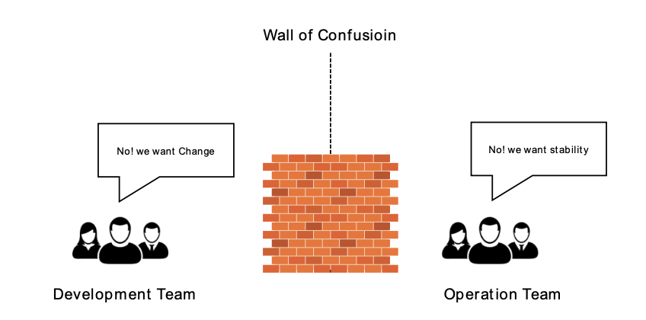

Figure 3: Wall of Confusion

The software release process is an essential part of software development, and optimization is critical for efficient, high-quality software releases. Agile methodologies, DevOps practices, containerization, container orchestration, security, testing, versioning, image manipulation, and service meshes are emerging trends in software development that are transforming the software release process. Istio is a popular open-source service mesh that provides a robust set of features for managing microservices in Kubernetes clusters. There are many numbers of solutions were

introduced for found problems and grow backs during the journey of DevOps into software release process. As the winner of the competition with different tools and technologies for containerization and container orchestrations, finally docker and Kubernetes survived their position with providing many numbers of features and solutions for raised problem during software release process and maintenance. Kubernetes architecture and Docker Architecture gives the clear and well-defined view for software release life cycle with providing the support to deploy and manage thousands of containerized applications [9]. During Docker manage the application images, Kubernetes manipulate the available containerized application.

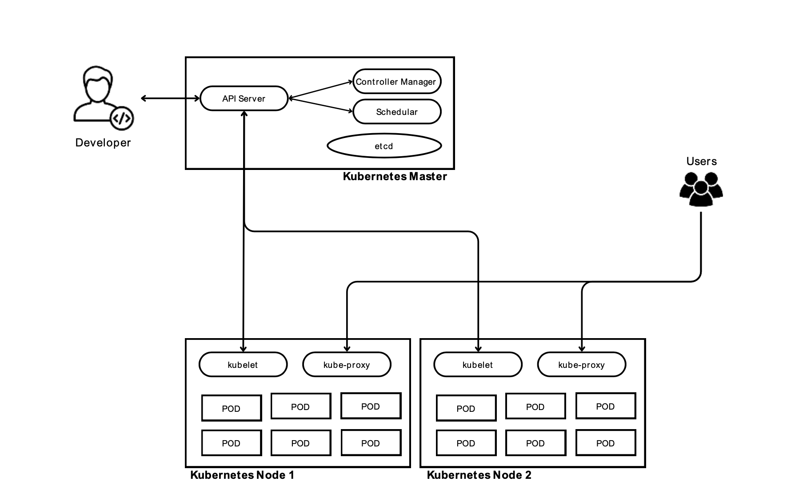

Figure 4: Kubernetes Architecture

Automated software release processes are invented to reduce the manual processes during software development life cycle. Currently, most of the software release process systems are automated but, they are not fully automated without the human interactions during approval processes and testing processes.

Because of the reason of not fully automated software release process systems, the need of fully automation become a common problem for the companies and businesses. As solutions CI/CD/CDT tools were invented. But there are only few of them are survived and became commonly used in the software industry. Not only those tools but also the tools and technologies for automated integration testing, automated security testing, unit testing and many other testing tools were invented and used in the industry.

Many reasons have influenced the need for automation and the implementation of DevOps techniques as software release processes have evolved gradually. One of the primary causes of this development has been the rising complexity of software systems, which has made manual release management increasingly challenging. As a result, a larger focus has been placed on automation and the use of tools and methods that can streamline the software release process.

Continuous Integration/Continuous Deployment (CI/CD) was a significant step forward in this development [10]. CI/CD is a software development methodology that stresses the significance of regular and automated code testing, integration, and deployment. This strategy has reduced the likelihood of mistakes and disputes during the software release process while also allowing teams to deliver software more swiftly and effectively.

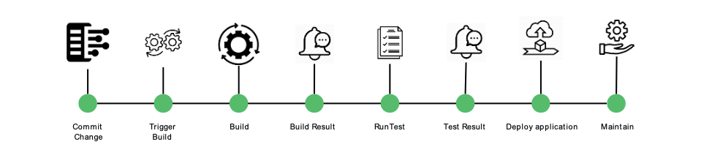

Figure 5: CI/CD Pipeline

The development of software release procedures has also been influenced by automation testing. Manual testing has become less efficient, time-consuming, and error prone as software systems have grown more complicated. Automation testing, on the other hand, allows teams to perform tests more swiftly, consistently, and frequently, lowering the risk of mistakes and conflicts during the software delivery process.

Another important element in the evolution of software release procedures has been the rise of DevOps techniques. DevOps is a concept that promotes cooperation, communication, and integration between development and operations teams. DevOps has helped to reduce the risk of errors and disputes during the software release process while also increasing the speed and efficiency of software delivery by breaking down silos between these teams and promoting a culture of cooperation.

Cloud computing has also changed the way software is released. Cloud platforms have allowed teams to scale their software systems rapidly and easily by giving on-demand access to a variety of computing resources, while also lowering the need for on- premises infrastructure [11]. Cloud platforms also offer a variety of tools and services that can assist teams in automating many parts of the software release process, from testing to distribution.

Even the software release processes are available with current automated tools, they have roadblocks due to some architectural attributes such as performance, security, extendibility, reliability, and modifiability [7]. And the current software release processes are not fully automated but only partially automated for different stages with the business requirement of different software companies. The current release process has mentioned architectural attributes that needed to be optimized because the systems are not easy to modify and easy to integrate with new tools and technologies to improve the quality of software development. Some systems take too much time to build and run tests, and as a result the software application get too much time to deploy in the necessary environments due to performance issues. The security is a main problem that needed to be covered during the software release life cycle and needed to be integrated and improved with streamlined software release process. Overall, the current software release processes needed to be well optimized under the mentioned attributes as a fully automated system.

#### 1.1.2 Centralized monitoring platform

Prometheus and Grafana are popular monitoring and visualization tools used for collecting and analyzing metrics data. These tools are often combined to create a comprehensive cloud data monitoring and visualization tool. However, this approach has its own set of problems and limitations. This literature review will explore the architecture of Prometheus and the limitations of combining Prometheus and Grafana for cloud data monitoring and visualization. Additionally, it will examine relevant research papers on this topic to provide a comprehensive review. Prometheus is an open-source monitoring system that is designed for metrics collection, monitoring, and alerting. It has a multi-dimensional data model that allows it to collect data from various sources and store it in a time-series database. The architecture of Prometheus consists of several components, including the Prometheus server, exporters, and alert manager.

The Prometheus server is responsible for collecting metrics data and storing it in a time- series database. It has a query language called PromQL, which allows users to query the collected data and perform analysis. The exporters are responsible for collecting metrics data from various sources, such as applications and operating systems, and converting it into a format that Prometheus can understand. The alert manager is responsible for processing alerts generated by Prometheus and sending them to various channels, such as email or Slack. Combining Prometheus and Grafana to create a cloud data monitoring and visualization tool has its own set of problems and limitations. One of the limitations is the need for expertise in both tools. Users must have knowledge of both Prometheus and Grafana to effectively use this combined tool. Additionally, the combination of Prometheus and Grafana can lead to data duplication, which can lead to performance issues and storage problems. Another limitation is the lack of support for advanced visualization options. While Grafana provides a wide range of visualization options, it may not be suitable for all use cases. The lack of customization options can also limit the flexibility of the tool.

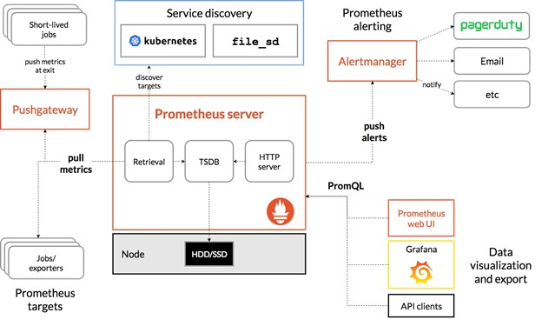

Figure 2 : Prometheus core architecture diagram

Source: ([4])

There are several research papers that have examined the use of Prometheus and Grafana for cloud data monitoring and visualization. For instance, a paper by Mehta et al. (2021) examined the use of Prometheus and Grafana to monitor and analyze Kubernetes cluster performance. The authors found that the combination of Prometheus and Grafana provided a comprehensive view of the system performance, but also highlighted the need for expertise in both tools. Another paper by Krishnan et al. (2021) examined the use of Prometheus and Grafana for monitoring and visualizing data from distributed systems. The authors found that while the combination of Prometheus and Grafana provided a powerful tool for monitoring and visualization, it required careful configuration to avoid data duplication and performance issues.

Jaeger is an open-source distributed tracing system that is commonly used for monitoring microservices. While Jaeger has several benefits, including real-time tracing and the ability to analyze complex systems, it also has several limitations. One of the limitations of Jaeger is its scalability. As the number of microservices in a system increases, Jaeger's ability to handle the large volumes of data generated by these services becomes limited. This can lead to delays in data processing and analysis, making it difficult for users to make informed decisions about the health and performance of their systems.

Another limitation of Jaeger is its complexity. Jaeger's user interface can be difficult to navigate, especially for non-technical stakeholders. This complexity can result in a lack of clarity and understanding of the data, leading to incorrect conclusions and suboptimal decision-making. Other open-source cloud monitoring tools, such as Zabbix and Nagios, also have limitations. For example, these tools often lack real-time data analysis capabilities, making it difficult for users to identify and respond to issues in a timely manner. Additionally, these tools can be difficult to configure and maintain, requiring specialized knowledge and expertise.

Several research papers have discussed the limitations of Jaeger and other open-source cloud monitoring tools. For example:

1. Moustafa, N., Dawoud, D., & Wu, J. (2021). An Intelligent Multi-Layered Architecture for Microservices Monitoring Using Distributed Tracing. IEEE Access, 9, 135000-135015.

This paper discusses the limitations of Jaeger and other distributed tracing systems for monitoring microservices. The authors propose an intelligent multi-layered architecture for monitoring microservices that addresses some of the limitations of existing systems.

2. Wang, J., Wang, R., & Chen, S. (2021). Cloud Service Monitoring Based on Distributed Tracing. In Proceedings of the 2021 International Conference on Intelligent Computing and Sustainable System (pp. 188-193). Springer.

This paper discusses the limitations of Jaeger and other distributed tracing systems for monitoring cloud services. The authors propose a cloud service monitoring framework based on distributed tracing that addresses some of the limitations of existing systems.

3. Oussous, A., Lahcen, A. A., & Belfkih, S. (2021). Monitoring and Alerting for Cloud Services: A Comprehensive Review of the State-of-the-Art. Journal of Cloud Computing, 10(1), 1-35.

This paper provides a comprehensive review of the state-of-the-art in cloud monitoring and alerting. The authors discuss the limitations of Jaeger and other open-source cloud monitoring tools and provide recommendations for improving the effectiveness of these tools. In conclusion, while Jaeger and other open-source cloud monitoring tools have several benefits, they also have limitations that can make it difficult for users to effectively monitor and analyze their systems. Further research is needed to address these limitations and improve the effectiveness of these tools.

#### 1.1.3 Resource Prediction and Allocation Server

Containerization is a technology that allows applications to be packaged and run in lightweight, isolated environments. instead of running a complete virtual machine (VM) with its own operating system (OS) on the top of virtualized hardware, containers provide an isolated environment for system resources (e.g., processes, file systems and networks) to run at the host OS level, this means that multiple

containers can be shared with the same OS kernel, hence start much faster, and use just a fraction of the system memory compared to booting an entire virtualized OS [14].

Due to the popularity of microservices the need to scale and automate the deployment was increased. so, google developed an open-sourced container orchestration platform called Kubernetes, also known as k8s. Kubernetes allows users to deploy and manage microservices in a distributed environment , make it a popular choice for building and deploying microservices based application.one of the important feature provided by Kubernetes is autoscaling in different ways such as automatically scale the number of pods running a microservice based on the matrices ( Horizontal Pod scaling ) , automatically adjust the resource limit of individual pods according to the usage (Vertical pod scaling). Kubernetes scaling was made according to the workload, so auto scaling microservices applications can be not accurate since services are distributed.

In [13] proposes an intelligent workload factoring approach to optimize resource

allocation in a hybrid cloud computing model. So, by identifying the challenges of workload factoring in hybrid cloud environments, where workloads can be distributed across multiple public and private clouds. The authors propose a solution that uses a workload characterization module to classify workloads into categories based on their resource requirements and performance characteristics. Then, a

decision module uses this information to allocate resources optimally across different clouds, considering factors such as cost and network latency. The authors also propose a feedback mechanism to adjust the workload factoring strategy dynamically based on changes in workload and resource availability.

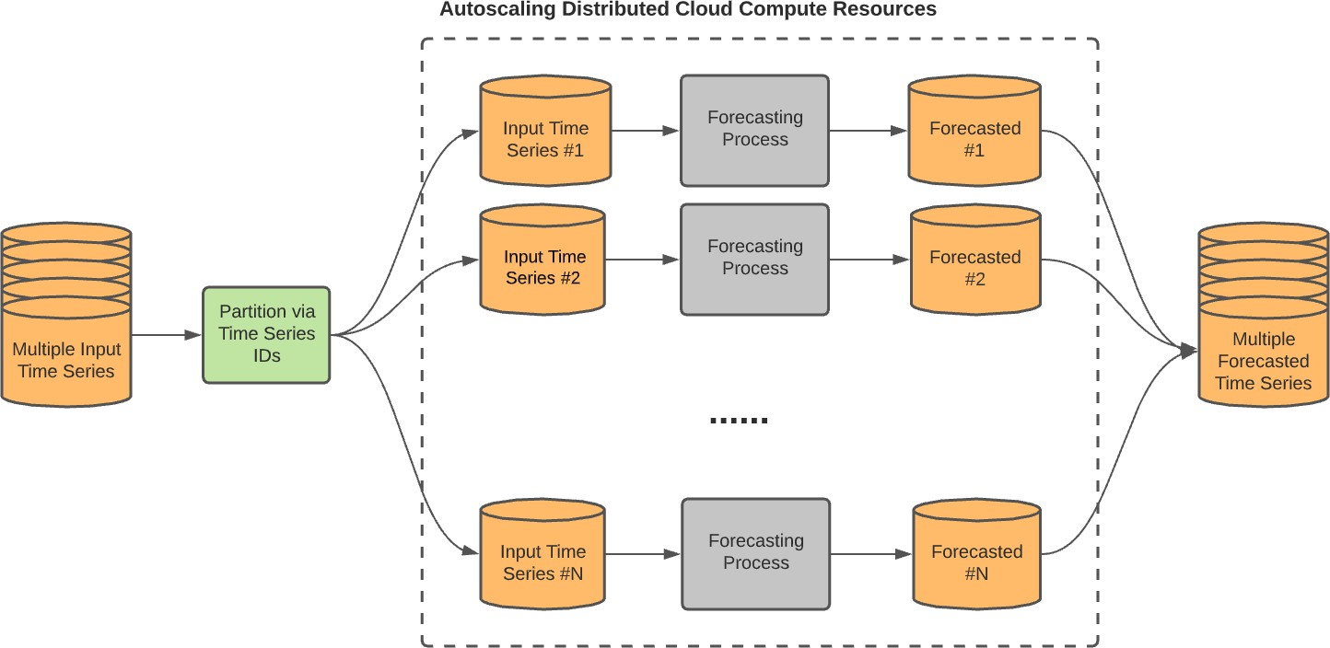

*Figure 1: Architecture of ARIMA Model*

In [15] proposes a deep learning-based autoscaling algorithm for Kubernetes, which is a popular open-source container orchestration platform. The proposed algorithm utilizes bidirectional long short-term memory (BiLSTM) neural networks to predict the future resource utilization of a Kubernetes cluster and dynamically adjust the number of replicas of containerized applications to optimize resource usage. The authors first trained the BiLSTM model on a dataset of historical resource utilization data collected from a Kubernetes cluster. The model was trained to predict future resource utilization based on past utilization patterns. Once the model was trained, it was deployed as a microservice within the Kubernetes cluster itself. The model continuously receives real-time resource utilization data from the Kubernetes cluster and predicts future utilization. The predicted future utilization is then used to

dynamically adjust the number of replicas of containerized applications to optimize resource usage.so by, evaluating the proposed algorithm using a real-world dataset collected from a Kubernetes cluster running various microservices. The evaluation results showed that the proposed algorithm achieved better performance in terms of resource utilization and response time compared to existing Kubernetes autoscaling algorithms such as the default Horizontal Pod Autoscaler (HPA) and the Predictive Horizontal Pod Autoscaler (PHPA).

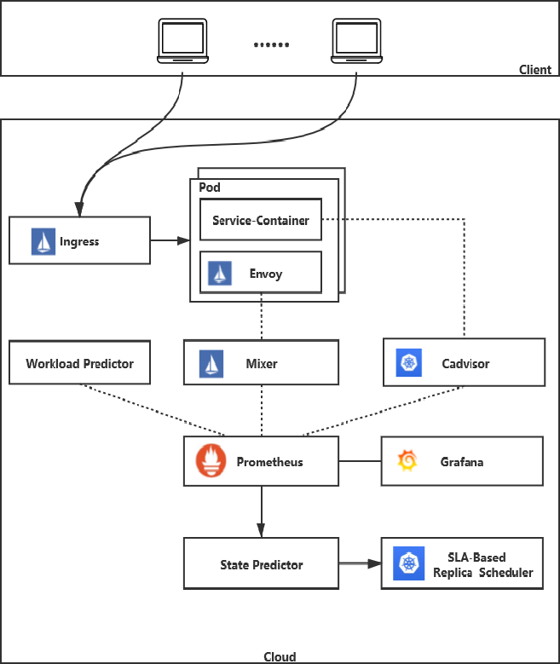

*Figure 2: Architecture Prometheus matrices gathering for prediction.*

In publication [2], proposes a new auto-scaling algorithm based on reinforcement learning (RL) for containerized cloud applications. The authors argue that existing.

auto-scaling approaches are often reactive and do not consider future resource usage, which leads to performance degradation and unnecessary resource consumption. To address these issues, the authors propose A-SARSA, an RL-based auto-scaling.

algorithm that takes both current and predicted future resource usage into account. A- SARSA uses the state-action-reward-state-action (SARSA) algorithm to learn an optimal policy that determines when to add or remove containers based on predicted future resource usage. The authors evaluate A-SARSA using several real-world benchmarks and show that it outperforms existing auto-scaling algorithms in terms of both resource utilization and application performance. A-SARSA achieves higher resource utilization by scaling proactively based on predicted future usage, and

improves application performance by avoiding under-provisioning and over- provisioning of resources. Overall, the paper proposes an innovative approach to auto-scaling containerized cloud applications that leverages RL to learn and optimize resource allocation policies. The results suggest that A-SARSA can improve both resource utilization and application performance, making it a promising direction for future research in this area.

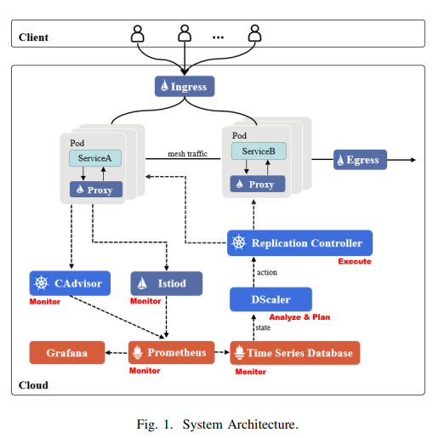

*Figure 3: Architecture of DScaler*

DScaler [1] was a horizontal autoscaler for microservice based application developed based on deep reinforcement learning. DScaler was developed for the usage of large scale and more complex microservice architecture applications to fix the scaling issues. DScaler uses a combination of deep neural networks and one of reinforcement learning algorithm called Q-learning algorithm to learn a policy for scaling microservices based system metrices. The proposed DScaler algorithm was tested with large e-commerce applications and with some rule based approaches.as a response DScaler has a good performance in resource utilization and response time.

|  |  |  |  |  |
| --- | --- | --- | --- | --- |
| Paper | Virtualization Technology | Monitored Metrics | Method | Technique |
| Zhang et al. [3] | VM | Request rate | Reactive | ARIMA |
| Li and Xia [4] | Container | CPU | Proactive | ARIMA |
| Rodrigo et al. [5] | VM | Request rate | Proactive | ARIMA |
| Xuehai Tang et al.[6] | Container | CPU | Proactive | Bi-LSTM |
| Ming Yan et al. [7] | Container | CPU, Memory | Hybrid | Bi-LSTM |
| Imdoukh et al. [8] | Container | Request rate | Proactive | LSTM |
| Laszlo Toka et al.[9] | Container | Request rate | Proactive | LSTM |
| Arabnejad et al. [11] | VM | CPU | Reactive | RL |
| Fabiana et al. [12] | Container | CPU | Reactive | RL |
| Prachimutita et al.[10] | VM | Request rate | Proactive | ANN, RNN |

*Table 1: existing research on scalability, metrics and technology used.*

Most of the research is based on the VM and container-based prediction for scale the resource load .so there are certain limitations on selecting the matrices for start the predictions. and all research is scaled based on the microservice architecture and deployed in and cloud-based cluster so there will be a cost that will be associated according to the resource load. So, through this component, first a prediction was made and according to the prediction by using an reinforcement algorithm, the predicted result will be optimized

### Research Gap

The main research gap in this research to fulfils the gap in current software release processes with optimizing according to the architectural attributes. This research is focused on invent an architecture to automate and optimize to avoid the gap between current solutions available in the software industry for software release process. The security of the available software release processes is too low level because both external and internal developers are working in a same company and must share the resources with external teams. It became a challenge and security issue of software release process because the external teams get accesses to databases and storages. The performance issues are getting higher with the scaling up the number of users of the software release process systems. The system may perform slowly or get some down times due to the reason of unable to maintain with the increasing number of users. With the new technologies and tools, the current release processes can be optimized and have more benefits with extending with novelties for performance, security, and maintaining. But the current systems are tight with the company environment and have not extendibility. Same as the extending, the modifiability is also a one main attribute that needed to have in a software release process system to improve the reliability, accessibility, and maintainability.

According to the publication [12], the security of Kubernetes and Docker Swam can be archived with cloud storages. But as discussed previously, the security is unable to archive when working with external teams. The system can have backups for a disaster recovery; but it cannot be assumed as a security aspect. PaaS and SaaS services are available to secure data inside cloud storages from external vulnerabilities. Inside the company, it needed to be easy to have the higher security for the stored data from external teams who needed to access same data during the software release process. Not only during using by the external teams, also need to improve the security of deployed application and docker images during building and pushing to a container registry. As the publication [13] is mentioned, there are challenges during applying Security with DevOps as DevSecOps. Also need to consider the given solutions but, data security and containerization security has lack of resources and available solutions as open-source solutions.

According to the publication [14], the performance on Kubernetes deployment is measured and studies under VMs. But the necessary solutions are only on Kubernetes clusters with docker images. The performance may slow due to the lack of memory, lack of storage and lack of available CPU. The available solutions of publications are not meeting the necessary performance level to avoid the mentioned problems. The Docker image build time is also a waste of the time for the software release process with downloading necessary dependencies or packages for Maven or Node building technologies. Current available release process systems are downloading and pulling necessary data from internet all the time. Need to be optimized the performance with giving a solution for mentioned performance drawbacks.

Furthermore, as the publication [15], the extendibility is applied with automated configuration, initialization, and deployment with algebraic approach. But the proposed system is not optimized with Kubernetes and Docker based automated software release process system. The solution needed to be more effective and improved to available the extendibility and modifiability. According to the publication [16], the unit testing is automated to avoid manual process of unit testing. But the solution is proposed with focusing Hydrologic Modeling. The current research is ongoing for microservice based architecture. Therefore, the solution needed to be improved to apply on microservice-based architecture. Moreover, the publication [17] I focused to automate the testing NodeJS and React projects. This needed to improve to available for any of the language or technology used in the software development. Once the testing is automated and could be applied to any programming technology, the extendibility can be optimized.

Software development reliability is needed to optimize from software building, testing, delivery, and deployment phases. As the publication [18], is focused to allocate resources during software testing phase. But the phases other than the testing is also needed to be optimized with the attribute of reliability. As the publication [19], the proposed solution is expensive and directly it effects to the cost of the software release process. The cost reducing is also a gap between available paid versions. Therefore, the proposed algorithm on cloud [19] is not the best solution when continue with open- source solutions.

There are some research and case studies are based on different areas of the architectural attributes that covered in this research projects. But they are not covered the architectural attributes cover in this research project during the optimization phase of the software release process. As mentioned in the publication [20], the attributes such as performance, security and reliability are considered during optimization, but they have not focused on extendibility, modifiability, and automation of the software release process. Also, in the publication [21], the research is focused to optimize performance and reliability, but they have not well optimized security, extendibility, modifiability, and automation.

As mentioned in the publication [22], the proposed automation is based on industrial architecture, and investigated with different microservice based architectures. But the solution is based on Eclipse and depends on the specific Eclipse based framework. If this solution is applied, the overall optimization cannot be archived due to the performance, extendible and modifiability architectural attributes cannot be archived.

## Research problem

One of the most critical challenges in micro service-based designs is optimizing performance, especially in multi-cloud environments where service delays and network traffic can significantly impact overall system performance. Several factors contribute to performance optimization, including enhancing containerization and orchestration methods, maximizing the efficient use of cloud resources, and identifying performance bottlenecks through real-time monitoring and data analysis.

When optimizing the software release process for micro service-based designs on multi-cloud platforms, security is another vital consideration. Micro services operate in distributed environments, where each application represents a potential security risk. Ensuring security requires the identification of potential vulnerabilities and weaknesses, the establishment of secure communication channels between services, and the implementation of effective access control methods. Security concerns in micro service deployments are among the most urgent research topics in this field, especially as more companies migrate to multi-cloud environments. Addressing this issue involves conducting research to identify and mitigate security risks and weaknesses in the software release process for micro service-based architectures on multi-cloud platforms.

Another aspect that can impact the software delivery process for micro service-based designs on cloud platforms is extensibility. Adapting micro services to meet evolving business requirements often necessitates architectural changes, which can affect the release process. Achieving extensibility while minimizing the impact on the release process can be facilitated by adopting a modular architecture and applying design patterns such as the microkernel and plug-in patterns.

Reliability is another critical factor to consider when optimizing the software distribution process for micro service-based designs on Kubernetes platforms. Ensuring reliability involves identifying potential points of failure, implementing fault-tolerant mechanisms like replication and redundancy, and incorporating automatic recovery mechanisms.

Modifiability is a key consideration when modifying micro services, requiring a deep understanding of service dependencies, assessing the impact of changes on the system, and ensuring backward compatibility.

Collaboration and communication are essential for efficient software delivery processes, particularly in the context of multi-cloud micro services deployment. Given the distributed nature of the system, effective collaboration and communication can be particularly challenging. In this context, it's essential to automate the software release process, from software development to deployment, without manual intervention.

Resource management and scaling are crucial concerns for micro services deployed on Kubernetes clusters. As the number of micro services and the volume of traffic increase, effectively managing resources to maintain optimal performance becomes a challenge. Traditional resource management approaches, such as manual scaling, are inefficient and can lead to over-provisioning or under-provisioning of resources, which can impact both performance and costs.

To address these challenges, there is a need for a resource management framework that can dynamically allocate resources based on workload and resource demands. This framework should leverage modern technologies, such as machine learning algorithms, to predict resource requirements and automate deployment strategies accordingly. Therefore, the research problem to be addressed in this paper is: How to develop a machine learning-based resource management framework for micro services on Kubernetes clusters? This framework should use machine learning algorithms to predict resource needs based on time series data and propose a reinforcement learning algorithm to automate optimized deployment strategies. The framework's performance must be evaluated under various workloads and resource demands to ensure scalability, efficiency, and cost-effectiveness.

Effectively analyzing and visualizing data from monitoring tools is crucial for informed decision-making regarding micro services' performance and health. However, current monitoring tools like Prometheus, Grafana, and Jaeger have limitations that hinder their ability to provide a comprehensive view of data. These tools often lack the capability to integrate data from multiple sources, resulting in fragmented and incomplete insights into system performance. This poses challenges for understanding results and making informed decisions.

Moreover, these monitoring tools often lack user-friendly interfaces and intuitive dashboards, making it difficult for users to navigate and gain meaningful insights from the data. The visualizations they offer are often complex and require specialized knowledge, making it challenging for non-technical stakeholders to understand the data. This can lead to a lack of clarity and understanding of the data, resulting in incorrect conclusions and suboptimal decision-making.

To address these issues, there's a need for a centralized platform capable of collecting data from various sources, analyzing and presenting it in a user-friendly manner, and offering meaningful insights for both technical and non-technical users. Such a platform should be designed with the needs of both types of users in mind, providing a simple and intuitive interface for data exploration and analysis. Developing such a platform can help organizations make informed decisions about their micro services' performance and health, ultimately leading to improved efficiency, better resource allocation, and enhanced business outcomes. In modern applications, where data volumes can be substantial, there are no restrictions on handling and displaying large amounts of data. However, when dealing with increasingly large datasets, users face numerous challenges when attempting to predict data trends.

## Objectives

### Main Objective

This research is aimed to invent an automated architecture and optimize the software release process system according to the architectural attributes such as performance, security, extendibility, reliability, modifiability. Focused to develop a centralized monitoring tool to visualize all the monitoring aspect in a single platform. And developing an ML model to predict the resource allocation on time-based manner.

### Sub Objectives

### Fully Automated and Optimized Software Release Process

Sub Objectives for the Fully Automated and Optimized Software Release Process are as follows.

* Identify the existing pain spots and inefficiencies in the software delivery process for cloud-based microservice designs. This could include performing questionnaires or conversations with release partners, evaluating existing release paperwork and data, or watching the current release process in action.
* Understand the architectural characteristics that are pertinent to the software release process, such as speed, security, extendibility, reliability, and modifiability. Conducting a literature study of best practices and research in these areas, speaking with subject matter specialists, or evaluating case studies of effective microservice-based designs are all examples of this.
* Using suitable metrics and tools, assess the present software release process against the specified architectural characteristics. This will aid in identifying areas for development and may entail running trials or models to try various release strategies or setups.
* Create and execute an automated release process system that takes into consideration the architectural characteristics found. Selecting suitable tools and technologies, creating a pipeline or procedure that processes the various phases of the release process, and ensuring that the system is scalable, dependable, and secure are all examples of what this entails.
* Test and verify the automated release process system using suitable measurements and benchmarks and compare its efficiency to the prior manual release process. This will help to show the efficacy of the new system and may include user testing or other forms of proof.
* Over time, monitor and optimize the automated release process system, using input from stakeholders and continuing data to find areas for growth. This may entail updating the system to account for new technologies or shifting requirements, as well as continuous maintenance and assistance to ensure that the system continues to operate as intended.

### Centralized Monitoring Platform

* To create a centralized platform that can collect and analyses data from various monitoring tools.
* To simplify the data visualization process by integrating data from multiple tools into one platform.
* To provide real-time insights into the performance and behavior of the monitored systems.
* To develop a user-friendly interface for monitoring multiple systems and applications.
* To enable users to customize the dashboard according to their preferences and requirements.
* To provide alerts and notifications in real-time to help identify and resolve issues promptly.
* To maintain a historical view of the performance and behavior of the monitored systems.
* To provide the ability to perform ad-hoc analysis of the data to support troubleshooting and problem resolution.

### ML Model to Predict the Resource Allocation

1. Configure the kubernetes cluster.

2. Configure the Istio service mesh.

3. Get the time series matrices of micro services using an API of Prometheus, Grafana and Kiali.

4. Store those gathered time series data to a persistent database, so that can be use in the machine learning model to make the predictions.

5. Identify and apply a machine learning algorithm that can be used to predict the resource load of microservices through the time series data queried from the cluster

6. Propose a machine learning algorithm to automate the optimized deployment strategy based on the prediction.

7. Configure Kubernetes cluster health check.

8. Automating performance test and make as a stage in CI pipeline execution.

## methodology

### Requirement Gathering

#### Past Research Analysis

Most of the previous research on software release process was focused on automated testing and several deployment stages partially automated or manual triggering method. Mainly focused on analysing the multi-cloud deployment solutions that can be applied with the automated and optimized deployment architecture. Secondly focused on identifying the methods to develop a centralized monitoring solution with simply capturing the data from the microservice based approach. Autoscaling with resource prediction server is needed to identify with the appropriate ML model to predict the resource allocation based on date and time basis.

#### Identify Existing Systems

Most of the existing systems were identified by referring academic and industrial level research. Also, the web resources are mentioned available systems to achieve the objective partially but not as a fully integrated solution.

### Feasibility Study

This section analyses the research's viability in the perspective of the resources and manpower needed to successfully carry out the research aims.

#### Technical Feasibility

The technological viability of a project is among the most crucial factors to consider. Successful completion of the research goals necessitates strong proficiency in both the ML and DevOps disciplines. The creation of the suggested system may benefit from the usage of technologies like anaconda, python, Docker, Kubernetes, Kaniko, and many more like Jenkins, Argo CD and Kiali, Jeager, and Prometheus.

#### Schedule Feasibility

To guarantee that the completed product could be delivered by the deadline, the recommended project's scope was developed. The project milestones were decided upon after considering a variety of variables. A grant chart was created in order to meet the academic requirements for the CDAP module and provide adequate time for model testing and benchmarking.

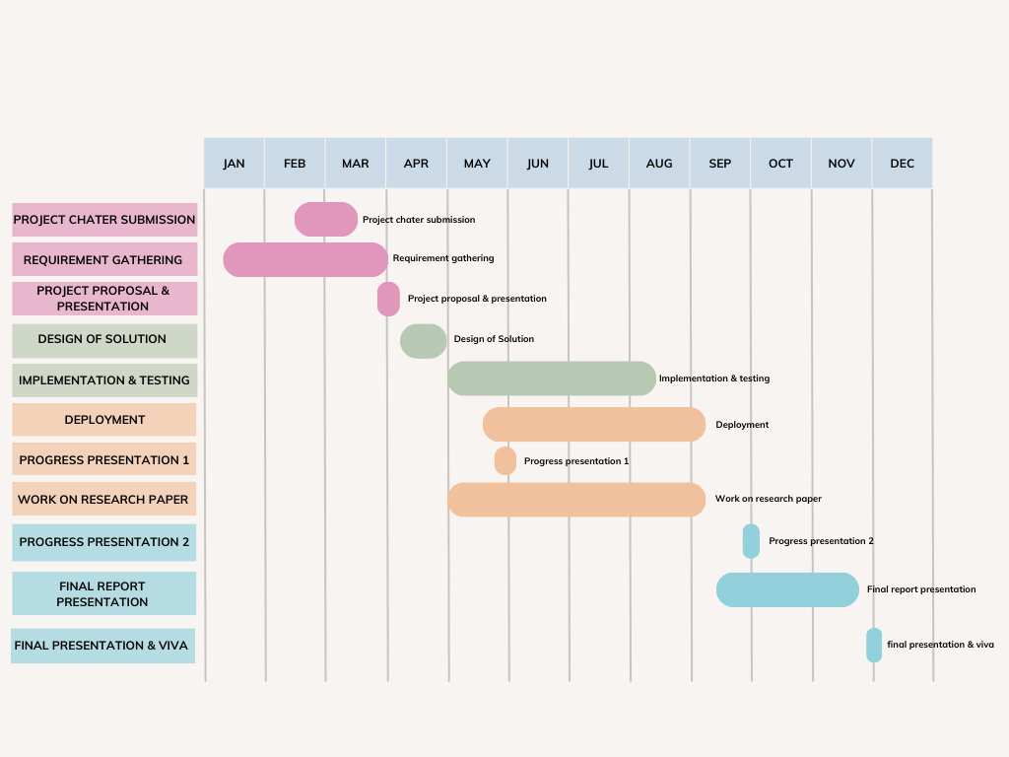

Figure 1:Gantt chart of schedule

#### Economic Feasibility

Economic viability is still another crucial factor. Because most development and deployments happen in a cloud environment, the resources are not free. In order to build and enhance the Fully Automated Software Release Process, Centralized Monitoring Tool, and ML model to anticipate the necessary resource allocations, it will help by providing the resources required to obtain deployment data. All automation and efficiency solutions must also be linked with open-source tools and technologies.

### Requirement Analysis

### Software System Analysis

### Fully Automated Software Release Process with Optimization

The following is an overview of the suggested software solution. The following are the major components of the approach.

* Continuous Integration Server
* Continuous Delivery Server
* Optimization of Automated CI/CD

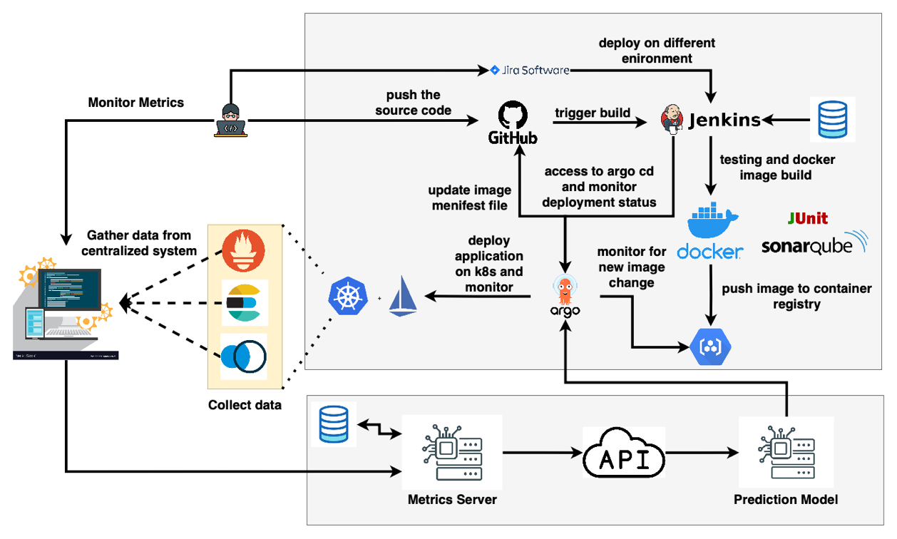

Figure 7: System Overview Diagram

### System Development and Implementation

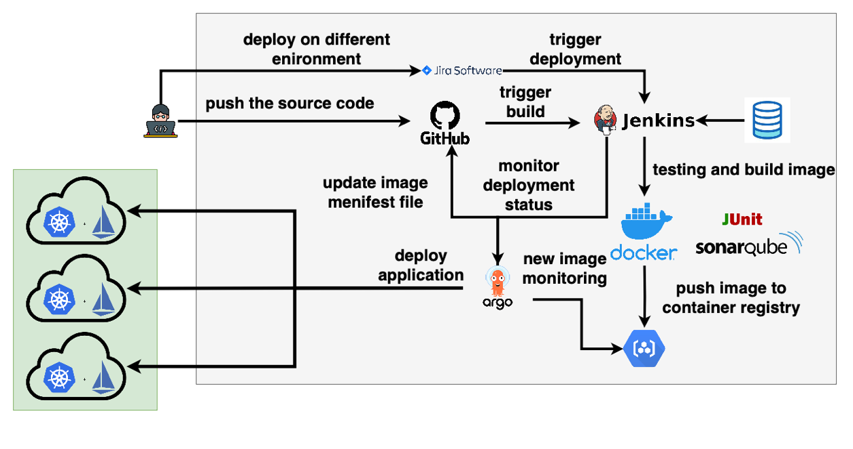

Figure 8: Automated Software Release Process Architecture Diagram

Followings are the main steps that needs to be covered during the development and implementation of the fully automated and optimized software release process.

1. Choose open-source tools and technologies that can help optimize the release process for the defined attributes, such as Jenkins for continuous integration, SonarQube for code quality analysis, and Docker for containerization.
2. Re-architect the software release process with the open-source solutions for fully automated software release process.
3. Optimize the architected software release process according to the architectural attributes focused on this research.
4. Define the stages and steps of the release pipeline, such as code integration, testing, deployment, and monitoring.
5. Implement a continuous integration process to automatically build, test, and integrate code changes, using tools such as Jenkins, Git, and Maven.
6. Implement a continuous delivery process to automate the deployment of code changes to staging and production environments, using tools such as Ansible, Chef, or Puppet.
7. Implement automated security testing to detect vulnerabilities in the code, using tools such as OWASP ZAP or SonarQube.
8. Implement automated performance testing to measure the performance of the system under different loads, using tools such as JMeter or Gatling.
9. Implement monitoring and alerting tools to detect and respond to issues in real- time, using tools such as Nagios or Prometheus.
10. Define and measure success metrics for the release process, such as the frequency and quality of releases, reduction in time to market, and improvement in customer satisfaction.
11. Train and educate stakeholders on the new release process and tools, to ensure smooth adoption and usage.
12. Continuously iterate and improve the release process and tools, based on feedback, results, and emerging best practices.

The tools and technologies are as mentioned as follows to development and implement the proposed architecture.

#### Provisioning the Kubernetes Clusters and Install the Istio

The Kubernetes is the targeted deployment platform in this research. There are two separate Kubernetes Clusters are provisioned in Azure Kubernetes Service (AKS) and Google Kubernetes Engine (GKE). The Istio is used as the service mesh manipulation tool and install in both clusters after they are provisioned.

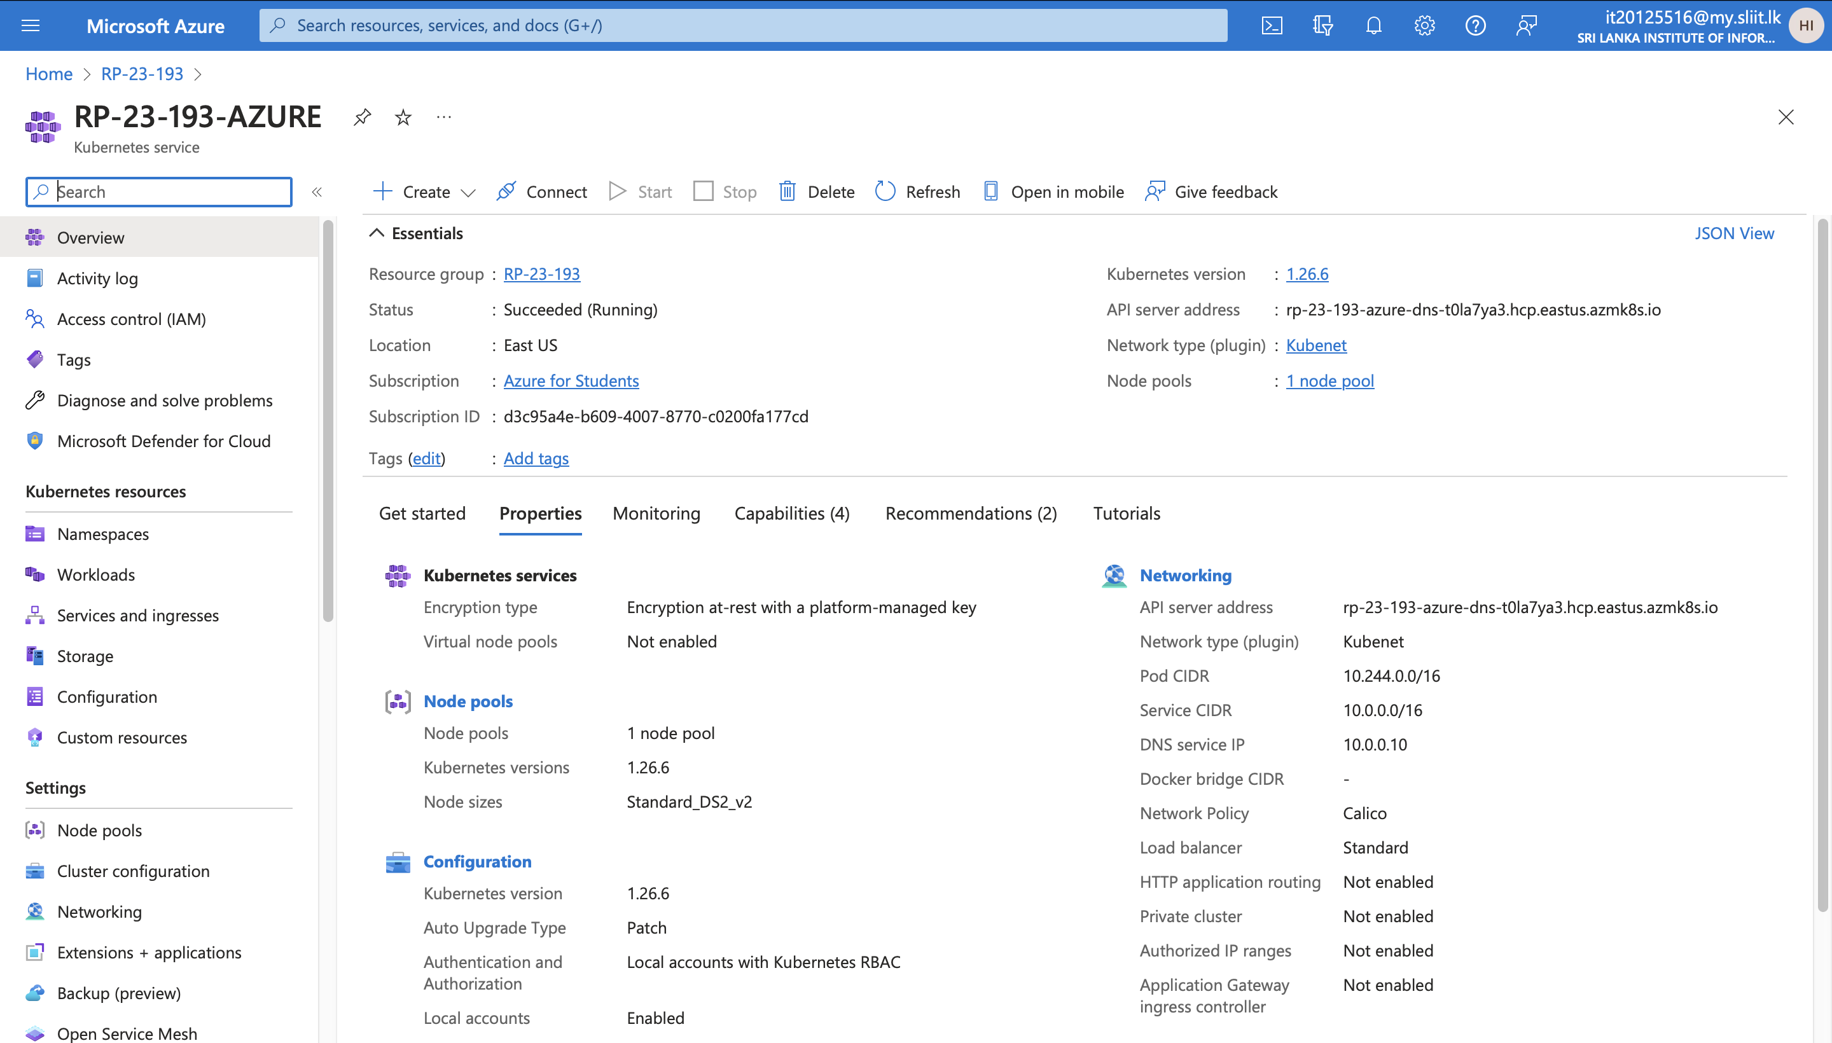

Figure 9: Kubernetes Cluster in AKS

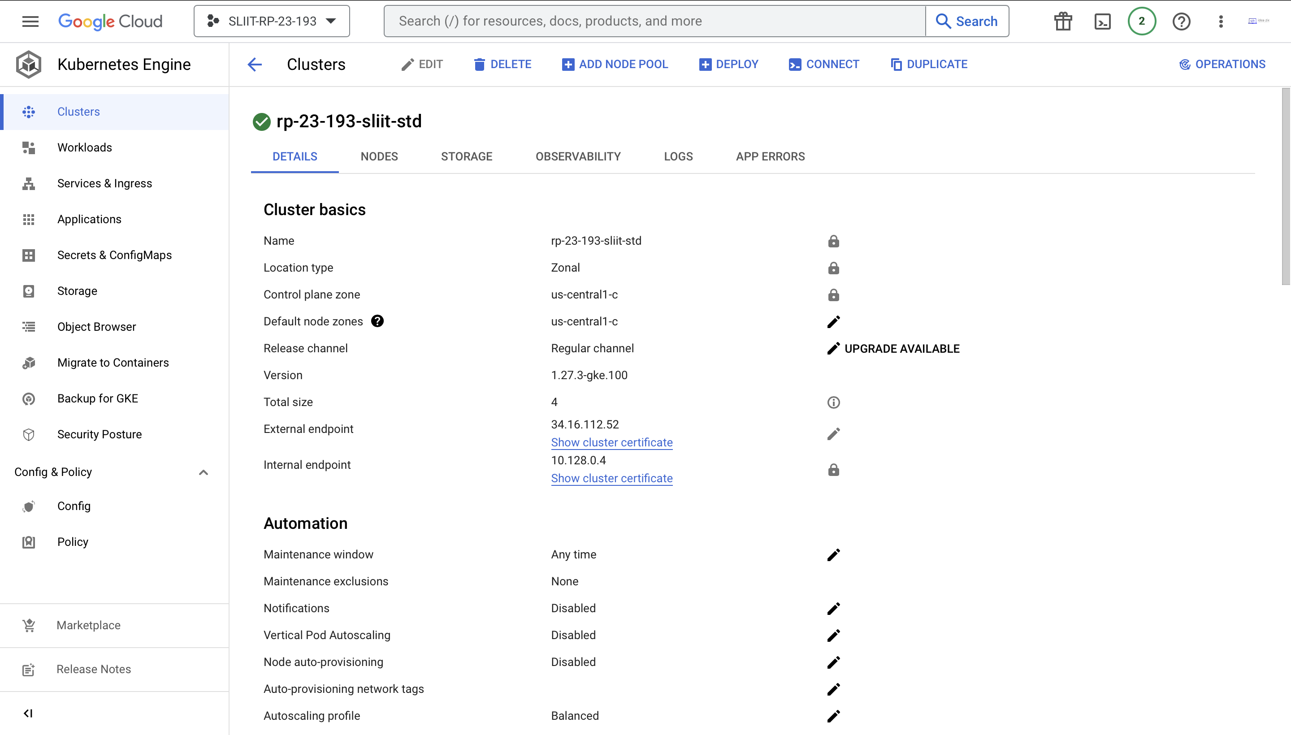

Figure 10: Kubernetes Cluster in GKE

The Istio is deployed in the cluster including the monitoring tools that can be bind with Istio.

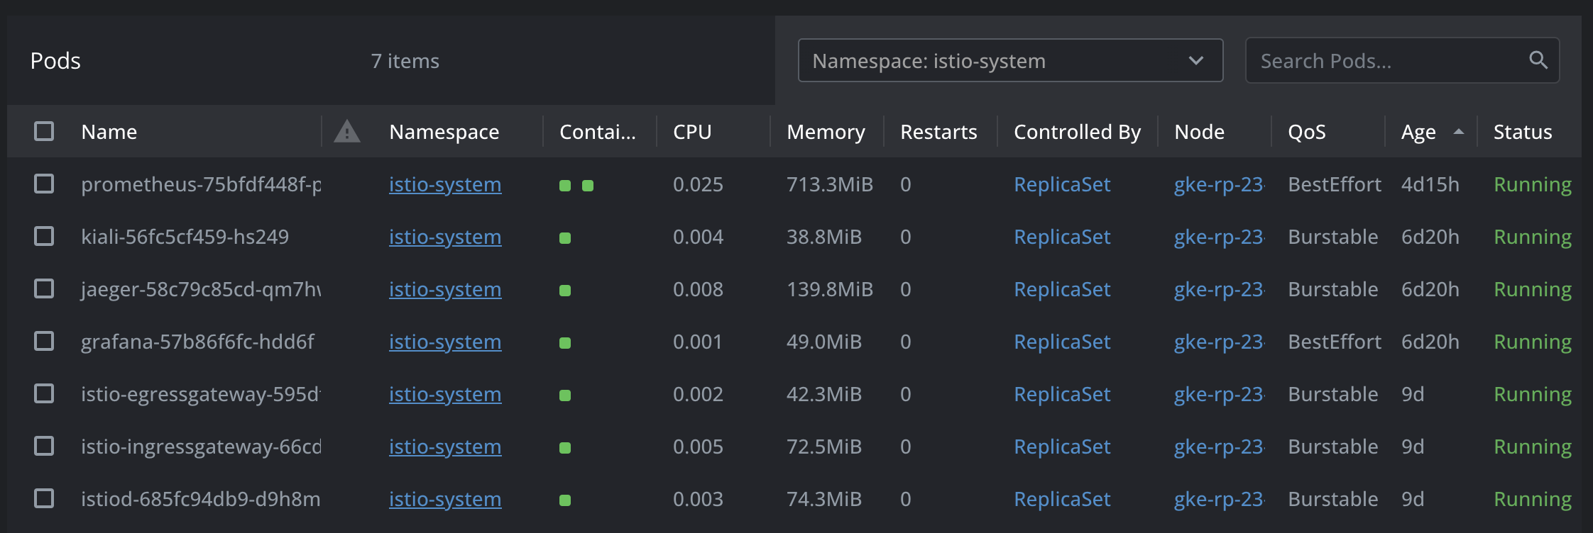

Figure 11: Istio Installed in the Cluster

#### Provisioning the Private Container Registry

The Azure Container Registry is used as the shared container registry platform in the research implementation. The cluster is provisioned as a private cluster and only can be accessed with the authentication keys.

The Kubernetes cluster is contained with the keys as secrets for each namespace that necessary to pull the pushed container images including in the Jenkins Server.

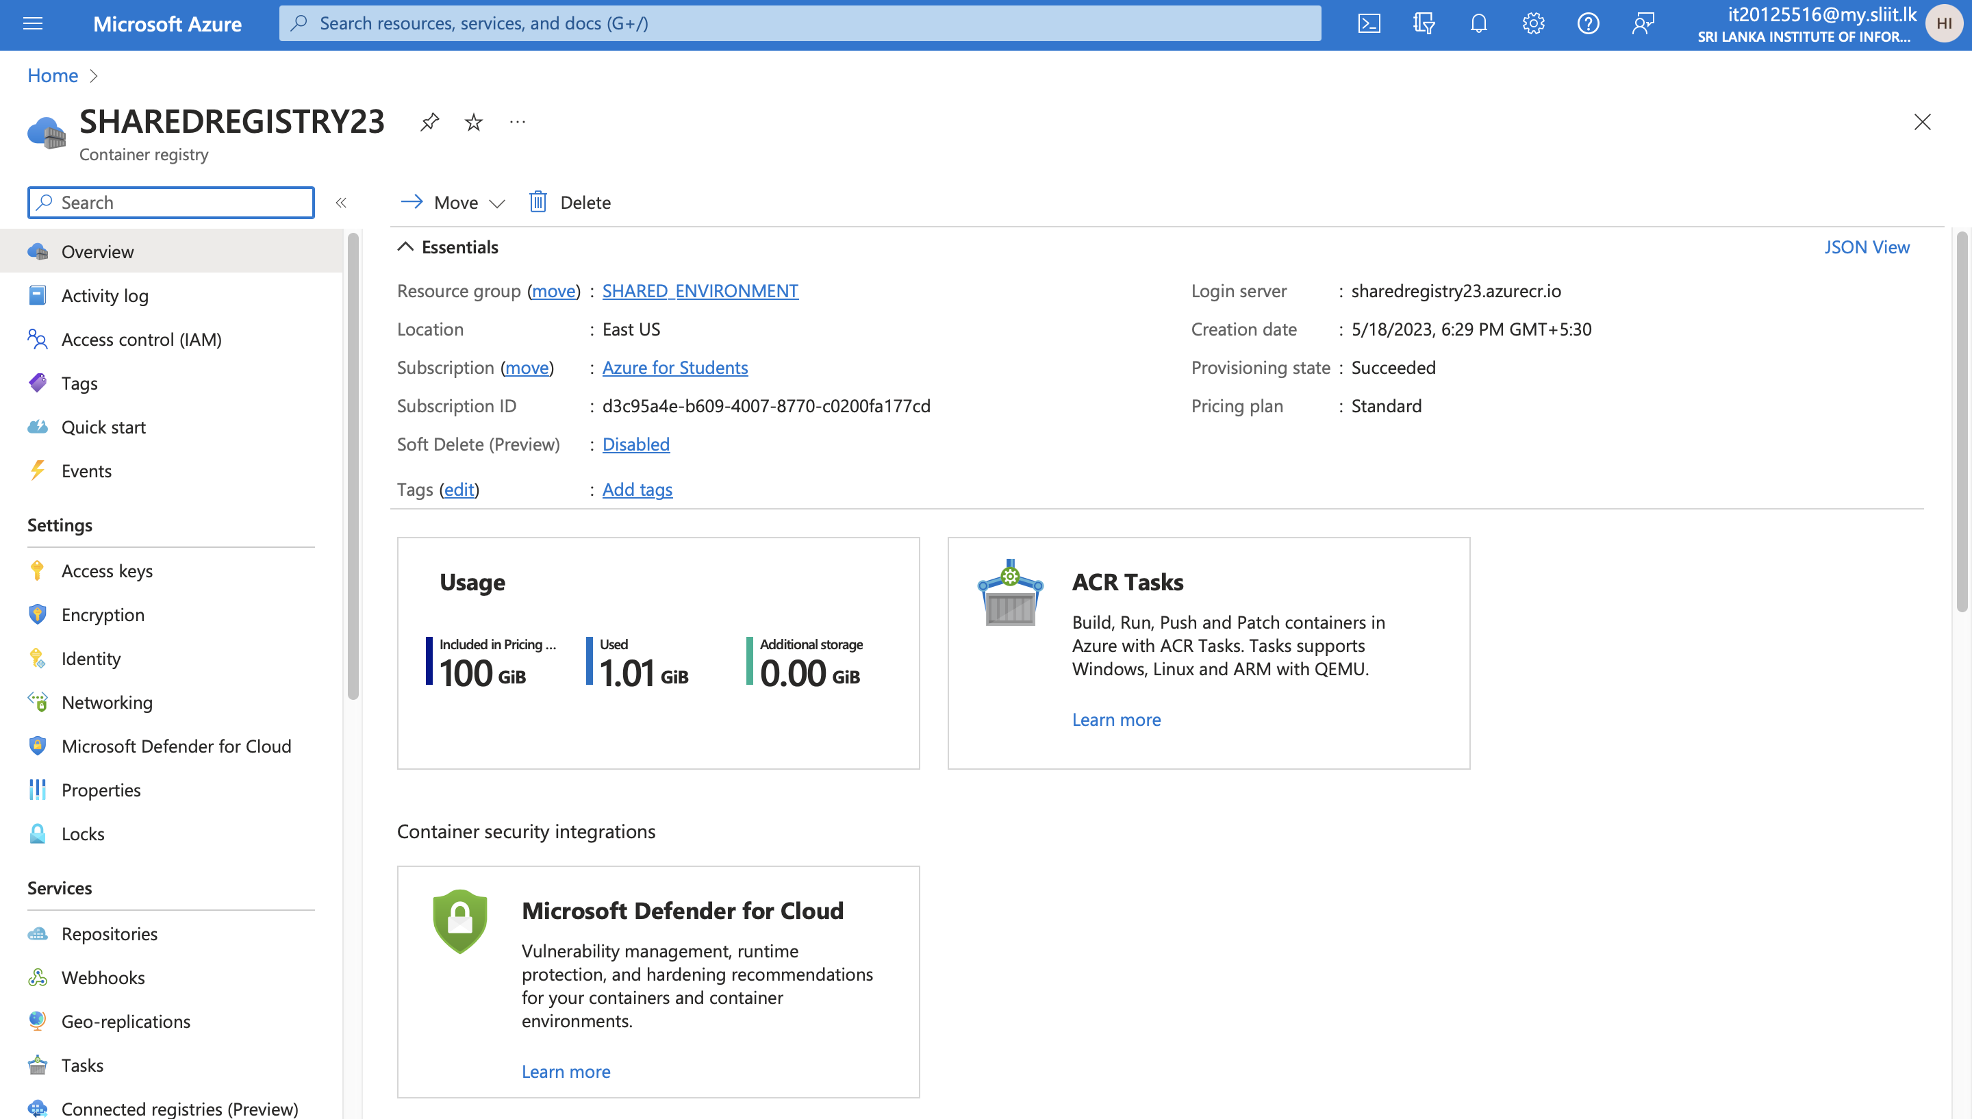

Figure 12: Shared Container Registry in ACR

#### Develop the Fully Automated and Optimized Continuous Integration Process

The responsible of this component is automatically triggering the docker image building pipeline of Jenkins server, docker image build and push the docker image to the container registry. The Azure Container Registry (ACR) is used for the implementation as the shared container registry for the all the deployment environment. Once the source code is updated and pushed to the GitHub, the GitHub webhook will trigger the related Jenkins pipeline and the pipeline starts to build the Docker image for the source code. As an optimization option, the Jenkins is using Kubernetes pods as slave nodes for every pipeline when they started. There is a pod is provisioned as a slave node of Jenkins related to the started pipeline and the slave node is separated from the Jenkins server. The slave pod will be automatically terminated once the Jenkins pipeline ends the job from the server side with all the junk files related to the pipeline job.

The Jenkins server is using a separate persistence volume as the main storage and the storage is basically used to store the data related to the Jenkins server. There are separate persistence volumes are used for all the build pipelines. There can be any number of volumes based on the programming languages the pipelines try to build such as Node JS, Java, Python, C#. The purpose of using separate volumes separately for different pipelines to save the old packages and necessary data related to each programming languages. This solution is used as an optimization solution to reduce the downloads from the internet for every builds. If this solution is not available, every build will download the necessary package resource and dependencies from the internet all the time. But in this solution, the downloaded packages and dependencies are stored in the related persistence volume and first check whether the package or the dependency available in the volume. If the necessary resource is available in the volume, the pipeline job uses the resource already available in the volume, or if the volume does not contain the resource, job will download it form the internet and store the newly downloaded package or dependance in the related persistence volume based on the programming language.

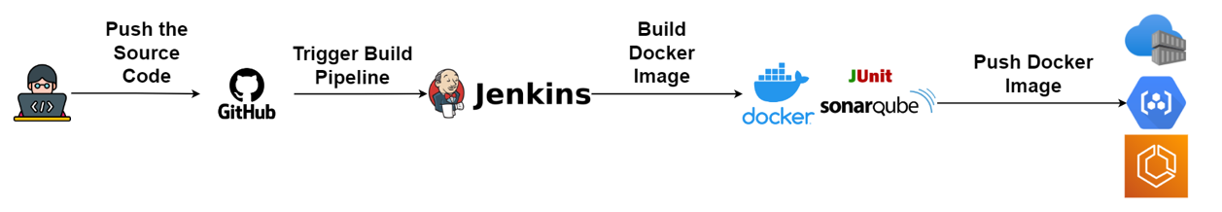

Figure 13: CI Architecture

In the docker image build stage, the pipeline job uses Kaniko as the docker build solution as an optimized solution. The Kaniko can be used to build docker images using the Dockerfile without the root permission. The docker daemon needs the root level permission to build the docker image. Also, it is allocated more resources than used by Kaniko and not needed to write separate lines to build the docker image and push the built docker image to the container registry. There is only one line to build and push the image to the container registry and we can build the docker image as a test without pushing it to the container registry. The docker image is pushed to the ACR once the build is successfully completed.

The CI Architecture is optimized to archive the architectural attributes that focused on this research such as performance, security, extendibility, reliability, and modifiability. GitHub SSO is used for the security of the Jenkins Server to Authenticate and Authorized based on RBAC. And shared volumes are used to reduce the unnecessary downloads.

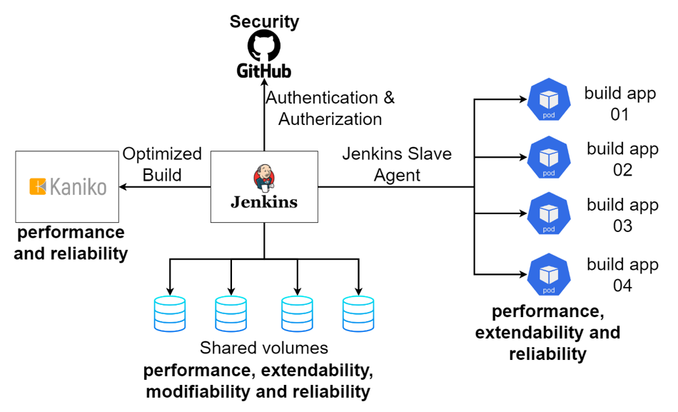

Figure 14: Optimized CI Architecture

#### Configure the Jenkins Server

The main purpose of the Jenkins server is to automate the CI process of the software release process life cycle. The Jenkins server is deployed in the Kubernetes server. This is using as a shared server for all deployments including for the multi-cloud deployments.

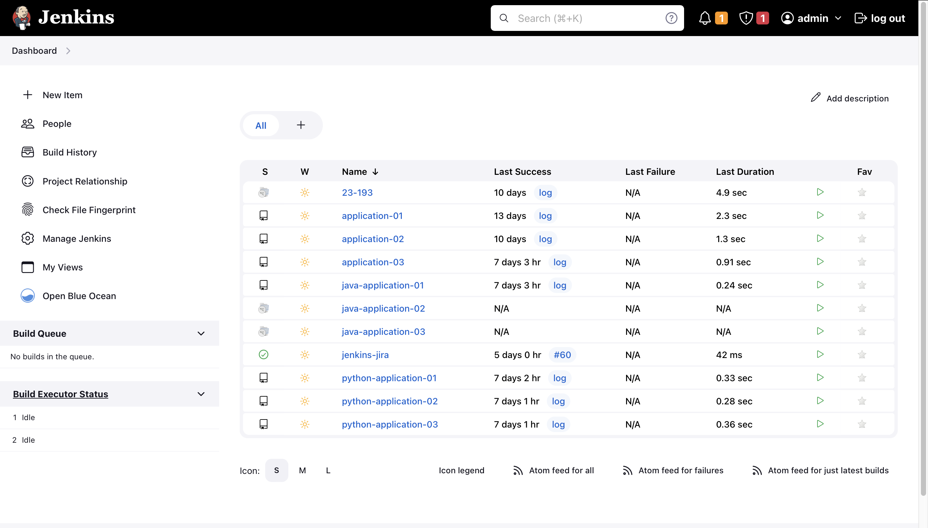

Figure 15: Deployed Jenkins Server

There is a persistence volume is used to store the data of the Jenkins and backup data in a restart of the Jenkins Server Pod.

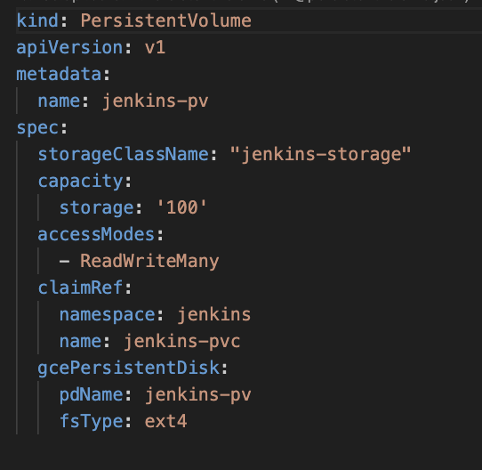

Figure 16: Persistence Volume for Jenkins Server

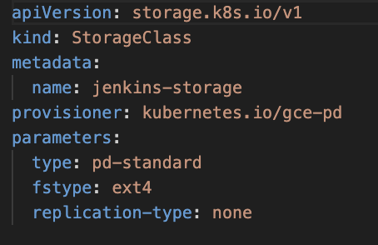

Figure 17: Storage Class Created for Persistence Volumes

#### Configure the Jenkins Server to use Kubernetes Slave Nodes

The clouds can be integrated into the Jenkins server. In this scenario, the Kubernetes Cluster is used as a cloud and integrated Kubernetes Cluster with Jenkins to allow Jenkins jobs to provision pods as Jenkins slave nodes. A shared folder is used to run Jenkins jobs commonly for all the pipelines and the common files are used to run the continuous integration using supportive Kubernetes slave nodes. One slave pod contains several containers such as JNLP container, maven version 8, maven version 11, Python 3 for specifically that needed for each slave pod. The shared folder is called shared-library, and this will be extended with the programming languages or the pipeline type that needed to be run commonly.

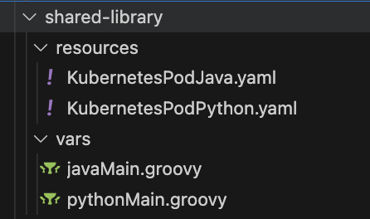

Figure 18: Shared Library Resources

The slave pods are provisioned in a specifically configured namespace in the Kubernetes Cluster. The name can be any with the preference of the DevOps Team.

#### Configure the Jenkins Server with GitHub SSO

The GitHub SSO based on SAML is allowed to integrate with Jenkins to enhance the security with RBAC. Once the integration is successfully configured with Jenkins, the Jenkins login will be automatically redirected to the GitHub login. First, the GitHub authentication needed to be verified and then it checks the role based on the GitHub Teams. With the given permissions, the user may authorize to access the given options in the Jenkins Server.

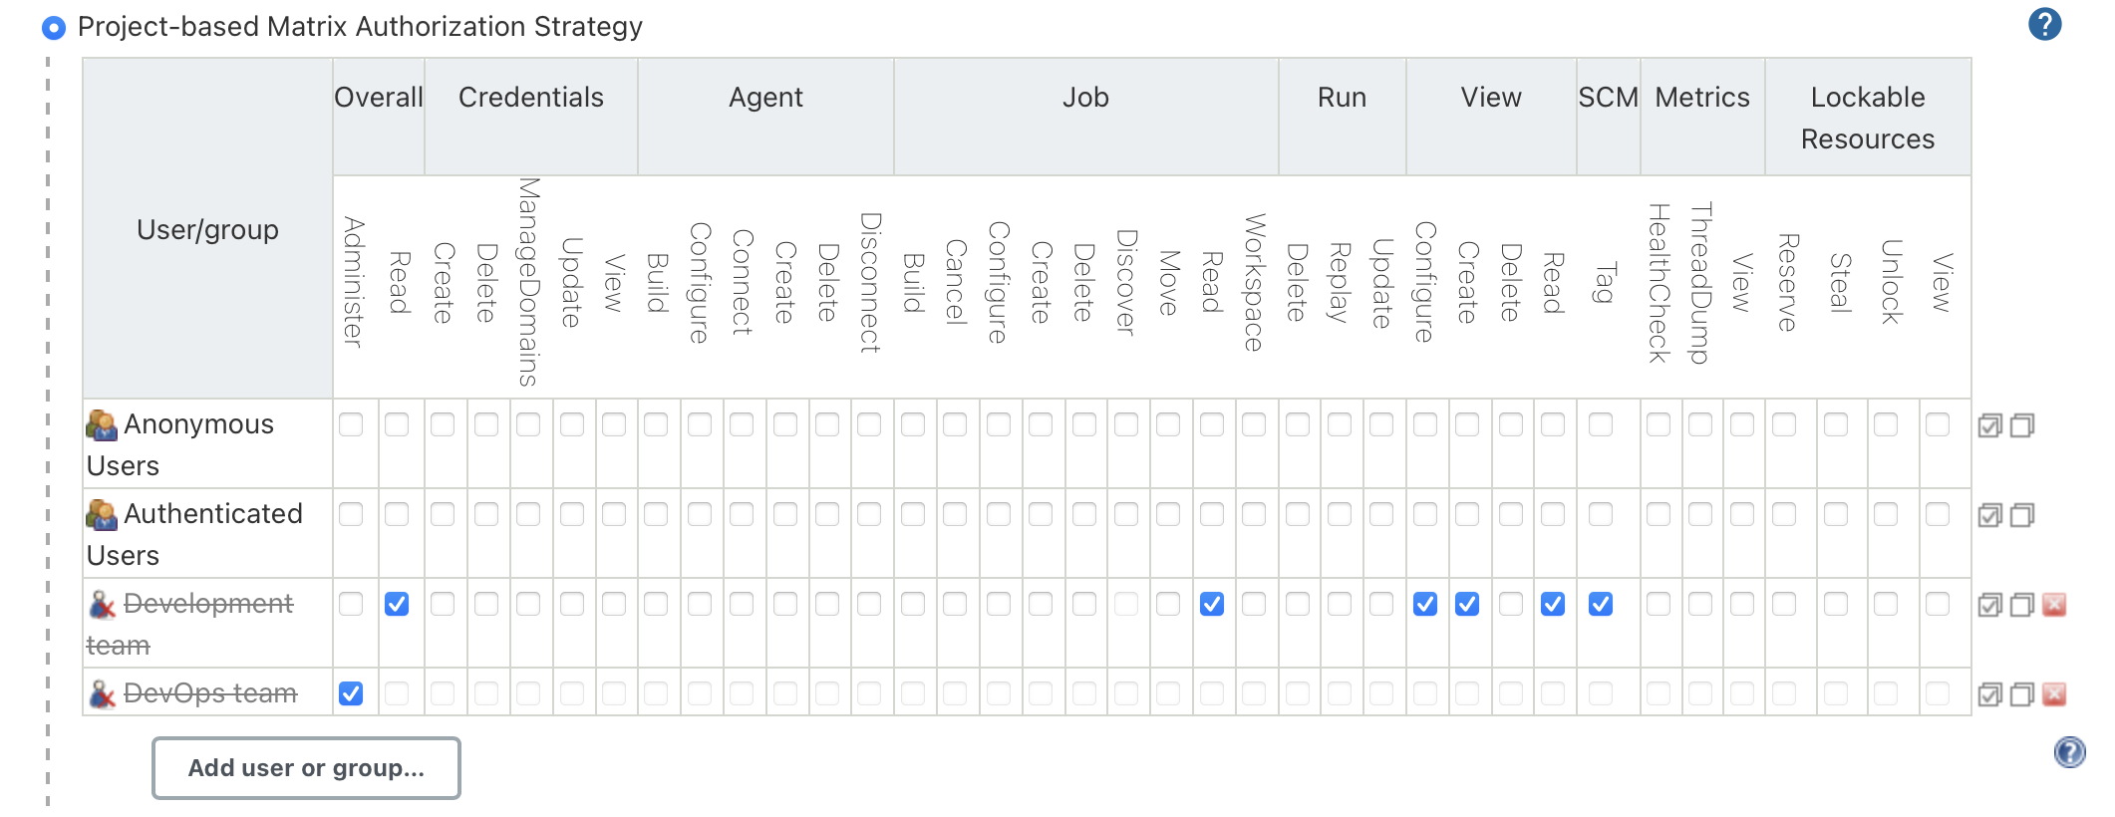

Figure 19: Role Based Authentication with GitHub Teams

#### Develop the Fully Automated and Optimized Continuous Deployment Process

The main responsibility of this component is automating the application deployment process with well optimized based on the focused architectural attributes.

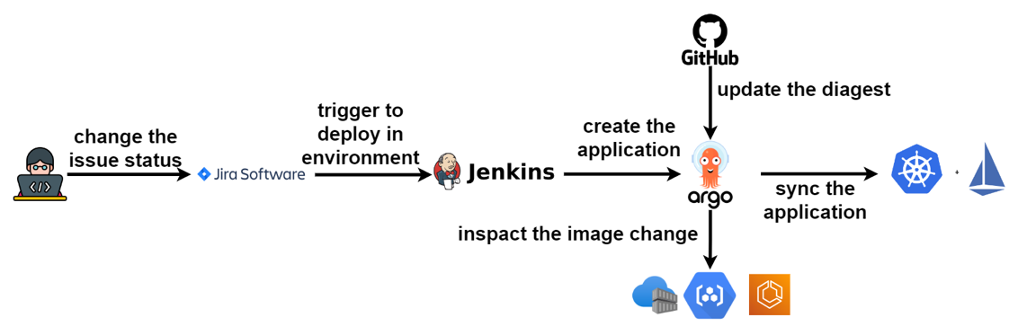

Figure 20: Fully Automated CD Architecture

The Argo CD is used as the centralized server to maintain the deployment process and ensure the service availability of the Kubernetes Cluster. The Argo CD server can automatically deploy the application over multi-cloud. The proposed system was developed to deploy in multi-cloud and selected two cloud providers as Azure and Google to provision the clusters.

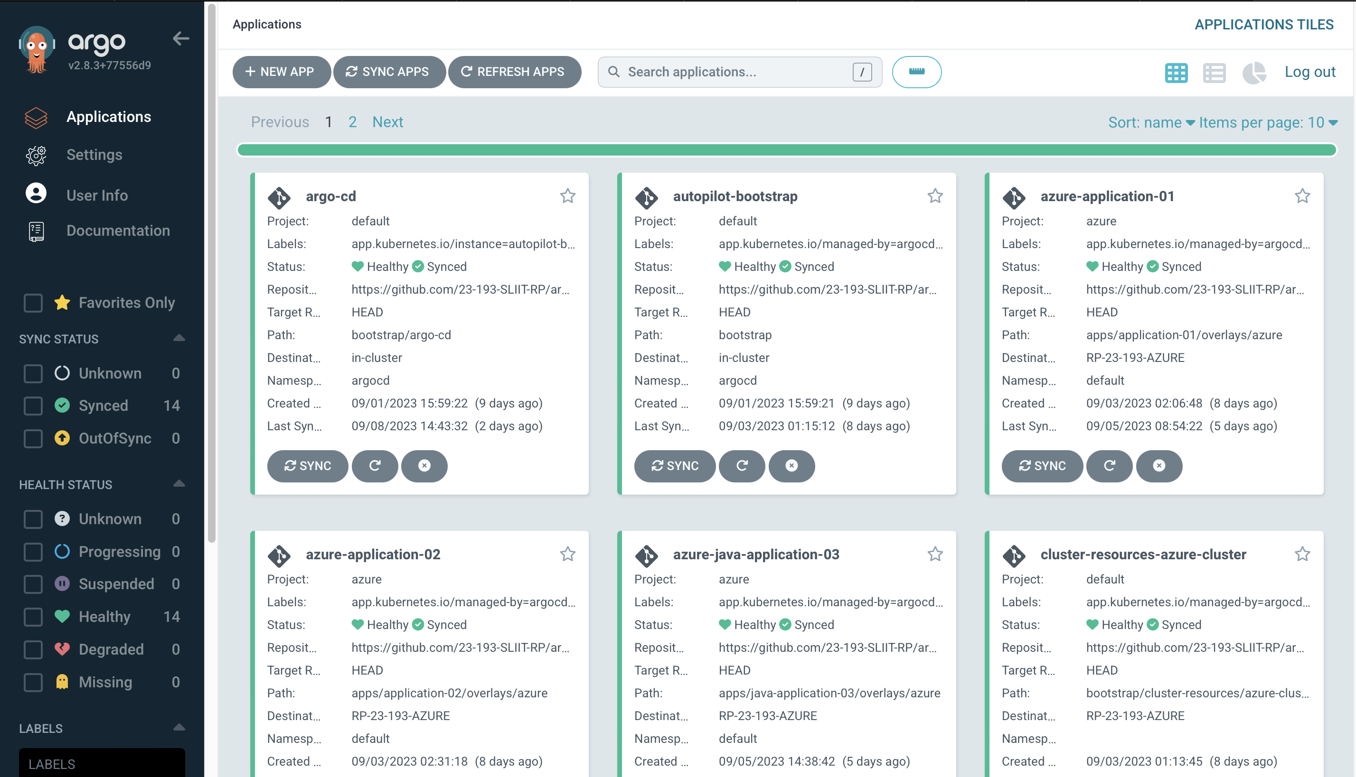

Figure 21: Deployed Argo CD Server

The users can define the environment or the cloud that they needed to deploy the application with Jira automatically. The Jira includes a flow that can be simply add a task and change the environment that needed to deploy the application. Same process we can deploy in multi-cloud.

The Argo CD image updater is a separate component that can be used to deploy the applications to the mentioned environment automatically once a new container image is pushed to the private container registry. The Image Updater is monitoring the registered container registry for any of a new container image and update the manifest file in the GitHub related to the Argo CD deployment that used by the Argo CD server to pick the new container image ID. Once Argo CD pick the container image ID, it compares the currently deployed version and deploy the new pod related to the application in the Kubernetes cluster with rolling update feature to ensure the service availability.

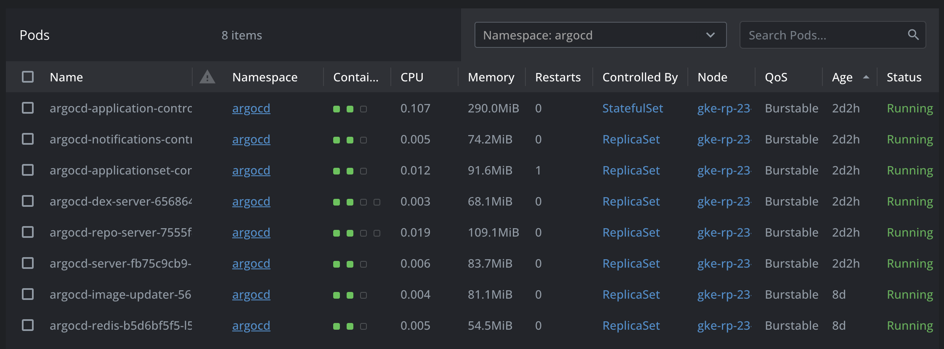

Figure 22: Deployed Argo CD Server Components

If the new image is failed to deploy due to an error in the container image, the available service will be served without any service unavailability to the end user until the error is fixed and the new image is pushed it to the container registry.

#### Configure automated deployment Jenkins Jobs

There is a centralized Jenkins pipeline job to deploy the necessary application in the selected environments and multi-cloud. The pipeline creates an Argo CD application by checking whether the application is available in the Argo CD Server. If the application is already available in the server, it deploys the new version of the container image or if the application is not available, it will automatically create by the Jenkins job.

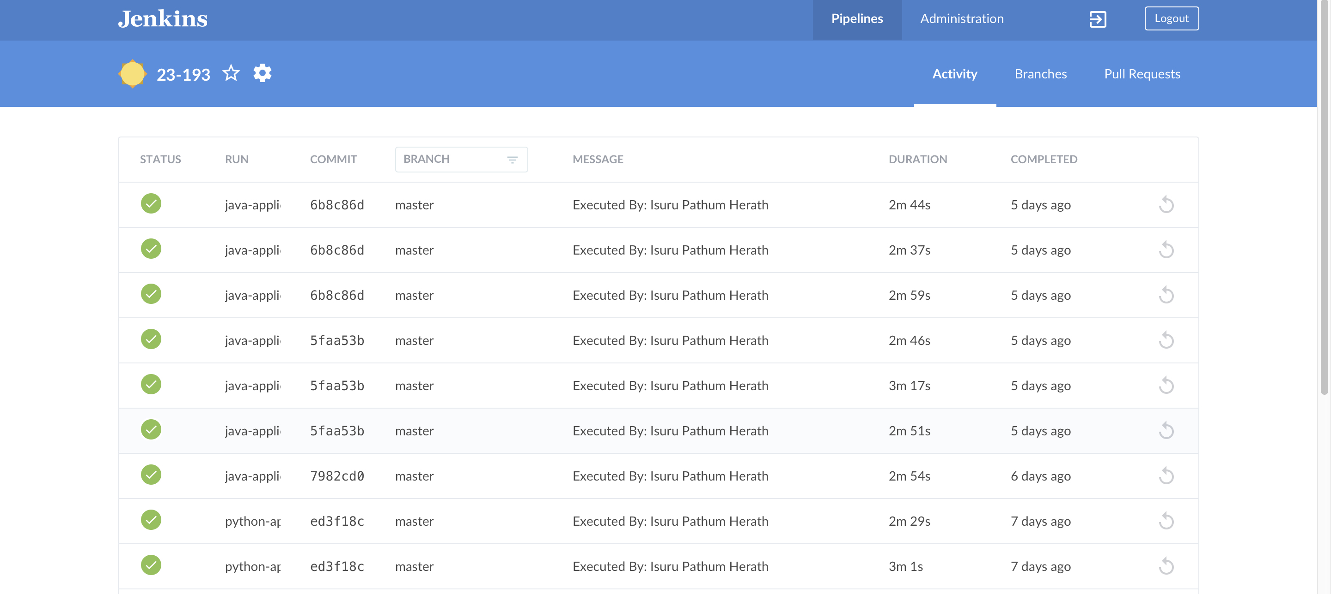

Figure 23: Centralized Jenkins Job to Deploy Applications

The centralized job is triggered by another job called “Jenkins-jira” that get the deployment data from the Jira updates. The triggering pipeline is getting necessary details from the Jira Server such as cloud details, environment details, application name and the name of the user who needs to deploy the application. Once the webhook triggers with the necessary data, the triggering pipeline triggers the centralized pipeline job by passing the necessary data to deploy in the relevant cloud and the environment.

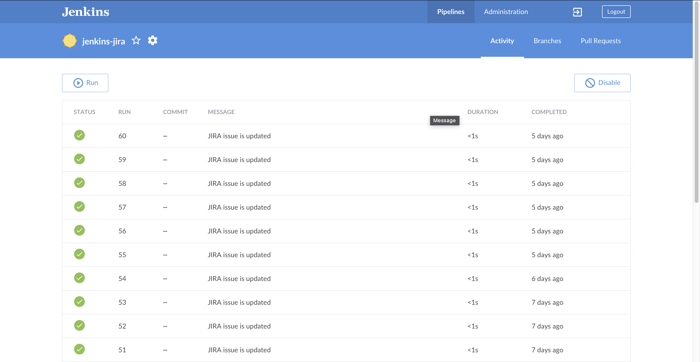

Figure 24: Triggering Pipeline called "jenkins-jira"

The pipeline picks the data and generate environment variables from a script.

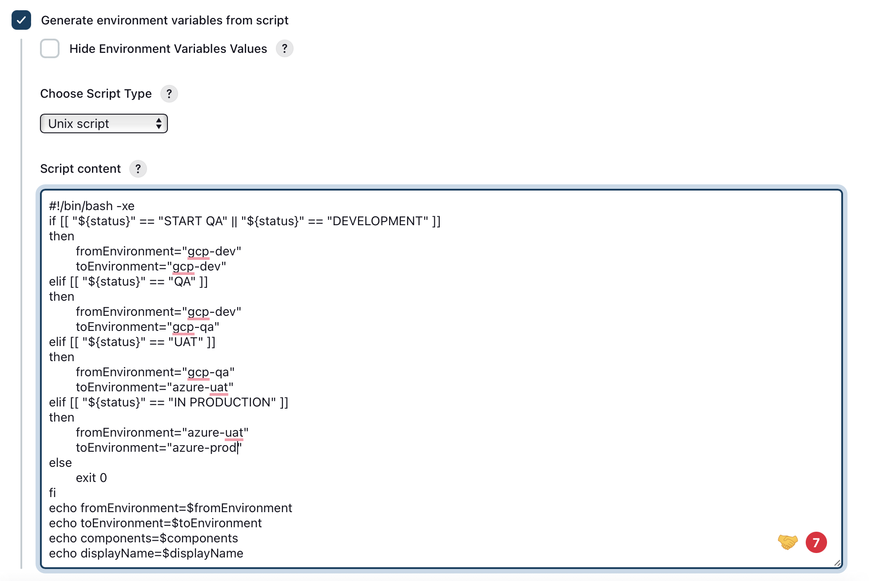

Figure 25: Generate Environment Variable by Script

#### Configure Jira to Deployment Process

The Jira Cloud is used as the deployment triggering service. Developers can create a task related to the assigned developments and it can be follows until it goes to production. The Jira project is created and there is a customized workflow is used to identify the cloud environments and the deployment environments.

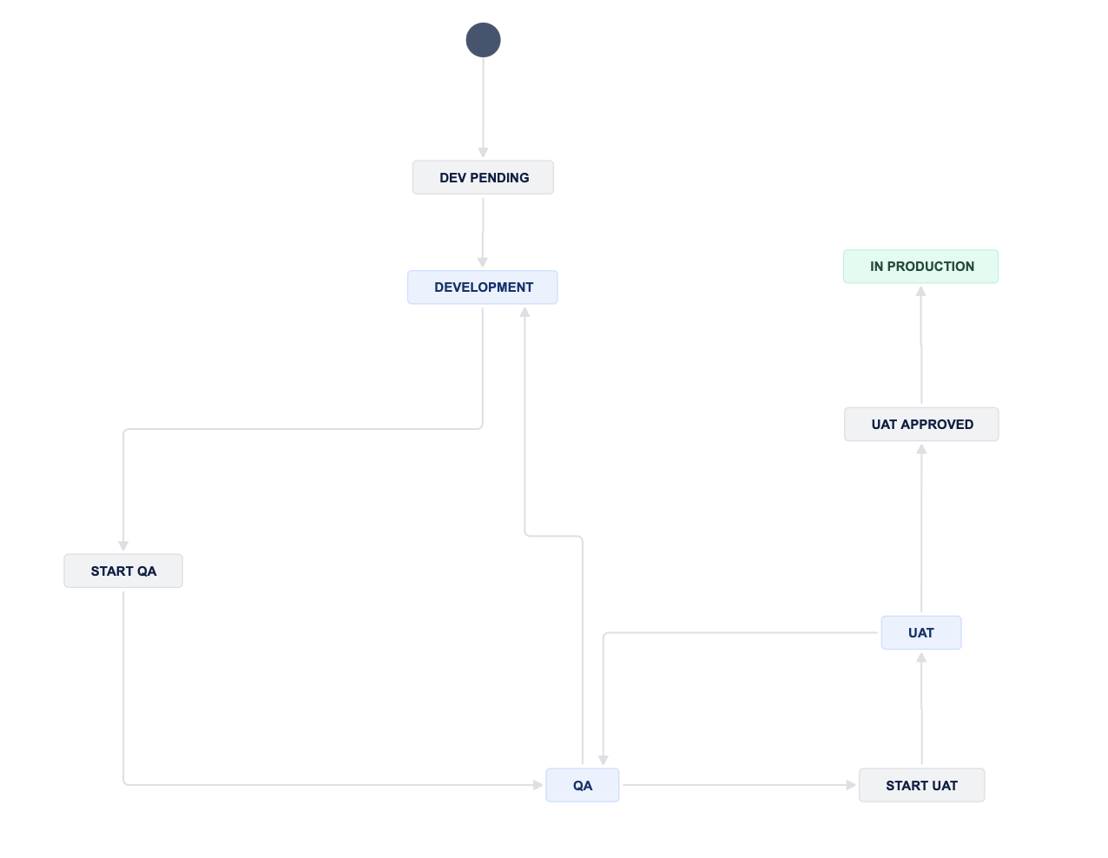

Figure 26: Jira Workflow to deployment process.

### Software analysis of the metric and prediction servers

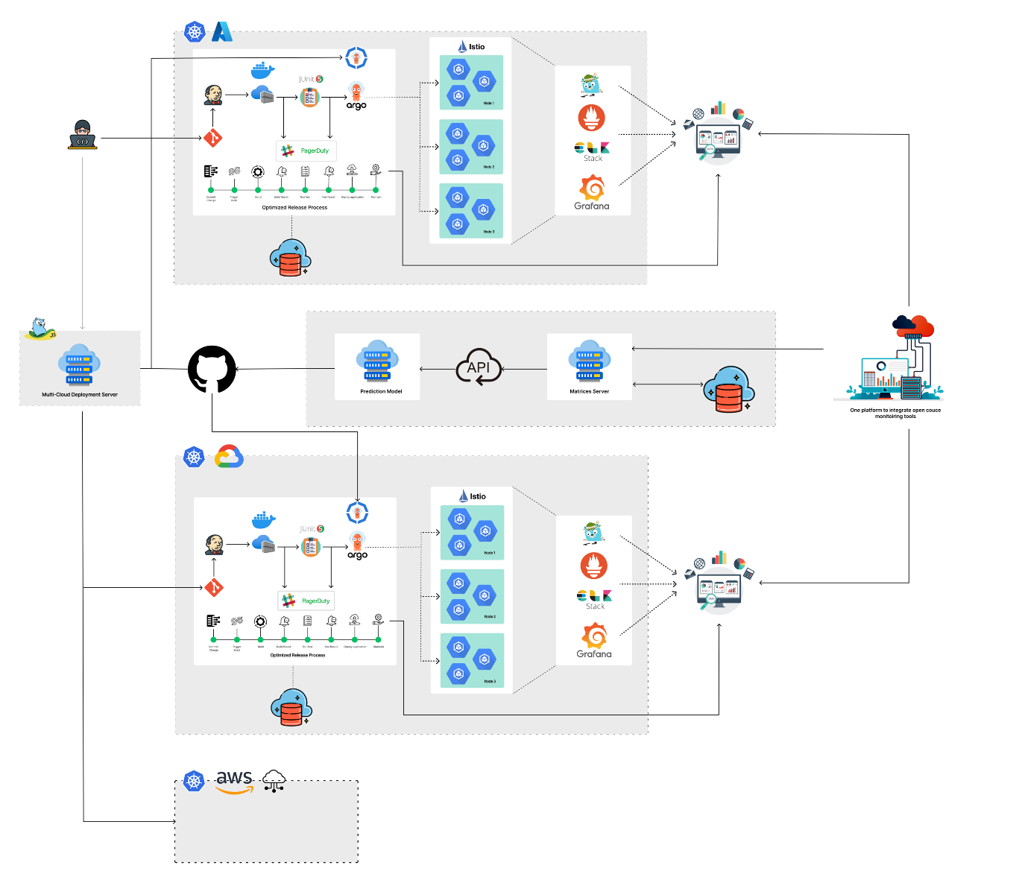

*Figure 4: System Overview Diagram*

in this component a helm chart was created with a set of Kubernetes yaml files, which define the resource requirement to run the application, such as deployment, services, and configmaps. So, the created helm chart was stored in a helm hub. So, from the repository the chart was retrieved and deployed to the Kubernetes cluster. By enabling the relevant configurations for Prometheus, Grafana and Kiali it can be used to query the data and stored in a persistence database for make the predictions.

When it comes to testing the performance of a Kubernetes cluster, tools like Gatling, JMeter, and Locust can be used to simulate various scenarios and test the clusters’ ability to handle different loads. Automating performance tests and making them part

of CI pipelines is essential to guarantee performance and quality expectations and reduce downtimes. Datadog can be integrated with Gatling, JMeter and Locust to provide real-time visibility into the performance of your applications and

infrastructure during the load testing.

Chaos monkey and Kube-monkey are open-source tools that simulate random failures in Kubernetes clusters.

Chaos testing is a technique that is used to test the resiliency of a Kubernetes cluster by deliberately injecting failure scenarios**.**

### The steps that are followed in this component as follows,

1. create a Kubernetes cluster using a cloud provider such as Azure AKS using Free tier.
2. Configure Istio service mesh, Prometheus, Grafana and Kiali in cloud environment and deployed to AKS cluster.
3. Gather the data and logs from the metrics through a metrics server and store them in a persistent database that can used to make the prediction using a machine learning model.
4. Develop the prediction server by using some popular and accurate time series prediction models like ARIMA and LSTM the prediction can be done, and the limit can be updated in the Kubernetes Vertical Pod Scaling (VPA).
5. Cluster Health Check (CHC), would, based on a criterion, automatically detect all deployed services and pull their Health Check Status over /healthz API endpoint. Using a rolling time window, the CHC service would calculate the overall availability of the cluster and provide the status of the cluster health on demand – either success (HTTP 200) of a failure (HTTP 4xx-5xx).
6. Generate a status report for CHC.
7. Configure Gatling and JMeter to run the performance tests on the Kubernetes cluster.
8. Create an automation script to automate the execution of the performance tests, including commands to start the Gatling or JMeter test and to generate test reports.
9. Modify the existing pipeline to include the automation scripts for the performance tests.
10. Generate a test reports using Gatling and JMeter after each test run, including metrices such as response time, through put, error rate and with graphs and charts.
11. Configure and setup Datadog agent on the where Gatling or JMeter is running. The agent collects and sends metrics and logs to Datadog.
12. Analyses the resource performance through the Datadog dashboard.
13. Create alerts based on the metrics and logs in the Datadog dashboard and analyze them to identify performance issues.

### System Development of the metric server

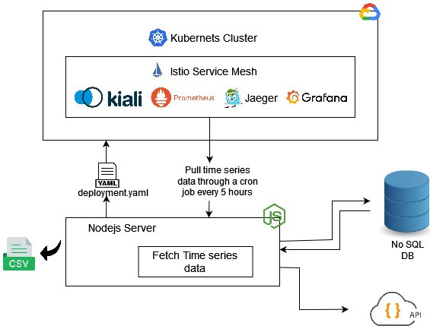

*Figure 5: Metric Diagram*

The system architecture depicted in Fig. 5 illustrates the Node.js server utilized for fetching metrics from a deployed microservice application in a Kubernetes cluster. The Kubernetes cluster is configured with the Istio service mesh. The deployed applications under Istio are subsequently monitored and visualized by the core metric server proposed as centralized monitoring tool. The metrics such as CPU usage, memory usage, and network are obtained by using a PromQL query to identify CPU and memory utilization at the Kubernetes pod, and node levels within the cluster.

Moreover, Kiali enables the visualization of dependency mappings between the microservices, presenting request and response times, thereby facilitating the identification of any breakdowns occurring between microservices. The Node.js server retrieves all relevant endpoints exposed through the Istio service mesh. Upon fetching the required metrics using a scheduled cron job, they are stored in a NoSQL database along with corresponding timestamps. These time series data, along with the timestamps, are then utilized by the optimization server to generate an optimal solution. Subsequently, The Node.js server generates a CSV file from the retrieved NoSQL data, which aids in optimizing the deployment strategy of the Kubernetes cluster. Based on the solution provided by the optimization server, the deployment YAML file is updated and deployed on the cluster

### System Development of the prediction server

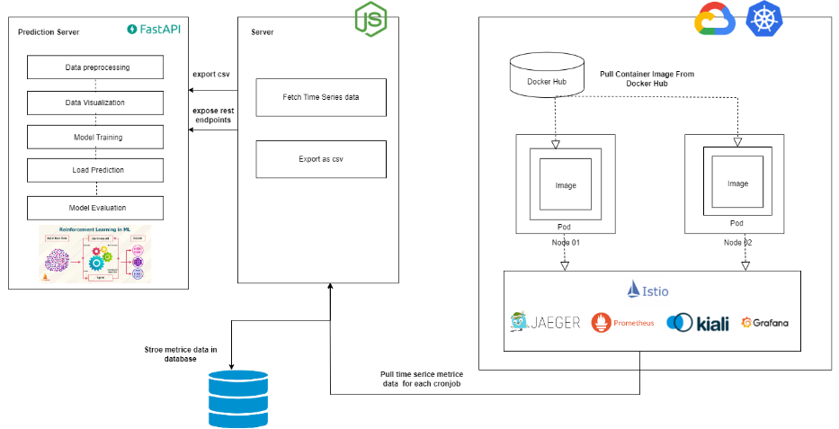

*Figure 6: Optimization Diagram*

The objective of the optimization server is to predict the future workload on microservice deployment by using the historical data that was continuously fetched through the NodeJS server to create an optimal solution to microservice deployment and create an autoscaling [21] policy through the predicted resource allocation.

The workload prediction is based on the resource utilization matrices that are fetched from the NodeJS server. Gathered resource utilization matrices perform Time series-based prediction on pod utilization metrics such CPU utilization and memory utilization and cluster level metrics, values are taken for a particular period of forecasting. The NodeJS server exposes an API that the optimal server can use to query the data. The data is applied for data-preprocessing steps and train the data for create the prediction module to generate an optimal solution.

Various time series mechanisms are employed for predicting future data. However, in this research, the Bi-LSTM [20] model was selected due to its capability to provide accurate predictions even with a limited amount of data. While ARIMA is a well-known time series method, it was utilized in this study to compare its accuracy with the Bi-LSTM model in predicting CPU and memory usage. The goal was to develop an autoscaling approach through vertical and horizontal auto-scaling methods.

Convolutional 1D (Conv1D) constitutes a foundational element within Convolutional Neural Networks (CNNs), custom-tailored to analyze one-dimensional sequences, such as temporal data. Conv1D operates by sliding a series of adaptable filters across the input sequence, adeptly capturing intricate local patterns and distinctive features embedded within the data. Conversely, the Bidirectional Long Short-Term Memory (Bi-LSTM) stands as a derivative of the Long Short-Term Memory (LSTM) architecture within the realm of recurrent neural networks (RNNs). Bi-LSTM innovatively extends this capability by concurrently processing input sequences in both forward and backward directions, enabling holistic insight into past and future contextual information at every timestep.

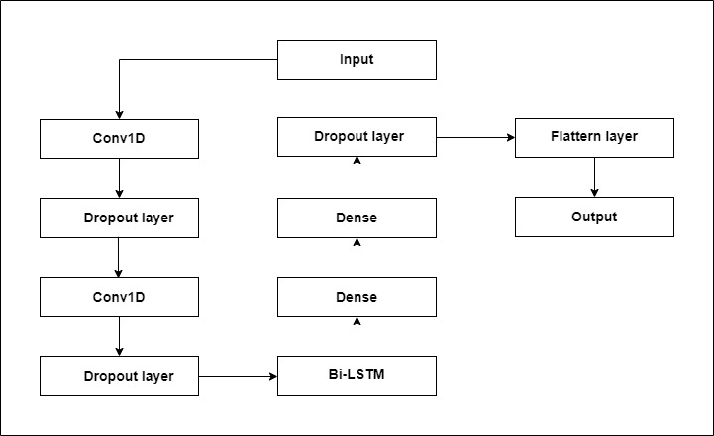

*Figure 7: Bi-Lstm-CNN Prediction Layers Diagram*

The prediction process relies on a hybrid deep learning architecture that combines Convolutional 1D (Conv1D) layers with Bidirectional Long Short-Term Memory (Bi-LSTM) networks. This combination aims to accurately predict future data patterns. By integrating Conv1D layers with Bi-LSTM networks, our objective was to benefit from the Conv1D layers' ability to identify local patterns while also capturing extensive temporal dependencies through the Bi-LSTM networks. This hybrid approach was carefully selected to enhance the accuracy of forecasting [25] CPU and memory usage.

### Istio

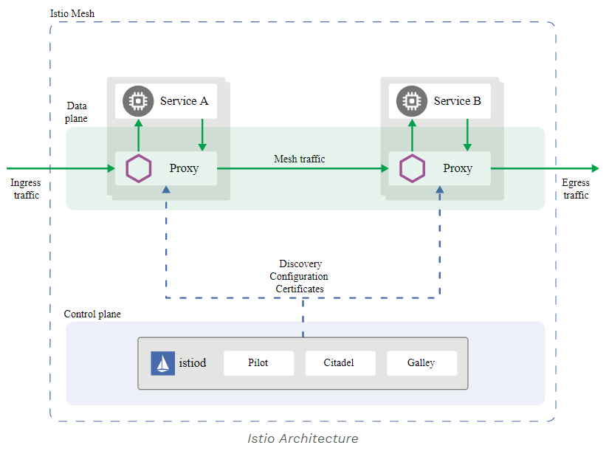Istio is an open-source service mesh platform designed to simplify the management of microservices in a containerized environment, such as Kubernetes. It provides a set of tools and services for managing traffic, securing communication, and monitoring microservices.

*Figure 8: Istio Architecture Diagram*

A service mesh is a dedicated infrastructure layer for managing communication between microservices. Istio is one such service mesh that intercepts and controls network communication between microservices. It acts as an intermediary between services, handling tasks like load balancing, security, and observability. Istio uses a sidecar proxy, often based on Envoy, alongside each microservice instance. This sidecar proxy is responsible for handling incoming and outgoing network traffic for the microservice. It provides features like load balancing, traffic routing, and encryption without requiring the microservice itself to be aware of these concerns. Istio allows you to define traffic routing rules, such as canary deployments, A/B testing, and blue-green deployments. These rules are configured in a central control plane and are enforced by the sidecar proxies. This enables you to easily manage and control the flow of traffic between microservices. Istio provides robust security features, including mutual TLS (mTLS) authentication between microservices, role-based access control (RBAC), and rate limiting. These features help protect your microservices from unauthorized access and potential threats. Prometheus is an open-source monitoring and alerting toolkit. Istio integrates with Prometheus to collect and store metrics related to the performance and behavior of your microservices. Prometheus scrapes data from the sidecar proxies and other relevant components in the Istio service mesh and stores this data in a time-series database.

In this research first we deployed the microservices to GKE through istio , the Prometheus monitoring tools also deployed under istio. So the metrices of pods that are deployed under istio can bre fetched.

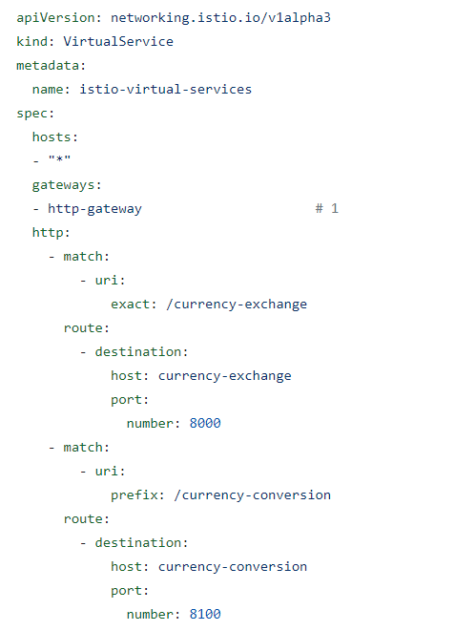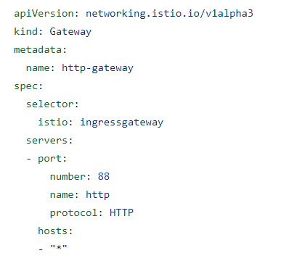

*Figure 9: Gateway and Virtual Service Yaml files*

### Software analysis of the Centralize Monitoring Tool

The following is an overview of the suggested software solution. The following are the major components of the approach.

* UI for data visualize.
* Backend service for integrate multiple open-source monitoring tools
* Database service

### System Development of the Centralize Monitoring Tool

Before starting the development, the development environment setup is the most challenging part. After a technical feasibility study, I decided to use ASP.NET Core as a backend framework and Angular as a frontend framework for the implementation. First, clone the project in GitLab and create the main folder in the common resource folder in the project. As a software backend, the most important part is the.NET Core MVC architecture, which is a very famous architecture for building web applications. Otherwise, this is a cloud data monitoring tool, not an easy project. First, I need to draw an ER diagram to get an idea of the system, how to collect data, and how to pass data to the visualisation tool. As a developer, always try to use best practices during development. Write logs, component breakdowns, use proper name conventions, etc.

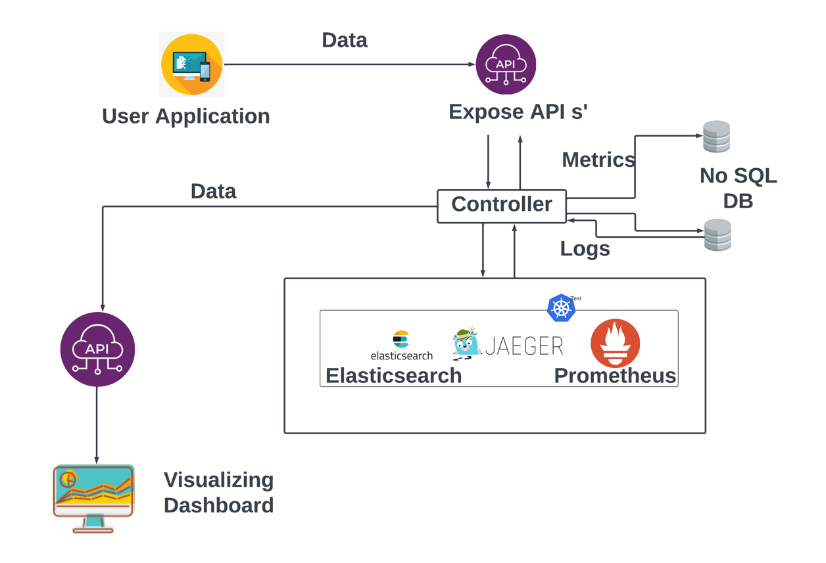

Figure 4 : Architecture of Centralize Monitoring Tool

In Figure 4, the implementation process of a centralized monitoring tool is depicted, highlighting the collection of metrics, logs, time series data, and other relevant information from user applications. The diagram also illustrates the seamless transfer of data between the visualization and monitoring tools. Primarily, the proposed system creates a centralized platform capable of collecting extensive data, thus eliminating the need to switch between multiple tools. There are three open-source monitoring tools have been utilized, with Prometheus being the first one. The utilization of Prometheus in the proposed solution is motivated by its numerous advantages, including high-quality data, queries, operations, and a wide range of libraries [13]. While Prometheus excels in monitoring and analyzing metrics, it does not support trace data. Consequently, Jaeger is incorporated into the proposed solution to address this limitation and enable efficient monitoring of trace data. ElasticSearch is capable of effectively monitoring log data. This inclusion is crucial to ensure comprehensive monitoring capabilities within the proposed solution. To establish the proposed solution, the first step involves hosting all the monitoring tools. By leveraging the cloud infrastructure, the monitoring tools can be efficiently deployed and managed. These tools expose their REST APIs, which can be accessed by making API calls to the endpoints provided by Prometheus, Jaeger, and Elasticsearch.

The proposed tool is designed to collect metrics, logs, and time series data from applications in a cloud environment. This tool utilizes APIs and libraries from open-source tools to gather data and expose these APIs to users. By utilizing these APIs, users can configure applications with the centralized tool. All the collected data is stored in MongoDB. Users can monitor and visualize metrics, logs, and time series data, eliminating the need to switch between different tools. The user can experience real-time updating of centralized cloud data visualization tools through the proposed solution.

When we discussed the code base, Used several libraries and packages for implementations. Some of the libraries shown in the following figure

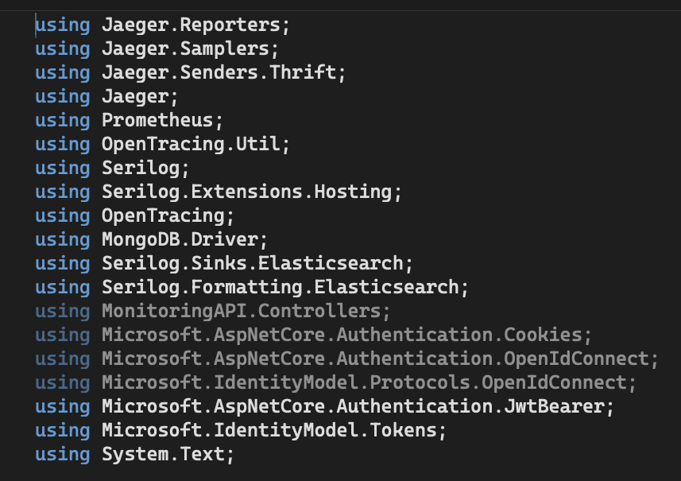

Figure 5 : Libraries and Packages

In the implementation, I handled separate models for metrics, logs, and traces. Then provide clear documentation for the user with API endpoints and data formats. Which data format allows centralising monitoring tools likewise. The following endpoints and data types are used to gather data from the user’s application and prepare that data for visualisation.

API Endpoint:

POST:

<https://releasex.tech/api/Metrics/metric>

**{**

**"name": "string",**

**"value": 0,**

**"description": "string",**

**"labels": {**

**"additionalProp1": "string",**

**"additionalProp2": "string",**

**"additionalProp3": "string"**

**},**

**"timestamp": "2023-09-10T16:18:30.109Z"**

**}**

<https://releasex.tech/api/Metrics/log>

**{**

**"message": "string",**

**"logLevel": "string",**

**"timestamp": "2023-09-10T16:18:30.107Z"**

**}**

<https://releasex.tech/api/Metrics/timeseries>

**{**

**"metricName": "string",**

**"value": 0,**

**"timestamp": 0**

**}**

<https://releasex.tech/api/Metrics/traces>

**{**

**"traceId": "string",**

**"spanId": "string",**

**"operationName": "string",**

**"startTime": "2023-09-10T16:19:40.227Z",**

**"duration": {**

**"ticks": 0**

**}**

**}**

Above endpoints used to gather users application data. Users can pass metrics, logs, and other data by configuring their applications with those endpoints.

GET:

<https://releasex.tech/api/Metrics/metrics/>

<https://releasex.tech/api/Metrics/logs>

<https://releasex.tech/api/Metrics/custommetrics>

<https://releasex.tech/api/Metrics/customtraces>

Above endpoints for users to pass the data to the visualisation tool. Each endpoint customises each format for visualisation.

### System Development of the visualization Tool

Monitoring tools can create data formats for visualization. Then monitoring tools provide APIs to pass collected data to visualisation tools. Then visualisation tools can show that data using graphs, charts, tables, and other proper methods. Visualising is a very tough part of this development because I have to use a few chart libraries and do some calculations to visualise the data in the charts. Otherwise, the user can get a good idea about the analysis of charts. Because of that, the visualisation tool should correctly show the data. In this development, Chart.js, D3, and ngx.js chart libraries are used for proper visualisation.

Figure 6 : Landing page of the Visualizing Tool

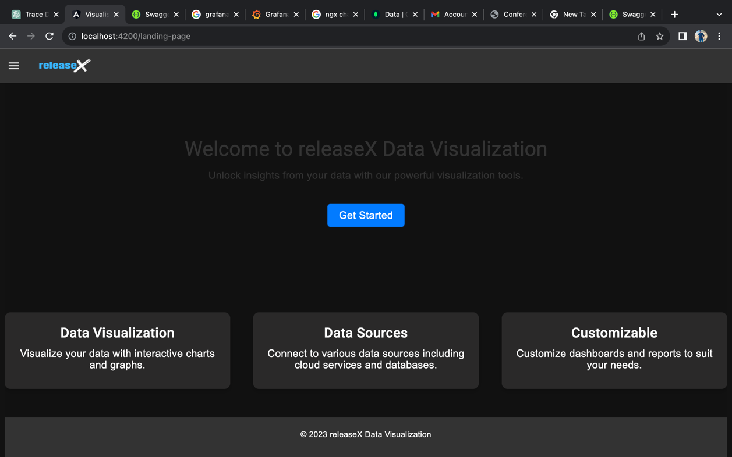

In the figure 6, the home screen of the visualisation tool is shown. This UI is very user-friendly, and the user can easily understand how to select data sources, visualise data, and create dashboards.

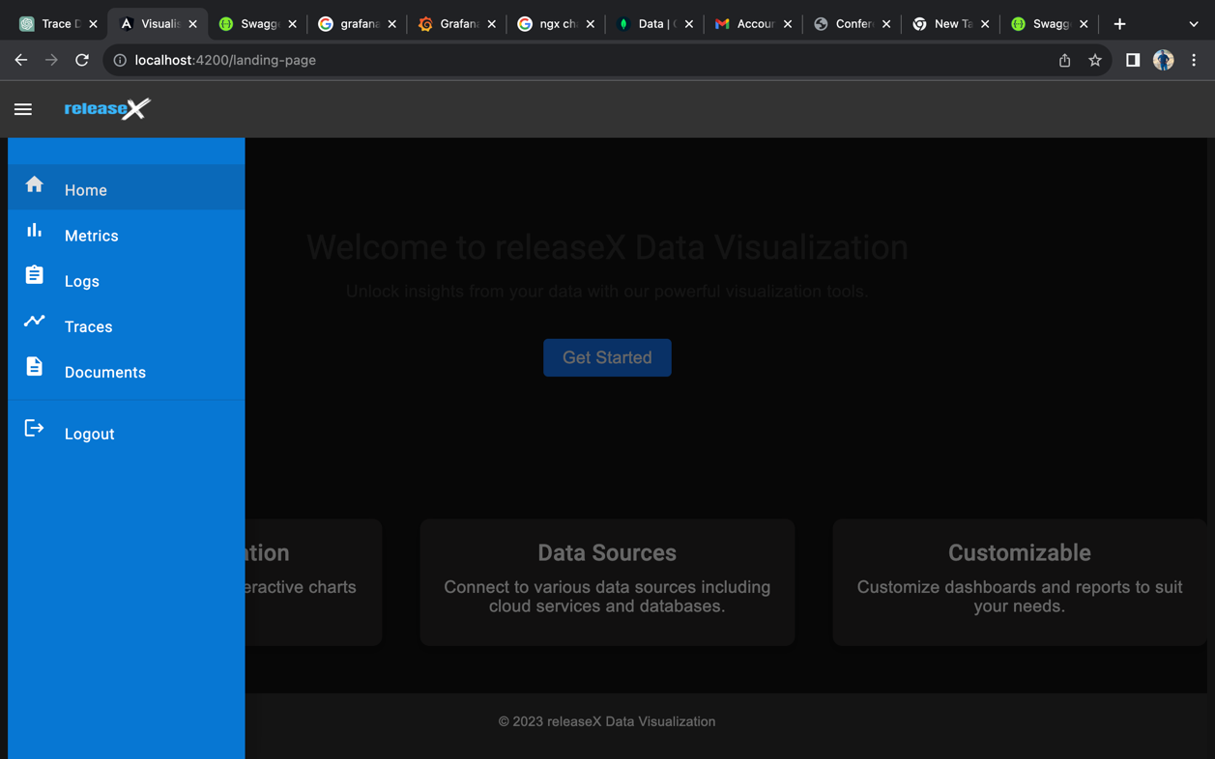

Figure 7 : Side Menu bar of visualizing Tool

The visualisation tool should be user-friendly and easy to understand. The proposed visualisation tool has a side menu bar. That menu bar includes current data types and documentation paths. The user can easily navigate to those screens by clicking on menu bar titles.

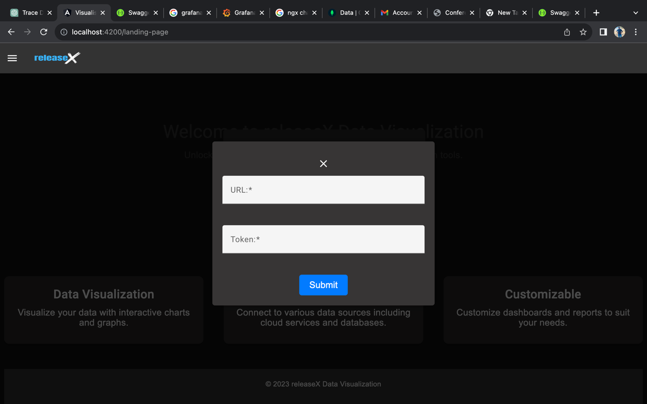

Figure 8 : Data Source Configuration

The user can configure their data source by typing the URL and JWT token in the data source screen. Then, after submitting the data source, it is connected with the visualisation tool.

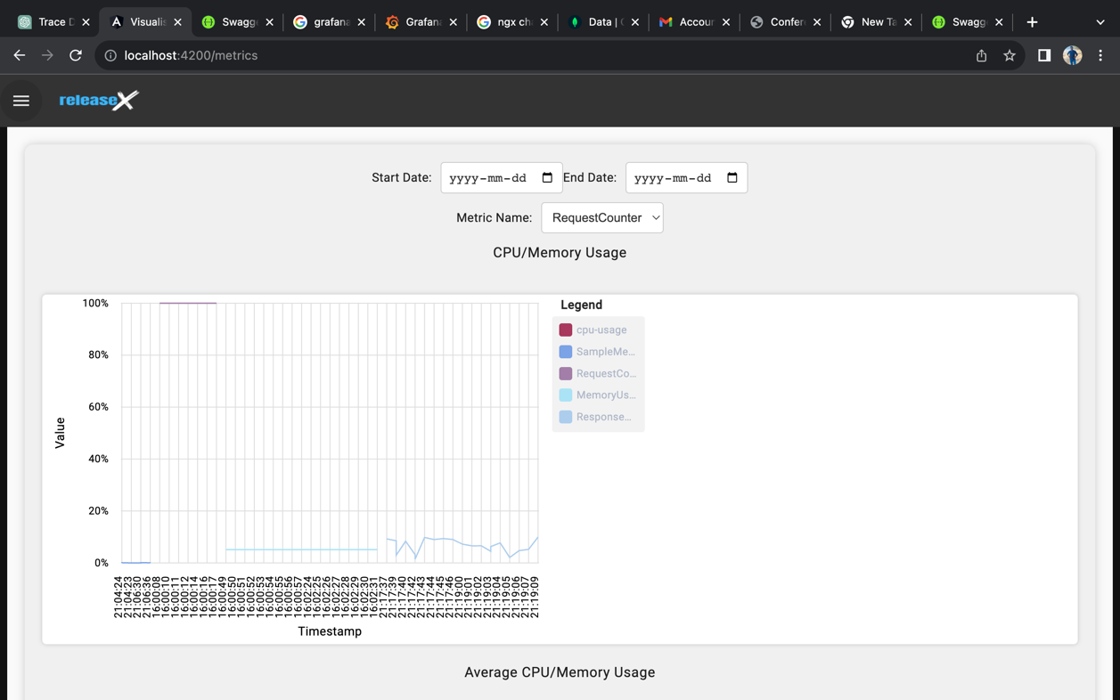

Figure 9 : CPU/Memory Usage chart-Metrics

This visualisation tool has proper data visualisation methods. This chart is one of the best for users. The user can analyze CPU and memory usage using this chart. Also proposed is a tool that provides chart filtering facilities to users. By default, users can see today's data in the charts, but they can analyse data by filtering by start date, end date, and metric name. That is a very attractive feature.

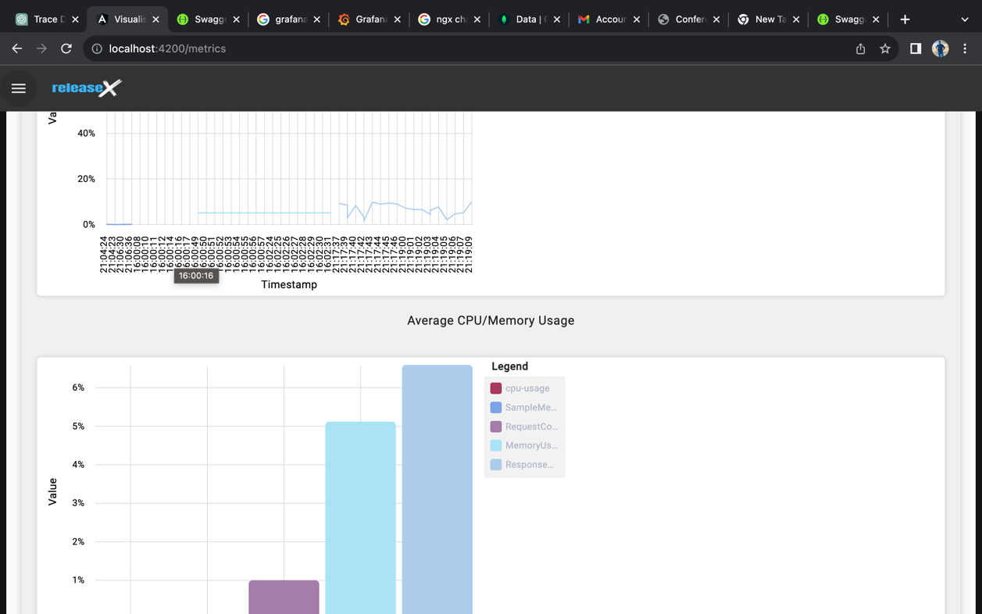

Figure 10 : Average CPU/Memory usage chart in visualization tool

When we can see data in different formats, that is very useful for clear analysis.

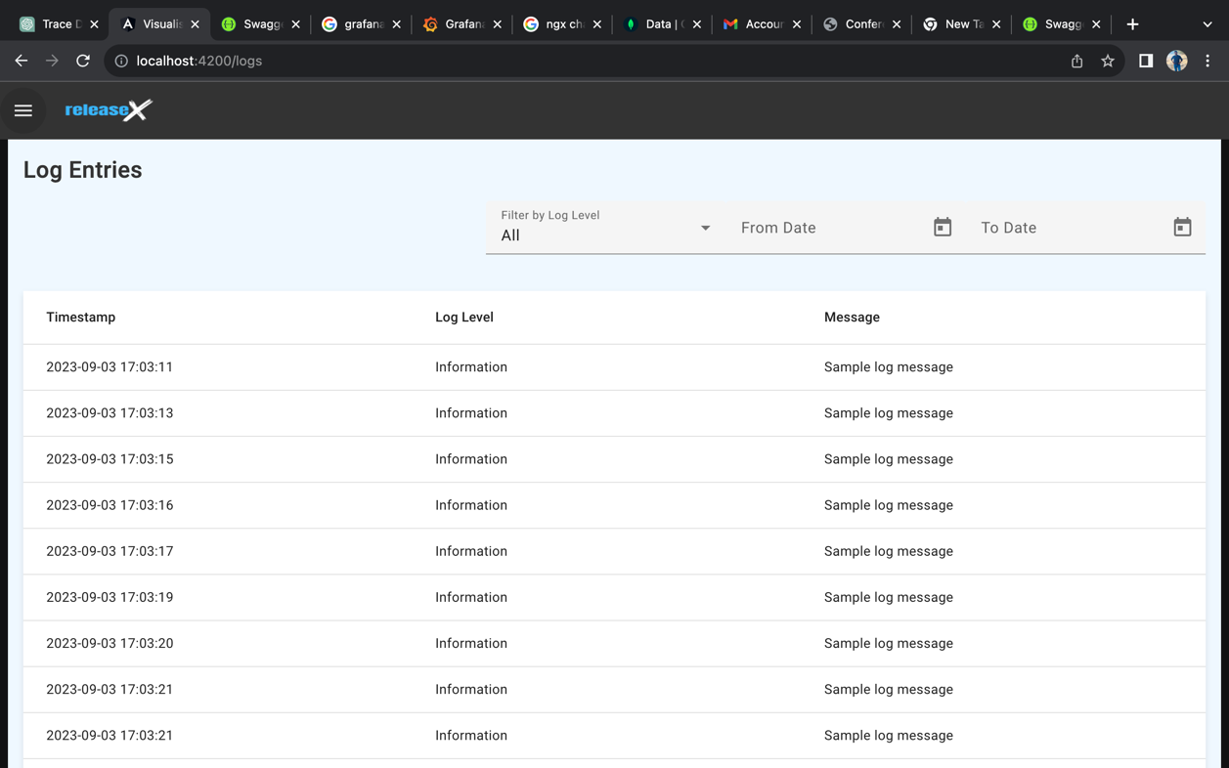

Figure 11 : Logs UI in visualization Tool

The proposed solution is a centralised data monitoring and visualisation tool. This is the advantage of this tool. The user can visualise metrics and logs using the same tool. When we discussed the log UI, it was very user-friendly and simple. The user can simply analyse logs by log level, time stamp, and message. Also, users can filter logs by date range and log level. This feature can’t see other existing visualisation tools.

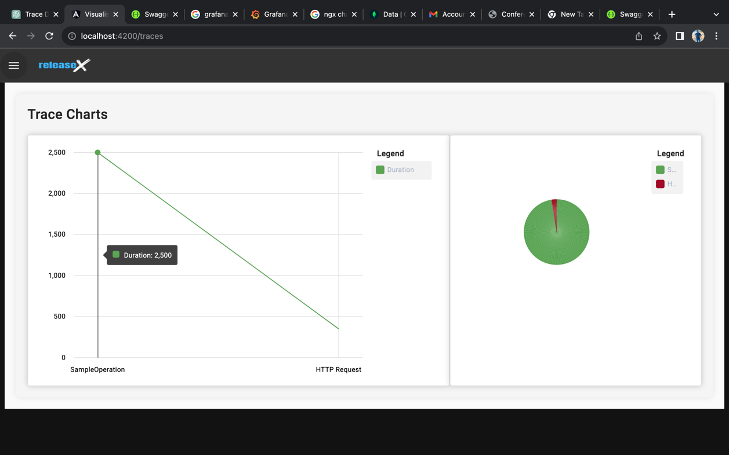

Figure 12 : Trace chart in visualization Tool

This is another data type that users can visualise using this visualisation tool. After configuring the centralised monitoring tool with the user’s application, the user can easily visualise metrics, logs, and traces using the visualisation tool. This visualisation tool is demo-only. We can develop this tool with more advanced features in future developments.

### 4.5 Project Requirements

The functional and non-functional requirements pertaining to this component is discussed below.

#### Functional Requirements

The primary functional requirements aimed at fulfilling during the implementation

Process of the Fully Automated and Optimized Software Release Process are as follows

• Automatically create the container image when the source code is updated in the SCM system.

• Automatically push the container image to the private container registry.

• Automatically trigger deployment pipelines.

• Automatically deploy the application on multi-cloud.

• Optimize based on architectural attributes such as performance, security, extendibility, reliability, and modifiability.

• Ensure the application's availability.

• Minimize deployment time and resource usage for deployments.

• Fast deployment through a fully automated sync process with GitOps.

Following are the functional requirements of the proposed system for the Centralized Monitoring Platform.

• The platform must be able to integrate data from various monitoring tools such as Prometheus, Grafana, and Jaeger.

• It should support the incorporation of data from multiple sources, including logs, metrics, traces, and external data streams.

• The platform must offer a range of visualization options, including charts, graphs, tables, and dashboards.

• Users should be able to customize and create their own dashboards easily.

Integration and Compatibility:

• The platform must have APIs and connectors for seamless integration with existing tools and services.

• Compatibility with popular monitoring tools and data formats is essential.

• Users should have the ability to search for specific data points and apply filters for data refinement.

The following functional requirements were provided for the optimization server

• Gather time series matrices and logs, structure the data, and store it in a persistence database.

• Expose an API to fetch data that includes all necessary details for creating a machine learning model.

• Develop a layer to deploy the optimal result to the cluster.

• Create a script to start Gatling and execute the performance tests.

• The system should be able to display cluster information through a monitoring server.

• There must be a change in performance when there is an attack on the cluster.

#### Non-Functional Requirements

The following are the non-functional requirements that are prioritized for the proposed component as follows.

Availability

Scalability

Performance

Reliability

Maintainability

Usability

Visibility

### Commercialization

The research in question holds significant commercialization potential due to its ability to efficiently automate and optimize the release process, particularly for organizations utilizing Kubernetes clusters. This solution can be marketed to companies and entities operating applications and services on such clusters. The advantages presented by this system are as follows:

1. The automated release process reduces costs by minimizing manual efforts, lowering error risks, and decreasing resource requirements.

2. Automation expedites release timelines, enhancing time-to-market for products.

3. Optimized architectural attributes ensure high-quality releases meeting performance, security, and extendibility, reliability, and modifiability requirements.

4. An automated and optimized release process sets organizations apart from competitors by delivering faster, higher-quality software releases.

5. Widespread adoption can turn this automated process into an industry standard, further boosting its commercial potential.

Additionally, the system helps organizations save costs through reduced manual efforts during releases. Its optimal architecture supports cluster performance via popular monitoring tools, and multi-cloud compatibility appeals to businesses spanning multiple cloud providers. Auto scaling could extend to other domains like network management or resource allocation, further enhancing its commercialization potential.

The proposed fully automated and optimized software release process, which leverages open-source solutions, offers a cost-effective solution for software companies and the industry as a whole. By embracing open-source tools, organizations reduce licensing expenses, access a wide array of development and deployment resources, and foster industry collaboration and knowledge-sharing.

The ability to offer comprehensive insights and real-time data visualization is pivotal to the commercial value of a centralized monitoring and visualization tool. In today's tech-driven landscape, businesses rely heavily on data availability and the ability to make informed decisions. Even brief monitoring interruptions or incomplete system operation insights can result in costly inefficiencies and suboptimal decision-making.

The suggested centralized tool addresses these challenges by amalgamating data from multiple monitoring sources into a single platform. It ensures a comprehensive understanding of system performance and addresses limitations of current tools like Prometheus, Grafana, and Jaeger. Users can seamlessly integrate various data sources, including logs, metrics, traces, and external data streams. The tool prioritizes user-friendliness with an interface designed for both technical and non-technical users. This approach simplifies data analysis and navigation, facilitating valuable insights for all users and emphasizing clarity over complex visualizations, which can be challenging for non-technical users.

In essence, this solution empowers organizations to make informed decisions regarding their micro services' performance and health by centralizing data collection, analysis, and visualization in a user-friendly manner. The result is improved business outcomes, enhanced efficiency, and optimized resource allocation. The ability to manage and present data coherently is transformative for organizations seeking predictive capabilities and data-driven insights in a data-intensive world.

## Results and discussion

**5.1 Testing**

**5.1.1 Micro service deployment**

# A sample microservice application has been deployed to GKE under the Istio service mesh. The purpose of deploying the microservice is to increase the load and traffic, enabling the monitoring of metrics for the deployed microservice pods through Prometheus. A Kubernetes cluster was created in GKE, and the applications were deployed using the GCloud CLI.

# 

*Figure 11: GKE Cluster*

# 

*Figure 12: GKE Application Deployments*

**5.1.2 Automated Deployment**

There are several applications are deployed via the developed software release process and tested based on the programming languages. Initially tested Java and Python programming languages in the test environment to ensure the CI and CD optimizations based on the time. The architecture solution is deployed in the enterprise level company as an enhanced solution for their software release process. The test results from the company are as follows based on a comparison of previous system and proposed system. Based on the programming language, the result outcome is showing the performance improvement of the CI Process and the CD Process.

|  |  |  |  |  |
| --- | --- | --- | --- | --- |
| Programming Language | Average Time to build in previous system | Average Time to build with proposed system | Average builds per day | Performance Improvement |
| Java (Spring Boot) | 10 - 15 min | 5 - 10 min | 30 + | 33.33 % |
| JavaScript (React) | 15 - 25 min | 5 - 15 min | 10 + | 40 % |

1. Table 2: Performance Improvement of CI Process

|  |  |  |  |  |
| --- | --- | --- | --- | --- |
| Programming Language | Average Time to deploy in previous system | Average Time to deploy with proposed system | Average deployments per day | Performance Improvement |
| Java (Spring Boot) | 10 - 15 min | 4 - 5 min | 50 + | 66.66 % |
| JavaScript (React) | 15 - 25 min | 4 - 5 min | 30 + | 80 % |

1. Table 3: Performance Improvement of CI Process

### 5.1.3 Selection of optimization model

# One of the primary components of the proposed solution involved the development of a prediction model. The aim was to select a model that could provide more accurate predictions, which could be utilized for forecasting future trends. To create the optimal prediction model, various modeling techniques were explored, including time series models such as statistical methods like ARIMA, and deep learning-based recurrent neural network models such as LSTM, Bi-LSTM, and GRU.

# These models were rigorously tested using collected metrics for CPU utilization and memory utilization. The following algorithms were employed in our research environment for comprehensive evaluation:

# LSTM

# ARIMA

# Holt-Winters

# GRU

# Bi-LSTM

# Bi-LSTM-CNN

# To further enhance prediction accuracy while maintaining efficiency, a combination of Convolutional 1D (Conv1D) layers and Bidirectional Long Short-Term Memory (Bi-LSTM) networks was implemented. This combination was specifically chosen due to its ability to achieve a low mean squared error and high accuracy, even when working with limited data.

# In our research environment, Jupyter Notebook was employed as the primary tool for model evaluation. We ensured the installation of relevant dependencies, including TensorFlow, scikit-learn, and Keras. The time series dataset for CPU utilization was collected at 5-minute intervals. Model accuracy and performance were assessed using metrics such as the Mean Absolute Error (MAE), Mean Squared Error (MSE) and Root Mean Squared Error (RMSE). These evaluations allowed us to fine-tune our models and select the most suitable one for our forecasting needs.

# 5.1.3.1 LSTM Model

# Long Short-Term Memory (LSTM) is a type of recurrent neural network (RNN) architecture that is particularly well-suited for handling sequential data and time series forecasting. LSTMs achieve this by incorporating a memory cell that can store and update information over time, allowing them to remember past observations and make informed predictions about future data points. They can effectively model seasonality, trends, and irregularities in the data, thereby enabling accurate predictions across various time horizons. The following result was obtained for the CPU utilization of the generated dataset.

# 5.1.3.2 ARIMA Model

# The Autoregressive Integrated Moving Average (ARIMA) model is a widely used statistical technique in the field of time series forecasting. The Autoregressive (AR) component considers the relationship between the current observation and its past values, while the Moving Average (MA) component models the influence of past forecast errors on the current observation, helping to capture short-term fluctuations and noise in the data. ARIMA models are particularly useful for time series forecasting because they can handle a wide range of data patterns, including trends, seasonality, and autocorrelation.

# 5.1.3.3 Holt-Winters Model

The Holt-Winters Model stands out as a widely embraced and potent technique in time series forecasting, particularly adept at handling datasets characterized by trend and seasonality components. The model comprises three essential components: Level (α), which signifies the baseline or average value of the time series data, effectively capturing the overall mean or trend within the dataset; Trend (β), responsible for modeling the direction and rate of change observed over time, thereby capturing any consistent upward or downward movements in the data; and Seasonality (γ), which accounts for recurrent patterns or cycles in the time series, such as daily, weekly, or yearly fluctuations. By estimating and extrapolating these components into the future, the Holt-Winters Model proves invaluable in the realm of time series forecasting

# 5.1.3.4 GRU Model

# The Gated Recurrent Unit (GRU) is a type of recurrent neural network (RNN) architecture commonly employed in various machine learning tasks, including time series forecasting. GRUs are composed of specialized gating mechanisms that enable them to selectively update and reset their internal states, enhancing their ability to capture crucial information over extended sequences. They can take a historical sequence of data points as input and learn to discern intricate patterns and dependencies in the data, which can subsequently be utilized for making future predictions.

# 5.1.3.5 Bi-Lstm Model

# The Bidirectional Long Short-Term Memory (Bi-LSTM) model represents a specialized form of recurrent neural network (RNN) architecture that excels in sequence modeling and time series forecasting. In contrast to conventional LSTM models, Bi-LSTM networks handle input sequences in both forward and backward directions. By conducting this bidirectional processing of time series data, the model can glean insights from historical values while also anticipating forthcoming trends. This dual perspective proves invaluable in enhancing the model's capacity to provide precise predictions.

# 5.1.3.6 Bi-Lstm-CNN Model

# The combination of Bidirectional Long Short-Term Memory (Bi-LSTM) and Convolutional Neural Networks (CNN) within a single model represents a potent approach for time series forecasting. Bi-LSTM layers prove highly effective in modeling long-range dependencies inherent in sequential data, as they maintain a memory of both past information and future context. Conversely, CNN layers are well-suited for capturing local patterns or features within time series data. When seamlessly integrated, the Bi-LSTM-CNN model demonstrates its capability to concurrently discern both short-term and long-term patterns within time series data, thus enhancing its forecasting accuracy and robustness.

**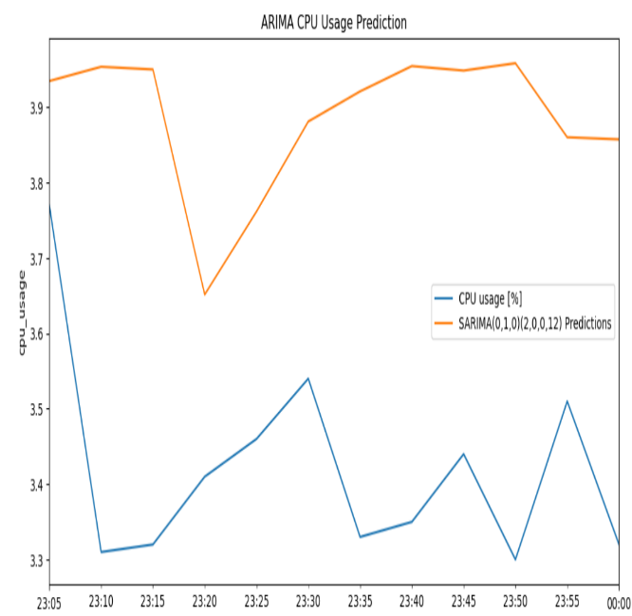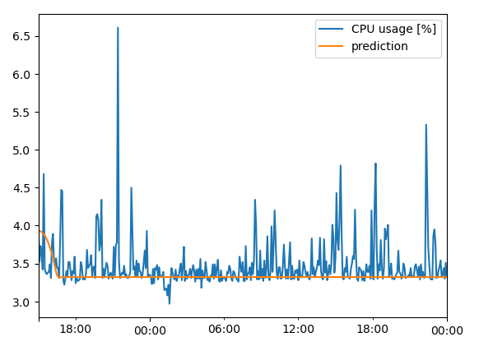***Figure 13: LSTM Model Accuracy Figure 14: ARIMA Model Accuracy*

# 

*Figure 15: HoltWinters Model Accuracy Figure 16: GRU Model Accuracy*

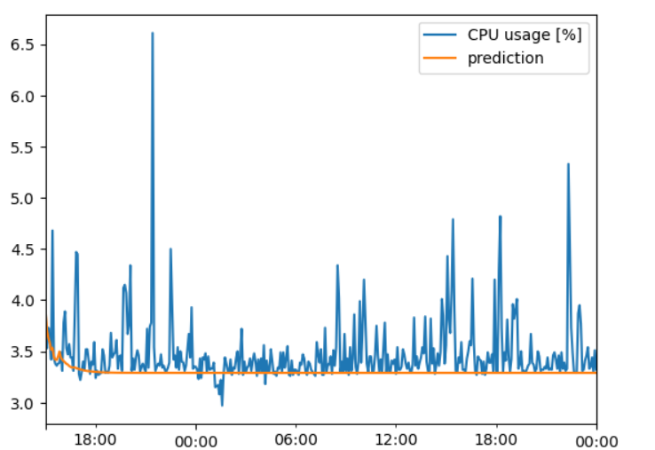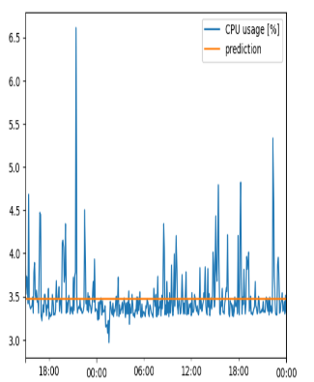

*Figure 17: Bi-Lstm Model Accuracy Figure 18: Bi-Lstm-CNN Model Accuracy*

|  |  |  |  |
| --- | --- | --- | --- |
| Model | RMSE | MSE | MAE |
| Holt-Winters | 0.34583 | 0.11959 | 0.19297 |
| ARIMA | 0.49341 | 0.24345 | 0.46432 |
| LSTM | 0.35320 | 0.12475 | 0.18310 |
| GRU | 0.35113 | 0.12329 | 0.27582 |
| Bi-Lstm | 0.36486 | 0.1331 | 0.19418 |
| Bi-Lstm-CNN | 0.31872 | 0.10158 | 0.18644 |

*Table 3: LSTM Model Accuracy.*

# Performance metrics such as Mean Absolute Error (MAE), Mean Squared Error (MSE), or Root Mean Squared Error (RMSE) are commonly used to assess the accuracy of LSTM models in time series forecasting. Through the evaluation process the bi-lstm model and bi-lstm-cnn model gives a law RMSE , MSE and MAE values. The bi-lstm and the combination model of bi-lstm and cnn was run through several times and tested with several am output of data.

### 5.1.4 Selection of optimization model

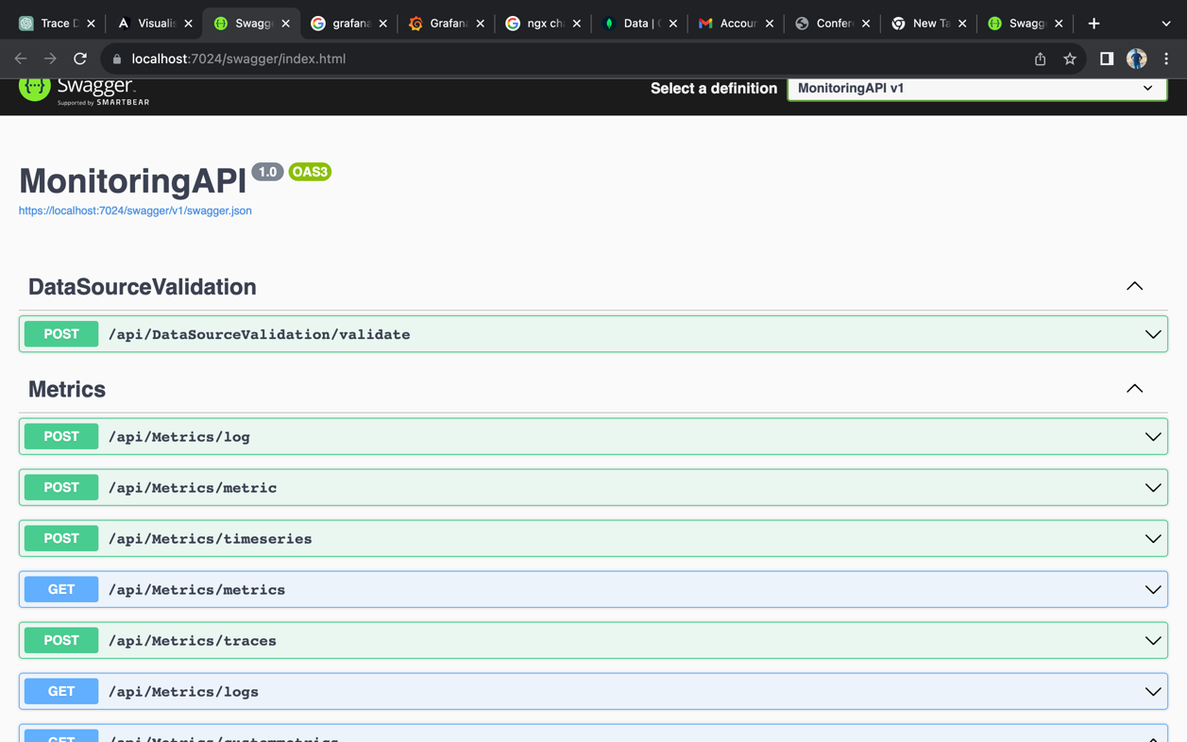

Figure 13 : Swagger UI of API Testing

For this implementation, use the ASP.NET Core MVC architecture. Swagger is the most suitable API testing platform for C# developments. After configuring the test application with end points, POST APIs should collect data. And GET APIs should retrieve collected data.

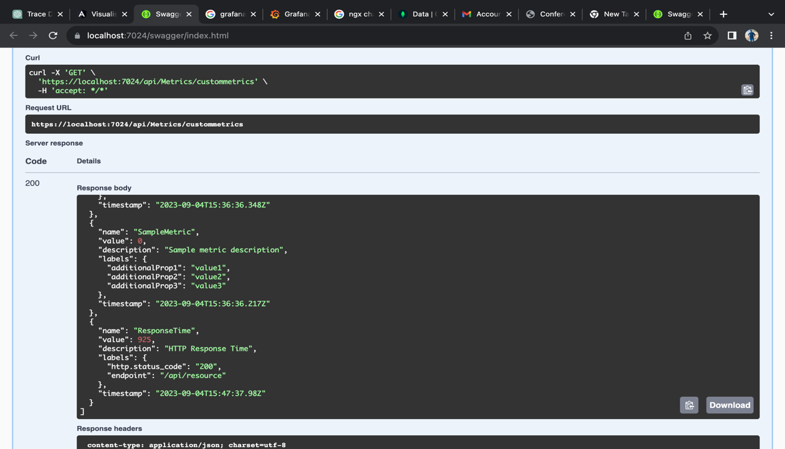

Figure 14 : testing data

**5.2 Data gathering for Optimization Model**

# Data gathered through the metric server, metric server trigger a cron job every 10min and gathered the metrices of cpu and memory utilization, metrices are gathered through and Prometheus monitoring tool that was deployed to gke(google kubernets engine) through the istio service mesh And the micro services that are monitored through the Prometheus also deployed through the sidecar of the istio service mesh.

# Once the metrices are getheres through the metric server with the following columns , CPU, CPU Usage[%],CPU Usage[KHZ], Memory, Memory usage[Mi],Memory usage[%],Timestamp with more than 2000 data. The data will be stored in the database , and generate and csv file for the prediction server and through and api that was exposed through metric server and request was made for optimization server to make the relevant predictions.

### 5.2 Data Storing for Centralized Monitoring Tool

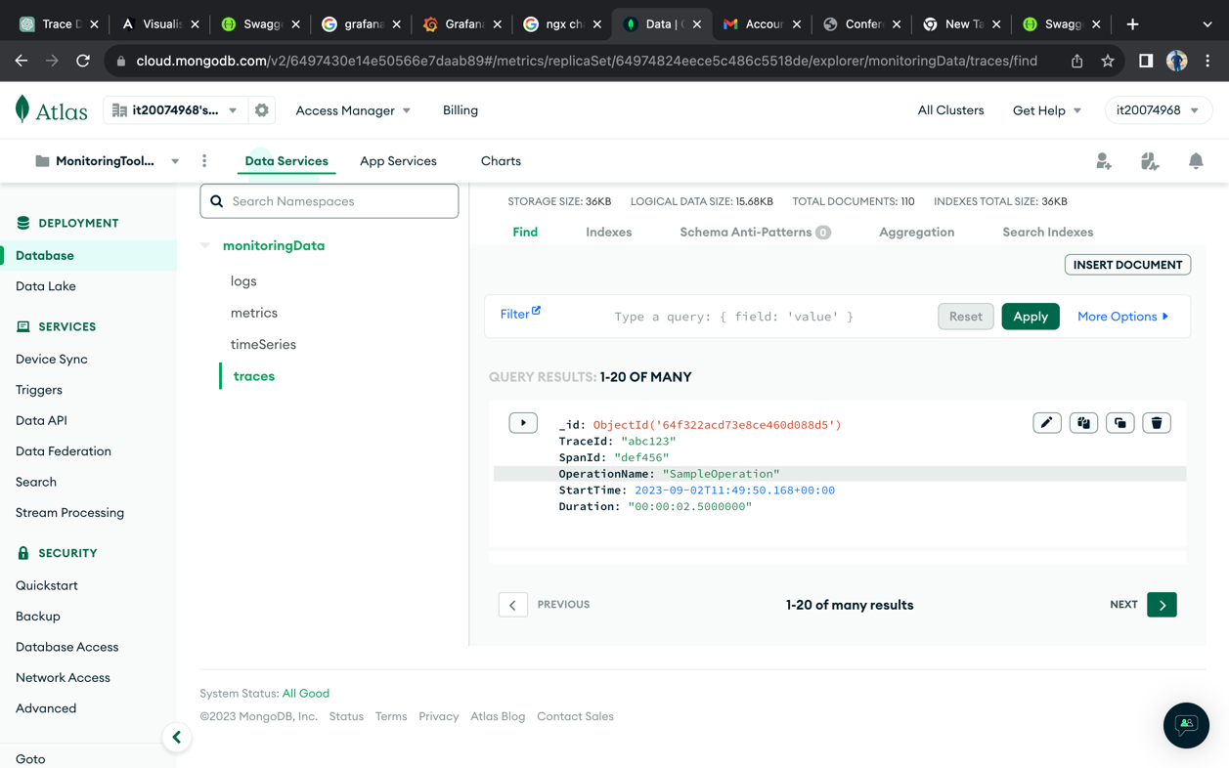

Figure 15 : MongoDb monitoring data collections.

The proposed centralised monitoring tool used MongoDB as a database for data storage. Because of that, MongoDB is a no-SQL database and supports time series data and other data.

## conclusion

The development of the resource prediction system represents a significant step forward in optimizing the software release process and resource management in Kubernetes environments. By harnessing the power of a combination of Convolutional Neural Networks (CNN) and a Bi-LSTM model, this system effectively learns from historical resource usage data per application. The overarching goal of this publication is to introduce a fully automated and highly optimized architecture that not only comprehensively monitors all relevant metrics through a centralized dashboard but also deploys predictive capabilities to allocate resources on-demand for Kubernetes pods.

The pivotal insight gained from this research is the establishment of a robust prediction mechanism that empowers organizations to scale out their resources effectively. Through the implementation of end-to-end autoscaling policies informed by this predictive model, companies can proactively adapt to fluctuations in demand, ultimately enhancing the efficiency, reliability, and cost-effectiveness of their software deployment processes. This innovative approach offers a promising avenue for achieving superior resource allocation and system performance in the ever-evolving landscape of containerized applications.

The proposed research project sets its sights on optimizing and automating the software release process for microservice-based architectures on multi-cloud platforms. Microservice architectures have been gaining increasing popularity due to their scalability, flexibility, and dependability. However, deploying and managing microservices on multi-cloud platforms can pose complex and time-consuming challenges, especially when it comes to releasing new software updates. The software release process encompasses several crucial phases, including development, testing, staging, and deployment. Each step demands a unique set of resources and tools, and each stage introduces the potential for human error. By optimizing and automating the software release process, organizations can mitigate the risk of errors, enhance the quality of releases, and expedite the deployment process.

To achieve full automation of the release process, organizations must leverage tools and technologies to automatically create, test, and deploy software updates. CI/CD pipelines, which automate the entire release process from code changes to deployment, can play a pivotal role in this endeavor. By eliminating the need for manual intervention, organizations can reduce the risk of errors and accelerate deployment. The identification and elimination of inefficiencies in the software delivery process are essential steps to optimization. This can be achieved by identifying bottlenecks, automating repetitive tasks, and improving resource utilization. Through these optimizations, organizations can cut costs, enhance resource management, and boost productivity.

The research is intently focused on optimizing the software release process in alignment with five architectural attributes: performance, security, extendibility, reliability, and modifiability. The proposed solution leverages open-source solutions available for DevOps and cloud platforms. Several factors must be meticulously considered to streamline the software release process for microservice-based architectures on cloud platforms, including containerization, orchestration, automation, monitoring, and security. By embracing best practices for each of these factors, organizations can bolster the reliability and scalability of their microservices, minimize downtime, implement multi-cloud deployment solutions, and fortify application security.

In conclusion, our research journey underscores the paramount importance of centralized monitoring and visualization tools in our data-driven environment. We have witnessed how outdated tools often falter, leaving businesses grappling with disjointed data and perplexing user interfaces. However, the solution described in this thesis is nothing short of intriguing. It revolves around the consolidation of information from various sources into a single, easily comprehensible platform. The benefits are manifold: smoother operations, swifter problem-solving, enhanced resource management, and more informed decision-making. Moreover, scalability guarantees that your business remains future-proof in a world where data continually expands. Consequently, it is abundantly clear that adopting centralized monitoring and visualization is not merely an option but a necessity as technology advances and data continues to accumulate

## Further improvements

Proposing the integration of reinforcement learning algorithms to enhance resource allocation decisions in Kubernetes environments is a compelling initiative. While existing Convolutional Neural Networks (CNN) and Bi-LSTM models offer valuable insights into historical resource usage, reinforcement learning can bring about dynamic adaptability.By incorporating reinforcement learning, the system can continually learn and optimize resource allocation policies based on real-time feedback and evolving workload patterns. This approach empowers the prediction system not only to forecast future resource requirements but also to actively fine-tune resource allocations in response to changing application needs and environmental conditions.

Furthermore, the system could greatly benefit from a self-learning mechanism that enables it to adapt and refine its predictions over time, reducing the need for manual adjustments. This self-improvement aspect of the system enhances its resilience and efficiency in managing resources, particularly in complex and dynamic Kubernetes environments.By synergizing deep learning with reinforcement learning and self-adaptation, the resource prediction system can achieve even higher levels of automation, efficiency, and cost-effectiveness, making it an invaluable asset for organizations striving for excellence in containerized application deployment.

This research's conclusions have underscored the need for centralized monitoring and visualization tools in our data-driven environment. We've identified the limitations of current technologies and recognized the potential of a centralized solution that unifies data sources and prioritizes user-friendliness. However, there is always room for advancement and further study.

One promising direction for additional research is the integration of cutting-edge machine learning and artificial intelligence techniques. These technologies can offer proactive insights and recommend optimal courses of action based on historical data, effectively merging automation and predictive analytics. Moreover, the platform can become more accessible with ongoing enhancements to the user interface and experience. Iterative improvements that cater to a broader user base can be guided by implementing user feedback and conducting usability tests.

Additionally, addressing security and compliance issues remains critical. Future studies can delve deeper into protecting sensitive data, exploring encryption methods, and staying up-to-date with evolving compliance standards.

The proposed architecture for the software release process is fully automated and optimized, in line with the architectural attributes emphasized in this research. The multi-cloud deployment solution is implemented, and the service monitors and ensures the availability of microservices-based applications by employing a well-managed GitOps solution. To enhance the solution, disaster recovery can be integrated by monitoring the availability of multi-cloud platforms, as unforeseen circumstances can render cloud platforms temporarily unavailable. The system is automatically deployed on multiple clouds, and when combined with multi-cloud disaster recovery, it becomes highly valuable in achieving the availability of microservices-based applications.

## References

1. “Exploring the Benefits of Combining DevOps and Agile,” Fernando Almeida, Jorge Simoes, Sergio Lopes, 19 February 2022.
2. “Method for Continuous Integration and Deployment Using a Pipeline Generator for Agile Software Projects,” Ionut-Catalin Donca, Ovidiu Petru Stan, Marius Misaros, Dan Gota, Liviu Miclea, 20 June 2022.
3. “Monolithic vs. Microservice Architecture: A Performance and Scalability Evaluation,” Grzegorz Blinowski, Anna Ojdowska, Adam Przybyłek, 18 February 2022
4. “Microservice Architecture Practices and Experience: a Focused Look on Docker Configuration Files,” Luciano Baresi, Giovanni Quattrocchi, Damian Andrew Tamburri, 6 Dec 2022.
5. “The key differences between Kubernetes and Docker and how they fit into containerization”, Josh Campbell, [Online]. Available: https://www.atlassian.com/microservices/microservices- architecture/kubernetes-vs-docker.
6. “Analyzing and Monitoring Kubernetes Microservices based on Distributed Tracing and Service Mesh,” Yu-Te Wang, Shang-Pin Ma, Yue-Jun Lai, Yan- Cih Liang, December 2022. [Accessed 04 March 2023].
7. “The Challenges and Mitigation Strategies of Using DevOps during Software Development,” Dhaya Sindhu Battina, 1 January 2021.
8. “Performance Assessment of Traditional Software Development Methodologies and DevOps Automation Culture,” P. Narang, P. Mittal, December 2022.
9. “Kubernetes - evolution of virtualization,” Marek Moravcik, Martin Kontsek, Pavel Segec, David Cymbalak, 15 December 2022.
10. “Effect of Using Continuous Integration (CI) and Continuous Delivery (CD) Deployment in DevOps to reduce the Gap between Developer and Operation,” Abrar Mohammad Mowad, Hamed Fawareh, Mohammad A. Hassan, 04 January 2023.
11. “Containerized Microservices Orchestration and Provisioning in CloudComputing: A Conceptual Framework and Future Perspectives,” Abdul Saboor, Mohd Fadzil Hassan, Rehan Akbar, Syed Nasir Mehmood Shah, Farrukh Hassan, Saeed Ahmed Magsi, Muhammad Aadil Siddiqui, 07 June 2022.
12. “CLOUD DATA SECURITY METHODS: KUBERNETES VS DOCKER SWARM,” Avinash Ganne, December-2022.
13. “Challenges and solutions when adopting DevSecOps,” Roshan N. Rajapakse, Mansooreh Zahedi, M. Ali Babar, Haifeng Shen, January 2022.
14. “Performance Study of Kubernetes Cluster Deployed on Openstack,VMs and BareMetal,” Yeddula Sai Dhanush Reddy, Padumati Saikiran Reddy, Nithya Ganesan, B. Thangaraju, 30 August 2022.
15. “Automation of Configuration, Initialization and Deployment of Applications Based on an Algebraic Approach,” PavelShapkin, 26 November 2022.
16. “Automated Unit Testing of Hydrologic Modeling Software with CI/CD and Jenkins,” Levi T. Connelly, Melody L. Hammel, Benjamin T. Eger, Lan Lin, 2022.
17. “AUTOMATED TESTING IN A CI/CD PIPELINE,” Ville Santala, 2022.
18. “Testing resource allocation for software with multiple versions,” Adarsh Anand, Subhrata Das, Ompal Singh, Vijay Kumar, February 19, 2022.
19. “Reliability modelling and optimization for microservice-based cloud application using multi-agent system”, Zheng Liu, Huiqun Yu, Guisheng Fan, Liqiong Chen, 13 March 2022.
20. Z. Zhu, M. A. Naeem, and L. Li, "Automated Continuous Deployment at Facebook," in Proceedings of the 17th International Conference on Mining Software Repositories, IEEE Press, 2020, pp. 460-470.
21. [21] H. Guo, J. Chen, T. Li, Z. Li, L. Zhang, and J. Li, "An optimization model for software release management based on continuous delivery," Information and Software Technology, vol. 107, pp. 101-115, 2019H. Guo, J. Chen, T. Li, Z. Li, L. Zhang, and J. Li, "An optimization model for software release management based on continuous delivery," Information and Software Technology, vol. 107, pp. 101-115, 2019
22. “AUTOMA TING DEPLOYMENTS OF THE LA TEST APPLICA TION VERSION USING CI-CD WORKFLOW”, 2022, Spoorthi Jayaprakash Malgund, Dr Sowmyarani C N. .
23. “Commit, Release, Package: Automation in the development process for the ReFEx GNC System,” Sommer, Jan, 9 February 2022. .
24. Grzegorz Blinowski, Anna Ojdowska, Adam Przybyłek, “Monolithic vs. Microservice Architecture: A Performance and Scalability Evaluation”, 18 February 2022.
25. Luciano Baresi, Giovanni Quattrocchi, Damian Andrew Tamburri, “Microservice Architecture Practices and Experience: a Focused Look on Docker Configuration Files”, 6 Dec 2022.
26. Josh Campbell, “The key differences between Kubernetes and Docker and how they fit into containerization”, [Online]. Available: https://www.atlassian.com/microservices/microservices-architecture/kubernetes-vs-docker, [Accessed 04 March 2023].
27. Ionut-Catalin Donca, Ovidiu Petru Stan, Marius Misaros, Dan Gota, Liviu Miclea, “Method for Continuous Integration and Deployment Using a Pipeline Generator for Agile Software Projects”, 2022.
28. Fernando Almeida, Jorge Simoes, Sergio Lopes, “Exploring the Benefits of Combining DevOps and Agile”, 2022.
29. Yeddula Sai Dhanush Reddy, Padumati Saikiran Reddy, Nithya Ganesan, B. Thangaraju, “Performance Study of Kubernetes Cluster Deployed on OpenStack, VMs and BareMetal”, 30 August 2022.
30. PavelShapkin, “Automation of Configuration, Initialization and Deployment of Applications Based on an Algebraic Approach”, 2022.
31. D. C Kalubowila, S. M Athukorala, B. A. S Tharaka, H. W. Y. R Samarasekara, Udara Srimath S. Samaratunge Arachchilage, Dharshana Kasthurirathna, “Optimization of Microservices Security,” December 2021.
32. Adarsh Anand, Subrata Das, Ompal Singh, Vijay Kumar, “Testing resource allocation for software with multiple versions”, February 19, 2022.
33. Zheng Liu, Huiqun Yu, Guisheng Fan, Liqiong Chen, “Reliability modelling and optimization for microservice-based cloud application using multi-agent system”, 13 March 2022.
34. Z. Zhu, M. A. Naeem, and L. Li, "Automated Continuous Deployment at Facebook," in Proceedings of the 17th International Conference on Mining Software Repositories, IEEE Press, 2020, pp. 460-470.
35. H. Guo, J. Chen, T. Li, Z. Li, L. Zhang, and J. Li, "An optimization model for software release management based on continuous delivery," Information and Software Technology, vol. 107, pp. 101-115, 2019.
36. Spoorthi Jayaprakash Malgund, Dr Sowmyarani C N, “Automating Deployments Of The Latest Application Version Using Ci-Cd Workflow”, 2022.
37. Yutsuki Miyashita, Yuki Yamada, Hiroaki Hashiura, Atsuo Hazeyama, “Design of the Inspection Process Using the GitHub Flow in Project Based Learning for Software Engineering and Its Practice", 6 Feb 2022.
38. Meixia Yang, Ming Hung, “A Microservice-Based OpenStack Monitoring Tool”,19 March 2020,doi: 10.1109/ICSESS47205.2019.9040740.
39. Lei Chen, Ming Xian, JianLiu, “Monitoring System of OpenStack Cloud Platform Based on Prometheus”,10-12 July 2020, doi:10.1109/CVIDL51233.2020.0-100.
40. Abhishek Pratap Singh, “A Data Visualization Tool- Grafana”, Jan 26 2023.
41. Andrea Janes, Xiaozhu Li, Valentina Lenarduzzi, “Open tracing tools: Overview and critical comparison”, Vol. 204, October 2023, 111793.
42. Mahantesh Birje, Chetan Bulla, “Commerical and Open Source Cloud Monitoring tools: A Review”, January 2020, doi: 10.1007/978-3-030-24322-7_59
43. Shubo Zhang1, Tianyang Wu1, Maolin Pan1, Chaomeng Zhang2 and Yang Yu, “A-SARSA: A Predictive Container Auto-Scaling Algorithm Based on Reinforcement Learning”, 2020 IEEE International Conference on Web Services (ICWS).
44. Nhat-Minh Dang-Quang and Myungsik Yoo, “Deep Learning-Based Autoscaling Using Bidirectional Long Short-Term Memory for Kubernetes”, Applied Science – 11
45. weave works, “Ensure High Availability and Uptime With Kubernetes HPA (Horizontal Pod Autoscaler) and Prometheus”, https://www.weave.works/blog/kubernetes-horizontal-pod-autoscaler-andprometheus
46. Wei Fang; ZhiHui Lu; Jie Wu; ZhenYin Cao, “RPPS: A Novel Resource Prediction and Provisioning Scheme in Cloud Data Center”,2012 IEEE Ninth International Conference on Services Computing
47. Mahmoud Imdoukh, Imtiaz Ahmad & Mohammad Gh. Alfailakawi,"Machine learning-based auto-scaling for containerized applications", https://link.springer.com/article/10.1007/s00521-019-04507-z
48. Xuehai Tang, Qiuyang Liu , Yangchen Dong, Jizhong Han, Zhiyuan Zhang ,“Fisher: An Efficient Container Load Prediction Model with Deep Neural Network in Clouds”, 2018 IEEE Intl Conf on Parallel & Distributed Processing with Applications, Ubiquitous Computing & Communications, Big Data & Cloud Computing, Social Computing & Networking, Sustainable Computing & Communication.

## APPENDIX

### [Appendix A: Jenkins Server Deployment YAML]

apiVersion: apps/v1

kind: Deployment

metadata:

name: jenkins

namespace: jenkins

spec:

replicas: 1

selector:

matchLabels:

name: jenkins

template:

metadata:

labels:

name: jenkins

spec:

volumes:

- name: jenkins-nfs-pvc-new

persistentVolumeClaim:

claimName: jenkins-pvc

- name: config

secret:

secretName: config

containers:

- name: kaniko

image: gcr.io/kaniko-project/executor:debug

command:

- /busybox/cat

resources: {}

volumeMounts:

- name: jenkins-nfs-pvc-new

mountPath: /var/jenkins_home

- name: config

mountPath: /var/jenkins_home/config

terminationMessagePath: /dev/termination-log

terminationMessagePolicy: File

imagePullPolicy: IfNotPresent

tty: true

- name: jenkins

image: jenkins/jenkins:2.404-jdk11

ports:

- name: http

containerPort: 8080

protocol: TCP

- name: executor

containerPort: 50000

protocol: TCP

env:

- name: "JENKINS_OPTS"

value: "--prefix=/jenkins"

- name: "JAVA_OPTS"

value: "-Xmx9800m"

resources:

limits:

cpu: '1'

memory: 1Gi

requests:

cpu: 500m

memory: 500Mi

volumeMounts:

- name: jenkins-nfs-pvc-new

mountPath: /var/jenkins_home

- name: config

mountPath: /var/jenkins_home/config

livenessProbe:

httpGet:

path: /jenkins/login

port: 8080

scheme: HTTP

initialDelaySeconds: 120

timeoutSeconds: 3

periodSeconds: 10

successThreshold: 1

failureThreshold: 3

readinessProbe:

httpGet:

path: /jenkins/login

port: 8080

scheme: HTTP

initialDelaySeconds: 120

timeoutSeconds: 3

periodSeconds: 10

successThreshold: 1

failureThreshold: 3

terminationMessagePath: /dev/termination-log

terminationMessagePolicy: File

imagePullPolicy: IfNotPresent

restartPolicy: Always

terminationGracePeriodSeconds: 30

dnsPolicy: ClusterFirst

serviceAccountName: jenkins

securityContext:

fsGroup: 1000

runAsUser: 1000

schedulerName: default-scheduler

strategy:

type: RollingUpdate

rollingUpdate:

maxUnavailable: 25%

maxSurge: 25%

revisionHistoryLimit: 10

progressDeadlineSeconds: 600

### [Appendix B: Jenkins Server Service YAML]

apiVersion: v1

kind: Service

metadata:

name: jenkins

namespace: jenkins

spec:

ports:

- name: http

protocol: TCP

port: 8080

targetPort: 8080

- name: agent

protocol: TCP

port: 50000

targetPort: 50000

selector:

name: jenkins

type: ClusterIP

### [Appendix C: Jenkins Server Virtual Service YAML]

apiVersion: networking.istio.io/v1beta1

kind: VirtualService

metadata:

namespace: jenkins

name: jenkins

spec:

gateways:

- default/argocd-gateway

hosts:

- releasex.tech

http:

- match:

- uri:

prefix: "/jenkins"

route:

- destination:

port:

number: 8080

host: jenkins.jenkins.svc.cluster.local

### [Appendix D: Jenkins Server Storage Class YAML]

apiVersion: storage.k8s.io/v1

kind: StorageClass

metadata:

name: jenkins-storage

provisioner: kubernetes.io/gce-pd

parameters:

type: pd-standard

fstype: ext4

replication-type: none

### [Appendix E: Jenkins Server Persistence Volume Claim YAML]

kind: PersistentVolumeClaim

apiVersion: v1

metadata:

name: jenkins-pvc

namespace: jenkins

spec:

storageClassName: "jenkins-storage"

accessModes:

- ReadWriteOnce

resources:

requests:

storage: 100Gi

### [Appendix F: Kubernetes & Jenkins integration RBAC Role Service Account]

apiVersion: v1

kind: ServiceAccount

metadata:

name: jenkins-admin

namespace: builder-jenkins

---

apiVersion: rbac.authorization.k8s.io/v1

kind: Role

metadata:

name: jenkins

namespace: builder-jenkins

labels:

"app.kubernetes.io/name": 'jenkins'

rules:

- apiGroups: [""]

resources: ["pods"]

verbs: ["create","delete","get","list","patch","update","watch"]

- apiGroups: [""]

resources: ["pods/exec"]

verbs: ["create","delete","get","list","patch","update","watch"]

- apiGroups: [""]

resources: ["pods/log"]

verbs: ["get","list","watch"]

- apiGroups: [""]

resources: ["secrets"]

verbs: ["get"]

---

apiVersion: rbac.authorization.k8s.io/v1

kind: RoleBinding

metadata:

name: jenkins-role-binding

namespace: builder-jenkins

roleRef:

apiGroup: rbac.authorization.k8s.io

kind: Role

name: jenkins

subjects:

- kind: ServiceAccount

name: jenkins-admin

namespace: builder-jenkins

### [Appendix E: Shared Volume Storage Class]

apiVersion: storage.k8s.io/v1

kind: StorageClass

metadata:

name: jenkins-bilder-storage

provisioner: kubernetes.io/gce-pd

parameters:

type: pd-standard

fstype: ext4

replication-type: none

### [Appendix F: Shared Volume Java, Node & Python Persistence Volume Claims]

kind: PersistentVolumeClaim

apiVersion: v1

metadata:

name: jenkins-python-bilder-storage-pvc

namespace: builder-jenkins

spec:

storageClassName: "jenkins-bilder-storage"

accessModes:

- ReadWriteOnce

resources:

requests:

storage: 10Gi

---

kind: PersistentVolumeClaim

apiVersion: v1

metadata:

name: jenkins-node-bilder-storage-pvc

namespace: builder-jenkins

spec:

storageClassName: "jenkins-bilder-storage"

accessModes:

- ReadWriteOnce

resources:

requests:

storage: 10Gi

---

kind: PersistentVolumeClaim

apiVersion: v1

metadata:

name: jenkins-python-bilder-storage-pvc

namespace: builder-jenkins

spec:

storageClassName: "jenkins-bilder-storage"

accessModes:

- ReadWriteOnce

resources:

requests:

storage: 10Gi

### [Appendix G: Centralized Deployment Pipeline Jenkins File]

def componentsArray

def componentNameList=''

pipeline {

agent {

kubernetes {

defaultContainer 'argocd-cli'

yamlFile 'KubernetesPod.yaml'

}

}

parameters {

string(name: 'componentsArray', defaultValue: 'name=loan-management,')

string(name: 'fromEnvironment', defaultValue: 'dev')

string(name: 'toEnvironment', defaultValue: 'qa')

string(name: 'displayName', defaultValue: 'isurupathumherath')

}

environment {

DOCKER_REGISTRY_CREDS = credentials('AZURE_CONTAINER_REGISTRY')

ARGOCD_SERVER = 'argocd-server.argocd.svc.cluster.local:80'

DOCKER_REGISTRY_URL = 'sharedregistry23.azurecr.io'

registry="sharedregistry23.azurecr.io"

scope="repository:application-01:pull,push"

acr_credential="U0hBUkVEUkVHSVNUUlkyMzpONDdkYzN5WUN1M2xIZDIza2JTbGFTREY0YnpqVnBOcTVwTkZrYVZXZlErQUNSQ3ZTNFN5"

}

stages {

stage("Preparing") {

steps {

container('curl') {

checkout scm

script {

currentBuild.description = "Executed By: ${displayName}"

componentsArray = params.componentsArray.split(', BasicComponent')

for (int i = 0; i < componentsArray.size(); i++) {

appName = (componentsArray[i] =~ /name=(.+),/)[ 0 ][ 1 ]

echo "appName: ${appName}"

componentNameList=(componentNameList.length()>0) ? componentNameList+','+appName : componentNameList+appName

stage("${appName} (${toEnvironment})") {

sh '''

set +x

REPOSITORY=${appName}

TAG_OLD=${fromEnvironment}

TAG_NEW=${toEnvironment}

CONTENT_TYPE="application/vnd.docker.distribution.manifest.v2+json"

TOKEN=$(curl -v -H "Authorization: Basic $acr_credential" "https://$registry/oauth2/token?service=$registry&scope=$scope" | jq -r .access_token)

echo "$TOKEN"

MANIFEST=$(curl -H "Accept: ${CONTENT_TYPE}" -H "Authorization: Bearer ${TOKEN}" "https://${registry}/v2/${REPOSITORY}/manifests/${TAG_OLD}")

echo "$MANIFEST"

curl -X PUT -H "Content-Type: ${CONTENT_TYPE}" -H "Authorization: Bearer ${TOKEN}" -d "${MANIFEST}" "https://${registry}/v2/${REPOSITORY}/manifests/${TAG_NEW}"

set -x

'''

}

}

currentBuild.displayName = "${componentNameList}"

}

}

}

}

stage("Deploy") {

steps {

container('argocd-cli') {

withCredentials([string(credentialsId: 'github_token', variable: 'github_token')]) {

script {

sh '''

git config --global user.email "it20125516@my.sliit.lk"

git config --global user.name "isurupathumherath"

'''

for (int i = 0; i < componentsArray.size(); i++) {

appName = (componentsArray[i] =~ /name=(.+),/)[ 0 ][ 1 ]

if (appName.contains("-")){

countryCode=appName.split('-')[1];

}

filePathList = sh ( script: "find ./common-resources -type d -name ${appName}" , returnStdout: true).trim().split('\n')

echo "${filePathList}"

namespace = sh ( script: "echo '${filePathList[0]}' | cut -d/ -f 3-3" , returnStdout: true).trim()

def argocdAppName =sh ( script: """echo \$(argocd-autopilot application list ${toEnvironment} --git-token ${github_token} --repo https://github.com/23-193-SLIIT-RP/argocd-gitops.git | grep ${appName} ) | grep -E "(^| )\""""+appName+""""( |\$)" && echo 'matched' || true """, returnStdout: true).trim()

if (!argocdAppName){

echo "APPLICATION IS NOT AVAILABLE. CREATING NOW ... "

sh "argocd-autopilot app create ${appName} --app github.com/23-193-SLIIT-RP/argocd-gitops/common-resources/${namespace}/${appName}/ -p ${toEnvironment} --git-token ${github_token} --repo https://github.com/23-193-SLIIT-RP/argocd-gitops.git"

} else {

echo "APPLICATION IS AVAILABLE"

}

}

}

}

}

}

}

stage("Wait") {

steps {

container('argocd-cli') {

withCredentials([string(credentialsId: 'argocd_password', variable: 'ARGOCD_PASS')]) {

sh 'sleep 60'

sh "echo y | argocd login ${ARGOCD_SERVER} --insecure --username jenkins-ci --password ${ARGOCD_PASS} --grpc-web-root-path /argo-cd"

script {

for (int i = 0; i < componentsArray.size(); i++) {

appName = (componentsArray[i] =~ /name=(.+),/)[ 0 ][ 1 ]

sh "argocd app wait ${toEnvironment}-${appName} --timeout 600"

}

}

}

}

}

}

}

}

### [Appendix H: Centralized Deployment Pipeline Slave Node]

apiVersion: v1

kind: Pod

metadata:

name: deploy-on-argocd

namespace: builder-jenkins

spec:

imagePullSecrets:

- name: registry-secret

containers:

- name: jnlp

image: jenkins/inbound-agent:latest

command: ["/bin/sh","-c"]

args: ["sleep 30; /usr/local/bin/jenkins-agent"]

- name: curl

image: sharedregistry23.azurecr.io/fusionx-curl:1.0.0

command:

- cat

tty: true

- name: argocd-cli

image: sharedregistry23.azurecr.io/argocd-cli:2.1.1

command:

- cat

tty: true

### [Appendix I: Shared Library Java Build Pipeline Jenkins File]

apiVersion: v1

kind: Pod

metadata:

name: jenkins-slave-spring-boot

namespace: builder-jenkins

labels:

name: jenkins-slave-spring-boot

spec:

containers:

- name: jnlp

image: jenkins/inbound-agent:latest

command: ["/bin/sh","-c"]

args: ["sleep 30; /usr/local/bin/jenkins-agent"]

- name: kaniko

image: gcr.io/kaniko-project/executor:debug

command:

- /busybox/cat

tty: true

volumeMounts:

- name: kaniko-secret

mountPath: /kaniko/.docker/

- name: maven-11

image: maven:3.6.0-jdk-11

command:

- cat

tty: true

- name: maven-8

image: maven:3.6.0-jdk-8

securityContext:

privileged: true

command:

- cat

tty: true

volumes:

- name: kaniko-secret

secret:

secretName: kaniko-secret

### [Appendix J: Shared Library Python Build Pipeline Jenkins File]

apiVersion: v1

kind: Pod

metadata:

name: jenkins-slave-spring-boot

namespace: builder-jenkins

labels:

name: jenkins-slave-spring-boot

spec:

containers:

- name: jnlp

image: jenkins/inbound-agent:latest

command: ["/bin/sh","-c"]

args: ["sleep 30; /usr/local/bin/jenkins-agent"]

- name: kaniko

image: gcr.io/kaniko-project/executor:debug

command:

- /busybox/cat

tty: true

volumeMounts:

- name: kaniko-secret

mountPath: /kaniko/.docker/

- name: maven-11

image: maven:3.6.0-jdk-11

command:

- cat

tty: true

- name: python-3

image: python:3-alpine

securityContext:

privileged: true

command:

- cat

tty: true

volumes:

- name: kaniko-secret

secret:

secretName: kaniko-secret

### [Appendix K: Shared Library Java Build Pipeline Kubernetes Slave Node]

def call(body) {

evaluate the body block, and collect configuration into the object

def pipelineParams = [: ]

body.resolveStrategy = Closure.DELEGATE_FIRST

body.delegate = pipelineParams

body()

def jobnameparts = JOB_NAME.tokenize('/') as String[]

def app_name = jobnameparts[0]

def gitCommit = 'UNKNOWN'

def applicationName = 'UNKNOWN'

pipeline {

agent {

kubernetes {

defaultContainer 'maven-11'

yaml libraryResource('KubernetesPodJava.yaml')

}

}

stages {

stage('package') {

steps {

sh "mvn package"

}

}

stage("Unit Tests") {

steps {

container('maven-11') {

sh 'mvn verify'

}

}

}

stage("Push to Registry") {

steps {

container('kaniko') {

echo "${env.GIT_COMMIT}"

script {

gitCommit = "${env.GIT_COMMIT}"

}

echo "${gitCommit}"

script {

def repositoryName = sh(returnStdout: true, script: "basename -s .git ${env.GIT_URL}").trim()

echo "Repository Name: ${repositoryName}"

sh "/kaniko/executor --dockerfile `pwd`/Dockerfile --context `pwd` --build-arg GIT_COMMIT=$gitCommit --build-arg ARTIFACT=target/spring-boot-hello-world-lolc.jar --label org.opencontainers.image.revision=$gitCommit --destination=sharedregistry23.azurecr.io/$repositoryName:gcp"

}

}

}

}

}

}

}

### [Appendix L: Shared Library Python Build Pipeline Jenkins File]

def call(body) {

evaluate the body block, and collect configuration into the object

def pipelineParams = [: ]

body.resolveStrategy = Closure.DELEGATE_FIRST

body.delegate = pipelineParams

body()

def jobnameparts = JOB_NAME.tokenize('/') as String[]

def app_name = jobnameparts[0]

def gitCommit = 'UNKNOWN'

def applicationName = 'UNKNOWN'

pipeline {

agent {

kubernetes {

defaultContainer 'python-3'

yaml libraryResource('KubernetesPodPython.yaml')

}

}

stages {

stage("Check Application Package") {

steps {

container('python-3') {

sh 'pip install -r requirements.txt'

}

}

}

stage("Push to Registry") {

steps {

container('kaniko') {

echo "${env.GIT_COMMIT}"

script {

gitCommit = "${env.GIT_COMMIT}"

}

echo "${gitCommit}"

script {

def repositoryName = sh(returnStdout: true, script: "basename -s .git ${env.GIT_URL}").trim()

echo "Repository Name: ${repositoryName}"

sh "/kaniko/executor --dockerfile `pwd`/Dockerfile --context `pwd` --build-arg GIT_COMMIT=$gitCommit --label org.opencontainers.image.revision=$gitCommit --destination=sharedregistry23.azurecr.io/$repositoryName:gcp"

}

}

}

}

}

}

}

### [Appendix M: Argo CD Config Management]

apiVersion: v1

data:

repository.credentials: |

- passwordSecret:

key: git_token

name: autopilot-secret

url: http://gitlab.sliit.lk/

usernameSecret:

key: git_username

name: autopilot-secret

timeout.reconciliation: 15s

accounts.jenkins-ci: apiKey, login

kind: ConfigMap

metadata:

annotations:

kubectl.kubernetes.io/last-applied-configuration: |

{"apiVersion":"v1","data":{"repository.credentials":"- passwordSecret:\n key: git_token\n name: autopilot-secret\n url: http://gitlab.sliit.lk/\n usernameSecret:\n key: git_username\n name: autopilot-secret\n","timeout.reconciliation":"15s"},"kind":"ConfigMap","metadata":{"annotations":{},"labels":{"app.kubernetes.io/instance":"argo-cd","app.kubernetes.io/name":"argocd-cm","app.kubernetes.io/part-of":"argocd"},"name":"argocd-cm","namespace":"argocd"}}

creationTimestamp: "2023-08-30T17:55:37Z"

labels:

app.kubernetes.io/instance: argo-cd

app.kubernetes.io/name: argocd-cm

app.kubernetes.io/part-of: argocd

name: argocd-cm

namespace: argocd

resourceVersion: "3708764"

uid: 5c6535c0-c730-4621-84a0-9df82485514b

### 

### [Appendix N: Argo CD RBAC Management]

apiVersion: v1

kind: ConfigMap

metadata:

labels:

app.kubernetes.io/instance: argo-cd

app.kubernetes.io/name: argocd-rbac-cm

app.kubernetes.io/part-of: argocd

name: argocd-rbac-cm

namespace: argocd

resourceVersion: "3169958"

uid: 608a7b09-d38b-49b9-b6c5-2c2a89f7a7cb

data:

policy.csv: |

p, role:org-admin, clusters, get, *, allow

p, role:org-admin, repositories, get, *, allow

p, role:org-admin, repositories, create, *, allow

p, role:org-admin, repositories, update, *, allow

p, role:org-admin, repositories, delete, *, allow

p, role:image-updater, applications, get, */*, allow

p, role:image-updater, applications, update, */*, allow

g, image-updater, role:image-updater

g, jenkins-ci, role:org-admin

policy.default: role:readonly

### [Appendix O: Argo CD Patch]

- op: add

path: "/spec/template/spec/containers/0/command/1"

value: "--insecure"

- op: add

path: "/spec/template/spec/containers/0/command/2"

value: "--rootpath"

- op: add

path: "/spec/template/spec/containers/0/command/3"

value: "/argo-cd/"

### [Appendix P: Argo CD Virtual Service]

apiVersion: networking.istio.io/v1beta1

kind: VirtualService

metadata:

namespace: argocd

name: argocd-server

spec:

hosts:

- "*"

gateways:

- default/argocd-gateway

http:

- match:

- uri:

prefix: /

route:

- destination:

host: argocd-server.argocd.svc.cluster.local

port:

number: 80

### [Appendix Q: Main Ingress Gateway]

apiVersion: networking.istio.io/v1beta1

kind: Gateway

metadata:

namespace: default

name: main-gateway

spec:

selector:

istio: ingressgateway

servers:

- hosts:

- "*"

port:

name: http

number: 80

protocol: HTTP

tls:

httpsRedirect: false

**Metric Server**

**[Appendix 1: Cpu_usage.model.js]**

import mongoose from "mongoose";

const { Schema } = mongoose;

const CpuUsageSchama = new Schema(

  {

    metrices: {

        type: String,

      },

    timestamp: {

        type: String,

      },

    data: [

        {

          pod: {

            type: String,

          },

          value: {

            type: String,

          },

        },

      ],

  },

  { timestamps: true, versionKey: false },

);

export const CPU = mongoose.model("cpuusage", CpuUsageSchama);

**[Appendix 2: Memory_usage.model.js]**

import mongoose from "mongoose";

const { Schema } = mongoose;

const MemoryUtilizationSchama = new Schema(

  {

    metrices: {

        type: String,

      },

    timestamp: {

        type: String,

      },

    data: [

        {

          pod: {

            type: String,

          },

          value: {

            type: String,

          },

        },

      ],

  },

  { timestamps: true, versionKey: false },

);

export const MEMORY = mongoose.model("memoryutilization", MemoryUtilizationSchama);

**[Appendix 3: Cpu_usage.controller.js]**

import express from "express";

import Success from "../utils/success.js";

import axios from "axios";

import fs from "fs";

import path from "path";

import {CPU} from "../models/index.js";

import XLSX from "xlsx";

import ExcelJS from 'exceljs';

const PROMETHEUS_PORT = "http://localhost:9090/api/v1";

const CPU_USAGE = `sum (rate (container_cpu_usage_seconds_total{image!=""}[1m])) by (pod)`;

  export const saveMetricData = async (req, res) => {

    axios

    .get(`${PROMETHEUS_PORT}/query?query=${CPU_USAGE}`).then(async (response) => {

        const metricdata = [];

        let temp_timestamp = 0;

        const data = response.data.data.result;

        await data.forEach(async (timeseries) => {

            let temp_data = {

              pod: "",

              timestamp: "",

              value: "",

            };

        temp_data.pod = timeseries.metric.pod;

        temp_timestamp = timeseries.value[0];

        temp_data.timestamp = timeseries.value[0];

        temp_data.value = timeseries.value[1];

        await metricdata.push(temp_data);

      });

            //Create a Object using Model

            const Cpu_Usage = new CPU({

                metrices: "cpu_usage",

                timestamp: temp_timestamp,

                data: metricdata,

              });

              //Save to Database

              await Cpu_Usage

                .save()

                .then((cpudata) => {

                    res.json(Success(cpudata, "Successfully cpu usage data saved."));

                })

                .catch((err) => {

                    res.status(err.status).json(err.message);

                });

            })

            .catch((err) => {

                res.status(err.status).json(err.message);

            });

  };

  export const fetchCpuUsage = async (req, res) => {

    CPU.find({})

    .then((cpu) => {

        res.json(Success(cpu, "Successfully fetched all  cpu usage data."));

    })

    .catch((err) => {

        res.status(err.status).json(err.message);

    });

  };

  export const fetchCpuUsageByPod = async (req, res) => {

    let pod_array = [];

    CPU.find({})

      .then(async (cpu) => {

        await cpu.forEach((cpu_data) => {

          let pod = {

            timestamp: 0,

            value: 0,

          };

          pod.timestamp = cpu_data.timestamp;

          let pod_data = cpu.data.filter(function (pod_data) {

            return pod_data.pod == req.params.pod;

          });

          pod_data.forEach((pod_value) => {

            pod.value = pod_value.value;

            pod_array.push(pod);

          });

        });

        res.json(Success(pod_array, "Successfully fetched all  cpu usage by pod name."));

      })

      .catch((err) => {

        res.status(err.status).json(err.message);

      });

  };

export const addDataToExcelByPod = async (req, res) => {

    try {

        const dataset = [];

        const file_name = req.params.pod;

        const filePath = path.join(__dirname, '..', '..', 'optimize_server', `${file_name}.xlsx`);

        const workbook = new ExcelJS.Workbook();

        const cpuData = await CPU.find();

        for (const pod_data of cpuData) {

          const pod = {

            timestamp: 0,

            value: 0,

          };

          pod.timestamp = pod_data.timestamp;

          const pod_single = pod_data.data.filter((data) => {

            const split_text = data.pod.split("-");

            const PodName = `${split_text[0]}-${split_text[1]}`;

            return req.params.pod.includes(PodName);

          });

          const worksheet = workbook.addWorksheet('Sheet 1');

          const headers = Object.keys(pod);

          worksheet.getRow(1).values = headers;

          pod_single.forEach((data) => {

            pod.value = data.value;

            dataset.push({ ...pod });

            const rowData = Object.values(pod);

            worksheet.addRow(rowData);

          });

        }

        await workbook.xlsx.writeFile(filePath);

        console.log("xlsx Generated");

        res.json(Success(dataset, "Successfully fetched all CPU usage by pod name."));

        await axios

        .get(

          "http://127.0.0.1:8000/prdiction-cpu/prediction_singlepod?pod_name=" +

            request.params.podName

        )

        .then(async (res) => {

          let tempArray = [];

          await res.data.res.forEach((singleValue) => {

            tempArray.push(singleValue[0]);

          });

          await response.json(tempArray);

        })

        .catch((error) => {

          response.json(error);

        });

      } catch (err) {

        console.error(err);

        res.status(500).json(Error("Internal server error"));

      }

  };

**[Appendix 4: Memory_usage.controller.js]**

import express from "express";

import Success from "../utils/success.js";

import axios from "axios";

import fs from "fs";

import path from "path";

import {MEMORY} from "../models/index.js";

import XLSX from "xlsx";

import ExcelJS from 'exceljs';

const PROMETHEUS_PORT = "http://localhost:9090/api/v1";

const MEM_USAGE = `sum (rate (container_memory_working_set_bytes{image!=""}[1m])) by (pod)`;

  export const saveMemoryMetricData = async (req, res) => {

    axios

    .get(`${PROMETHEUS_PORT}/query?query=${MEM_USAGE}`).then(async (response) => {

        const metricdata = [];

        let temp_timestamp = 0;

        const data = response.data.data.result;

        await data.forEach(async (timeseries) => {

            let temp_data = {

              pod: "",

              timestamp: "",

              value: "",

            };

        temp_data.pod = timeseries.metric.pod;

        temp_timestamp = timeseries.value[0];

        temp_data.timestamp = timeseries.value[0];

        temp_data.value = timeseries.value[1];

        await metricdata.push(temp_data);

      });

            //Create a Object using Model

            const Memory_Usage = new MEMORY({

                metrices: "memory_utilization",

                timestamp: temp_timestamp,

                data: metricdata,

              });

              //Save to Database

              await Memory_Usage

                .save()

                .then((memorydata) => {

                    res.json(Success(memorydata, "Successfully memory usage data saved."));

                })

                .catch((err) => {

                    res.status(err.status).json(err.message);

                });

            })

            .catch((err) => {

                res.status(err.status).json(err.message);

            });

  };

  export const fetchMemoryUsage = async (req, res) => {

    MEMORY.find({})

    .then((memory) => {

        res.json(Success(memory, "Successfully fetched all  memory usage data."));

    })

    .catch((err) => {

        res.status(err.status).json(err.message);

    });

  };

  export const fetchMemoryUsageByPod = async (req, res) => {

    let pod_array = [];

    MEMORY.find({})

      .then(async (memory) => {

        await cpu.forEach((memory_data) => {

          let pod = {

            timestamp: 0,

            value: 0,

          };

          pod.timestamp = memory_data.timestamp;

          let pod_data = memory.data.filter(function (pod_data) {

            return pod_data.pod == req.params.pod;

          });

          pod_data.forEach((pod_value) => {

            pod.value = pod_value.value;

            pod_array.push(pod);

          });

        });

        res.json(Success(pod_array, "Successfully fetched all  cpu usage by pod name."));

      })

      .catch((err) => {

        res.status(err.status).json(err.message);

      });

  };

  export const addMemoryDataToExcelByPod = async (req, res) => {

    try {

        const dataset = [];

        const file_name = req.params.pod;

        const filePath = path.join(__dirname, '..', '..', 'optimize_server', `${file_name}.xlsx`);

        const workbook = new ExcelJS.Workbook();

        const memoryData = await MEMORY.find();

        for (const pod_data of memoryData) {

          const pod = {

            timestamp: 0,

            value: 0,

          };

          pod.timestamp = pod_data.timestamp;

          const pod_single = pod_data.data.filter((data) => {

            const split_text = data.pod.split("-");

            const PodName = `${split_text[0]}-${split_text[1]}`;

            return req.params.pod.includes(PodName);

          });

          const worksheet = workbook.addWorksheet('Sheet 1');

          const headers = Object.keys(pod);

          worksheet.getRow(1).values = headers;

          pod_single.forEach((data) => {

            pod.value = data.value;

            dataset.push({ ...pod });

            const rowData = Object.values(pod);

            worksheet.addRow(rowData);

          });

        }

        await workbook.xlsx.writeFile(filePath);

        console.log("xlsx Generated");

        res.json(Success(dataset, "Successfully fetched all Memory usage by pod name."));

        await workbook.xlsx.writeFile(filePath);

        console.log("xlsx Generated");

        res.json(Success(dataset, "Successfully fetched all CPU usage by pod name."));

        await axios

        .get(

          "http://127.0.0.1:8000/prdiction-memory/prediction_singlepod?pod_name=" +

            request.params.podName

        )

        .then(async (res) => {

          let tempArray = [];

          await res.data.res.forEach((singleValue) => {

            tempArray.push(singleValue[0]);

          });

          await response.json(tempArray);

        })

        .catch((error) => {

          response.json(error);

        });

      } catch (err) {

        console.error(err);

        res.status(500).json(Error("Internal server error"));

      }

  };

**[Appendix 5: Cpu_usage.route.js]**

import express from "express";

import {

  saveMetricData,

  fetchCpuUsage,

  fetchCpuUsageByPod,

  addDataToExcelByPod,

} from "../controllers/index.js";

const cpuRouter = express.Router();

cpuRouter.get("/", fetchCpuUsage);

cpuRouter.get("/saveCpuMetrices", saveMetricData);

cpuRouter.get("fetchByPod/:pod", fetchCpuUsageByPod);

cpuRouter.get("export/exportCpuDataToExcel/:pod", addDataToExcelByPod);

export default cpuRouter;

**[Appendix 6: Memory_usage.route.js]**

import express from "express";

import {

 saveMemoryMetricData,

 fetchMemoryUsage,

 fetchMemoryUsageByPod,

 addMemoryDataToExcelByPod,

} from "../controllers/index.js";

const memoryRouter = express.Router();

memoryRouter.get("/", fetchMemoryUsage);

memoryRouter.get("/saveMemoryMetrices", saveMemoryMetricData);

memoryRouter.get("fetchMemoryByPod/:pod", fetchMemoryUsageByPod);

memoryRouter.get("export/exportMemoryDataToExcel/:pod", addMemoryDataToExcelByPod);

export default memoryRouter;

**[Appendix 7: index.route.js]**

import express from "express";

import memoryRouter from "./memory_usage.route.js";

import cpuRouter from "./cpu_usage.route.js";

const apiRouter = express.Router();

apiRouter.use("/cpu", cpuRouter);

apiRouter.use("/memory", memoryRouter);

export default apiRouter;

**[Appendix 8: app.js]**

import "dotenv/config";

import express from "express";

import cors from "cors";

import { connect } from "./utils/dbConnect.js";

import apiRouter from "./routes/index.js";

const app = express();

app.use(cors());

app.use(express.json());

// mongodb connection

connect();

app.set("views", "views");

app.set("view engine", "pug");

app.use(express.static("public"));

app.use("/api", apiRouter);

app.get("/", (req, res) => {

  res.render("index");

});

export default app;

**[Appendix 9: server.js]**

import app from "./app.js";

const PORT = process.env.PORT || 5000;

app.listen(PORT, () => {

  // eslint-disable-next-line no-console

  console.log(`Server started on port ${PORT}`);

});

**[Appendix 10: Package.json]**

{

  "name": "plantme-backend",

  "version": "1.0.0",

  "description": "This project is related to the platme application backend.",

  "main": "app.js",

  "type": "module",

  "scripts": {

    "start": "node server.js",

    "dev": "nodemon server.js",

    "test": "jest --setupFiles dotenv/config",

    "lint": "eslint .",

    "lint:fix": "eslint . --fix",

    "format": "prettier --write .",

    "format:check": "prettier --check .",

    "prepare": "husky install",

    "build": "webpack --config webpack.dev.js"

  },

  "jest": {

    "transform": {

      "^.+\\.[t|j]sx?$": "babel-jest"

    }

  },

  "license": "GPL-3.0",

  "dependencies": {

    "all": "^0.0.0",

    "axios": "^1.5.0",

    "bcrypt": "^5.0.1",

    "celebrate": "^15.0.1",

    "cors": "^2.8.5",

    "dotenv": "^16.0.0",

    "exceljs": "^4.3.0",

    "express": "^4.17.3",

    "jsonwebtoken": "^8.5.1",

    "mongoose": "^6.2.9",

    "pug": "^3.0.2",

    "xlsx": "^0.18.5"

  },

  "devDependencies": {

    "@babel/core": "^7.17.9",

    "babel-jest": "^27.5.1",

    "eslint": "^8.12.0",

    "eslint-config-airbnb-base": "^15.0.0",

    "eslint-config-prettier": "^8.5.0",

    "eslint-plugin-import": "^2.25.4",

    "eslint-plugin-prettier": "^4.0.0",

    "husky": "^7.0.0",

    "jest": "^27.5.1",

    "nodemon": "^2.0.15",

    "prettier": "^2.6.2",

    "supertest": "^6.2.2"

  }

}

**Optimization Server**

**[Appendix 11: Server.js]**

from fastapi import FastAPI  
from routes import CPU_Usage_Route,MEMORY_Usage_Route  
app = FastAPI()  
  
app.include_router(CPU_Usage_Route)  
app.include_router(MEMORY_Usage_Route)  
  
@app.get('/')  
def index():  
 return 'Prediction Server Backend api Up and running'

**[Appendix 12: cpu_usage_prediction.py]**

from utils.data_preprocessing import change_timestamp_to_dateTime, drop_column, missing_values, split_test_train, \  
 scale_minmax_scaler, import_dataframe_from_csv, create_timeSeries_generater  
from prediction_models import BiLstm_CNN_model  
  
  
async def make_predictions_cpu(pod_name: str):  
 df = await data_load_cpu_by_podname(pod_name)  
 df = await preprocess_cpu_utilization_dataset(df)  
 dataframe = df[["value"]]  
 print(dataframe.head())  
 train, test = split_test_train(dataframe, 0.8)  
 scaler_train, scaler_test, scaler = scale_minmax_scaler(train, test)  
 generator = create_timeSeries_generater(scaler_train)  
 model_bilstm_cnn = BiLstm_CNN_model(64, generator, 100, 32)  
 model_bilstm_cnn = model_bilstm_cnn.build_model()  
 history_BiLSTM_CNN, model_bilstm_cnn = await model_bilstm_cnn.fit_model(model_bilstm_cnn)  
  
 ## Los Plot ####  
  
 prediction_bilstm_cnn = model_bilstm_cnn.predict(model_bilstm_cnn, test, scaler_train, 12, 1, scaler)  
  
 res = prediction_bilstm_cnn.tolist()  
  
 return {"res": res}  
  
 df = import_dataframe_from_csv('cpu_usage.csv')  
 df = change_timestamp_to_dateTime_and_sort(df, 'dateTime', 'timestamp')  
 return df  
  
  
async def data_load_cpu_by_podname(pod: str):  
 df = import_dataframe_from_csv("CPU/ " + pod + ".csv")  
 df = change_timestamp_to_dateTime(df, 'dateTime', 'timestamp')  
 return df  
  
  
async def preprocess_cpu_utilization_dataset(dataframe):  
 df = missing_values(dataframe)  
 return df

**[Appendix 13: memory_usage_prediction.py]**

from utils.data_preprocessing import change_timestamp_to_dateTime, drop_column, missing_values, split_test_train, \  
 scale_minmax_scaler, import_dataframe_from_csv, create_timeSeries_generater  
from prediction_models import BiLstm_CNN_model  
  
  
async def make_predictions_cpu(pod_name: str):  
 df = await data_load_cpu_by_podname(pod_name)  
 df = await preprocess_cpu_utilization_dataset(df)  
 dataframe = df[["value"]]  
 print(dataframe.head())  
 train, test = split_test_train(dataframe, 0.8)  
 scaler_train, scaler_test, scaler = scale_minmax_scaler(train, test)  
 generator = create_timeSeries_generater(scaler_train)  
 model_bilstm_cnn = BiLstm_CNN_model(64, generator, 100, 32)  
 model_bilstm_cnn = model_bilstm_cnn.build_model()  
 history_BiLSTM_CNN, model_bilstm_cnn = await model_bilstm_cnn.fit_model(model_bilstm_cnn)  
  
 ## Los Plot ####  
  
 prediction_bilstm_cnn = model_bilstm_cnn.predict(model_bilstm_cnn, test, scaler_train, 12, 1, scaler)  
  
 res = prediction_bilstm_cnn.tolist()  
  
 return {"res": res}  
  
 df = import_dataframe_from_csv('cpu_usage.csv')  
 df = change_timestamp_to_dateTime_and_sort(df, 'dateTime', 'timestamp')  
 return df  
  
  
async def data_load_cpu_by_podname(pod: str):  
 df = import_dataframe_from_csv("CPU/ " + pod + ".csv")  
 df = change_timestamp_to_dateTime(df, 'dateTime', 'timestamp')  
 return df  
  
  
async def preprocess_cpu_utilization_dataset(dataframe):  
 df = missing_values(dataframe)  
 return df

**[Appendix 14: Bi_Lstm_Model.py]**

import tensorflow as tf  
from tensorflow import keras  
from keras.models import Sequential  
from keras.layers import Dense, LSTM,Bidirectional  
import numpy as np  
  
  
class Bi_LSTM_model():  
 def __init__(self, units, generator, epohs, batch_size):  
 self.units = units  
 self.generator = generator  
 self.epohs = epohs  
 self.batch_size = batch_size  
  
 def build_model(self):  
 model = Sequential()  
 # Input layer  
 model.add(Bidirectional(  
 LSTM(units=self.units, return_sequences=True),  
 input_shape=(12, 1)))  
 # Hidden layer  
 model.add(Bidirectional(LSTM(units=self.units)))  
 model.add(Dense(1))  
 # Compile model  
 model.compile(optimizer='adam', loss='mse')  
 return model  
  
 async def fit_model(self, model):  
 early_stop = keras.callbacks.EarlyStopping(monitor='val_loss',  
 patience=50)  
 history = model.fit(self.generator, epochs=self.epohs,  
 batch_size=self.batch_size,  
 callbacks=[early_stop])  
 return history, model  
  
 def predict(self, model, test, scaler_train,n_input,n_features,scaler):  
 test_prediction = []  
 first_eval_batch = scaler_train[-12:]  
 current_batch = first_eval_batch.reshape((1, n_input, n_features))  
  
 for i in range(len(test)):  
 current_pred = model.predict(current_batch)[0]  
 test_prediction.append(current_pred)  
 current_batch = np.append(current_batch[:, 1:, :], [[current_pred]], axis=1)  
  
 true_prediction = scaler.inverse_transform(test_prediction)  
 return true_prediction

**[Appendix 15: Bi_Lstm_Cnn_Model.py]**

import tensorflow as tf  
from tensorflow import keras  
from keras.models import Sequential  
from keras.layers import Dropout  
from keras.layers import Flatten  
from keras.layers import Input, Dense, LSTM, Conv1D, Dropout, Bidirectional, Multiply  
from keras.models import Model  
from keras.optimizers import Adam  
from keras.models import *  
import numpy as np  
  
  
class Bi_LSTM_CNN_model():  
 def __init__(self, units, generator, epohs, batch_size):  
 self.units = units  
 self.generator = generator  
 self.epohs = epohs  
 self.batch_size = batch_size  
  
 def build_model(self):  
 inputs = Input(shape=(12, 1))  
 x = Conv1D(filters=128, kernel_size=1, activation='relu')(inputs)  
 x = Dropout(0.02)(x)  
  
 x = Conv1D(filters=64, kernel_size=3, activation='relu')(x)  
 x = Dropout(0.02)(x)  
  
 x = Conv1D(filters=32, kernel_size=3, activation='relu')(x)  
 x = Dropout(0.02)(x)  
 lstm_out = Bidirectional(LSTM(16, return_sequences=False, activation='relu'))(x)  
 lstm_out = Dense(16)(lstm_out)  
 lstm_out = Dense(8)(lstm_out)  
 lstm_out = Dense(4)(lstm_out)  
 attention_mul = Flatten()(lstm_out)  
 output = Dense(2)(attention_mul)  
 output = Dense(1)(output)  
 model = Model(inputs=[inputs], outputs=output)  
 model.compile(loss='mean_squared_error', optimizer=Adam(learning_rate=0.001))  
 return model  
  
 async def fit_model(self, model):  
 early_stop = keras.callbacks.EarlyStopping(monitor='val_loss',  
 patience=50)  
 history = model.fit(self.generator, epochs=self.epohs,  
 batch_size=self.batch_size,  
 callbacks=[early_stop])  
 return history, model  
  
 def predict(self, model, test, scaler_train,n_input,n_features,scaler):  
 test_prediction = []  
 first_eval_batch = scaler_train[-12:]  
 current_batch = first_eval_batch.reshape((1, n_input, n_features))  
  
 for i in range(len(test)):  
 current_pred = model.predict(current_batch)[0]  
 test_prediction.append(current_pred)  
 current_batch = np.append(current_batch[:, 1:, :], [[current_pred]], axis=1)  
  
 true_prediction = scaler.inverse_transform(test_prediction)  
 return true_prediction

**[Appendix 16: Lstm_Model.py]**

import tensorflow as tf  
from tensorflow import keras  
from keras.models import Sequential  
from keras.layers import Dense, LSTM,Bidirectional  
import numpy as np  
  
  
class LSTM_model():  
 def __init__(self, units, generator, epohs, batch_size):  
 self.units = units  
 self.generator = generator  
 self.epohs = epohs  
 self.batch_size = batch_size  
  
 def build_model(self):  
 model = Sequential()  
 # Input layer  
 model.add(  
 LSTM(units=self.units, return_sequences=False, activation='relu', input_shape=(12,1)))  
 # Hidden layer  
 model.add(LSTM(units=self.units))  
 model.add(Dense(1))  
 # Compile model  
 model.compile(optimizer='adam', loss='mse')  
 return model  
  
 async def fit_model(self, model):  
 early_stop = keras.callbacks.EarlyStopping(monitor='val_loss',  
 patience=50)  
 history = model.fit(self.generator, epochs=self.epohs,  
 batch_size=self.batch_size,  
 callbacks=[early_stop])  
 return history, model  
  
 def predict(self, model, test, scaler_train,n_input,n_features,scaler):  
 test_prediction = []  
 first_eval_batch = scaler_train[-12:]  
 current_batch = first_eval_batch.reshape((1, n_input, n_features))  
  
 for i in range(len(test)):  
 current_pred = model.predict(current_batch)[0]  
 test_prediction.append(current_pred)  
 current_batch = np.append(current_batch[:, 1:, :], [[current_pred]], axis=1)  
  
 true_prediction = scaler.inverse_transform(test_prediction)  
 return true_prediction

**[Appendix 17: Cpu_usage_route.py]**

from fastapi import APIRouter  
from controller import make_predictions_cpu  
router = APIRouter(  
 prefix="/prdiction-cpu",  
 tags=['CPU_prediction']  
)  
  
  
@router.get('/prediction_singlepod')  
async def make_predictions_cpu(pod_name:str):  
 result = await make_predictions_cpu(pod_name)  
 return result

**[Appendix 18: memory_usage_route.py]**

from fastapi import APIRouter  
from controller import make_pod_predictions_memory  
router = APIRouter(  
 prefix="/prdiction-memory",  
 tags=['MEMORY_prediction']  
)  
  
  
@router.get('/prediction_singlepod')  
async def make_pod_predictions_memory(pod_name:str):  
 result = await make_pod_predictions_memory(pod_name)  
 return result

**[Appendix 19: data_preprocessing.py]**

from sklearn.preprocessing import MinMaxScaler, StandardScaler  
import numpy as np  
from keras.preprocessing.sequence import TimeseriesGenerator  
import pandas as pd  
from datetime import datetime  
import os  
  
  
def change_timestamp_to_dateTime(dataframe, dateTime_col_name, timestamp_col_name):  
 dataframe[dateTime_col_name] = [datetime.fromtimestamp(x) for x in dataframe[timestamp_col_name]]  
 dataframe = dataframe.sort_values('dateTime')  
 dataframe = dataframe.set_index('dateTime')  
 return dataframe  
  
  
def drop_column(dataframe, column_name):  
 return dataframe.drop(column_name, axis=1)  
  
  
def missing_values(dataframe):  
 for col in dataframe.columns:  
 if col == 'timestamp' or col == 'dateTime':  
 continue  
 print(dataframe[col].isna().sum())  
 print('')  
  
 if dataframe[col].isna().sum() > 0:  
 # Locate the missing value  
 df_missing_date = dataframe.loc[dataframe[col].isna() == True]  
 # Replcase missing value with interpolation  
 dataframe[col].interpolate(inplace=True)  
 dataframe.fillna(method='pad')  
  
 return dataframe  
  
  
def split_test_train(dataframe, ratio):  
 train_size = int(len(dataframe) * ratio)  
 train = dataframe.iloc[:train_size]  
 test = dataframe.iloc[train_size:]  
 return train, test  
  
  
def scale_minmax_scaler(train, test):  
 scaler = MinMaxScaler()  
 scaler_train = scaler.fit(train)  
 scaler_train = scaler.transform(train)  
 scaler_test = scaler.transform(test)  
 return scaler_train, scaler_test, scaler  
  
  
def create_timeSeries_generater(scaler_train):  
 n_input = 12  
 n_features = 1  
 generator = TimeseriesGenerator(scaler_train, scaler_train, length=n_input, batch_size=1)  
 return generator  
  
  
def import_dataframe_from_csv(csv_name):  
 directory = os.getcwd() + '/app/util/datasets/' + csv_name  
 df = pd.read_csv(directory)  
 return df

## API Controller]

using Microsoft.AspNetCore.Mvc;

using Prometheus;

using Serilog;

using MongoDB.Driver;

using MonitoringAPI.Models;

using Microsoft.AspNetCore.Authentication;

using Microsoft.AspNetCore.Authorization;

using Serilog.Events;

using Jaeger;

using MonitoringAPI.DTO;

namespace MonitoringAPI.Controllers

{

[ApiController]

[Route("api/[controller]")]

public class MetricsController : ControllerBase

{

private static readonly Counter MetricCounter = Metrics.CreateCounter("my_application_metric", "My Application Metric");

private readonly HttpClient prometheusClient;

private readonly Serilog.ILogger logger;

private readonly OpenTracing.ITracer tracer;

private readonly IMongoClient mongoClient;

private readonly IMongoDatabase database;

private readonly IMongoCollection<LogModel> logCollection;

private readonly IMongoCollection<MetricModel> metricCollection;

private readonly IMongoCollection<TimeSeriesModel> timeSeriesCollection;

private readonly IMongoCollection<TraceModel> traceCollection;

private readonly IAuthenticationService _authenticationService;

private static readonly IMetricServer MetricsServer = new MetricServer(hostname: "localhost", port: 9090);

public MetricsController(Serilog.ILogger logger, OpenTracing.ITracer tracer, IMongoClient mongoClient, IAuthenticationService authenticationService)

{

prometheusClient = new HttpClient();

prometheusClient.BaseAddress = new Uri("https://releasex.tech/prometheus/api/v1/");

this.logger = logger;

this.tracer = tracer;

this.mongoClient = mongoClient;

this.database = mongoClient.GetDatabase("monitoringData");//database name

this.logCollection = database.GetCollection<LogModel>("logs");

this.metricCollection = database.GetCollection<MetricModel>("metrics");

this.timeSeriesCollection = database.GetCollection<TimeSeriesModel>("timeSeries");

this.traceCollection = database.GetCollection<TraceModel>("traces");

this._authenticationService = authenticationService;

}

[HttpPost("log")]

public IActionResult LogData([FromBody] LogModel logModel)

{

try

{

if (!ModelState.IsValid)

{

return BadRequest(ModelState);

}

// Define a mapping for custom log level strings

var logLevelMappings = new Dictionary<string, LogEventLevel>

{

["information"] = LogEventLevel.Information,

["warning"] = LogEventLevel.Warning,

["error"] = LogEventLevel.Error

};

var logLevel = logModel.LogLevel?.ToLower();

if (!logLevelMappings.TryGetValue(logLevel, out var serilogLevel))

{

serilogLevel = LogEventLevel.Information;

}

var timestamp = logModel.Timestamp != default ? logModel.Timestamp : DateTime.UtcNow;

logger.Write(serilogLevel, "Log Message: {Message} - Timestamp: {Timestamp}", logModel.Message, timestamp);

logCollection.InsertOne(logModel);

return Ok();

}

catch (Exception ex)

{

logger.Error(ex, "An error occurred while processing the log data.");

return StatusCode(500, "An error occurred while processing the request.");

}

}

[HttpPost("metric")]

public IActionResult MetricData([FromBody] MetricModel metricModel)

{

try

{

if (!ModelState.IsValid)

{

return BadRequest(ModelState);

}

// Insert the metric data into MongoDB

metricCollection.InsertOne(metricModel);

// Process metric data

var gauge = Metrics.CreateGauge(metricModel.Name, metricModel.Description);

gauge.Set(metricModel.Value);

var histogram = Metrics.CreateHistogram(metricModel.Name, metricModel.Description);

histogram.Observe(metricModel.Value);

// Increment the MetricCounter

MetricCounter.Inc();

return Ok();

}

catch (Exception ex)

{

Log.Error(ex, "An error occurred while processing the metric data.");

return StatusCode(500, "An error occurred while processing the request.");

}

}

[HttpPost("timeseries")]

public IActionResult TimeSeriesData([FromBody] Models.TimeSeriesModel timeSeriesModel)

{

try

{

var metric = Metrics.CreateGauge("my_time_series_metric", "My Time Series Metric");

metric.Set(timeSeriesModel.Value);

MetricCounter.Inc();

timeSeriesCollection.InsertOne(timeSeriesModel);

return Ok();

}

catch(Exception ex)

{

Log.Error(ex, "An error occurred while processing the time series data.");

return StatusCode(500, "An error occurred while processing the request.");

}

}

[HttpGet("metrics")]

public async Task<IActionResult> GetMetricsByQuery(string query)

{

try

{

// Validate the query parameter

if (string.IsNullOrWhiteSpace(query))

{

return BadRequest("Query is required.");

}

var prometheusBaseUrl = "https://releasex.tech/prometheus"; // Prometheus server URL

var encodedQuery = Uri.EscapeDataString(query);

using (var client = new HttpClient())

{

client.Timeout = TimeSpan.FromSeconds(10); // Set a timeout

var response = await client.GetAsync($"{prometheusBaseUrl}/api/v1/query?query={encodedQuery}");

if (response.IsSuccessStatusCode)

{

var content = await response.Content.ReadAsStringAsync();

return Content(content, "application/json");

}

else

{

// Handle Prometheus server errors

var errorMessage = await response.Content.ReadAsStringAsync();

return StatusCode((int)response.StatusCode, errorMessage);

}

}

}

catch (HttpRequestException ex)

{

// Handle network-related errors

return StatusCode(500, $"Error communicating with the Prometheus server: {ex.Message}");

}

catch (TaskCanceledException)

{

// Handle timeouts

return StatusCode(504, "The request to Prometheus timed out.");

}

catch (Exception ex)

{

// Handle other exceptions

return StatusCode(500, $"An error occurred: {ex.Message}");

}

}

[HttpPost("traces")]

public IActionResult CollectTraces([FromBody] Models.TraceModel traceModel)

{

try

{

using (var scope = tracer.BuildSpan("UserApplicationTrace")

.WithTag("user_id", traceModel.TraceId)

.StartActive(true))

{

var childSpan = tracer.BuildSpan("ChildOperation").StartActive(true);

try

{

childSpan.Span.Log("ChildOperation started");

}

finally

{

childSpan.Dispose();

}

scope.Span.Log("UserApplicationTrace completed");

}

traceCollection.InsertOne(traceModel);

return Ok();

}

catch(Exception ex)

{

logger.Error(ex, "Error occurred while collecting traces.");

return StatusCode(500, "An error occurred while processing traces.");

}

}

[HttpGet("logs")]

public IActionResult GetLogs()

{

try

{

// Retrieve and format log data in the LogDtoClass format

var logsData = logCollection.AsQueryable()

.Select(log => new LogDtoClass

{

Message = log.Message,

LogLevel = log.LogLevel,

Timestamp = log.Timestamp

})

.ToList();

return Ok(logsData);

}

catch (Exception ex)

{

Log.Error(ex, "An error occurred while fetching logs.");

return StatusCode(500, "An error occurred while processing the request.");

}

}

[HttpGet("custommetrics")]

public IActionResult GetCustomMetrics()

{

try

{

// Retrieve and format metrics data in the MetricDtoClass format

var metricsData = metricCollection.AsQueryable()

.Select(metric => new MetricDtoClass

{

Name = metric.Name,

Value = metric.Value,

Description = metric.Description,

Labels = metric.Labels,

Timestamp = metric.Timestamp

})

.ToList();

return Ok(metricsData);

}

catch (Exception ex)

{

Log.Error(ex, "An error occurred while fetching custom metrics data.");

return StatusCode(500, "An error occurred while processing the request.");

}

}

[HttpGet("customtraces")]

public IActionResult GetCustomTraces()

{

try

{

// Retrieve and format trace data in the TraceDtoClass format

var traceData = traceCollection.AsQueryable()

.Select(trace => new TraceDtoClass

{

TraceId = trace.TraceId,

SpanId = trace.SpanId,

OperationName = trace.OperationName,

StartTime = trace.StartTime,

Duration = trace.Duration

})

.ToList();

return Ok(traceData);

}

catch (Exception ex)

{

Log.Error(ex, "An error occurred while fetching custom trace data.");

return StatusCode(500, "An error occurred while processing the request.");

}

}

}

}

## 5.2 [Appendix 2: Open-Source tools configuration and database configuration]

using Jaeger.Reporters;

using Jaeger.Samplers;

using Jaeger.Senders.Thrift;

using Jaeger;

using Prometheus;

using OpenTracing.Util;

using Serilog;

using Serilog.Extensions.Hosting;

using OpenTracing;

using MongoDB.Driver;

using Serilog.Sinks.Elasticsearch;

using Serilog.Formatting.Elasticsearch;

using MonitoringAPI.Controllers;

using Microsoft.AspNetCore.Authentication.Cookies;

using Microsoft.AspNetCore.Authentication.OpenIdConnect;

using Microsoft.IdentityModel.Protocols.OpenIdConnect;

using Microsoft.AspNetCore.Authentication.JwtBearer;

using Microsoft.IdentityModel.Tokens;

using System.Text;

try

{

var builder = WebApplication.CreateBuilder(args);

var auth0Domain = builder.Configuration["Auth0:Domain"];

var auth0ClientId = builder.Configuration["Auth0:ClientId"];

var auth0ClientSecret = builder.Configuration["Auth0:ClientSecret"];

var audience = builder.Configuration["Auth0:Audience"];

// Add services to the container.

builder.Services.AddControllers();

builder.Services.AddEndpointsApiExplorer();

builder.Services.AddSwaggerGen();

builder.Services.AddHttpClient();

builder.Services.AddSingleton<DiagnosticContext>();

builder.Services.AddSingleton<Serilog.ILogger>(Log.Logger);

// Configure CORS

builder.Services.AddCors(options =>

{

options.AddPolicy("AllowAll", builder =>

{

builder.AllowAnyOrigin()

.AllowAnyMethod()

.AllowAnyHeader();

});

});

// Register the ITracer service

builder.Services.AddSingleton<ITracer>(sp =>

{

// Create and configure the Jaeger tracer instance

var tracer = new Tracer.Builder("jaeger-agent")

.WithReporter(new RemoteReporter.Builder()

.WithSender(new UdpSender("jaeger-agent-hostname", 16686, 0))

.Build())

.WithSampler(new ConstSampler(true))

.Build();

// Set the tracer as the global tracer

GlobalTracer.Register(tracer);

return tracer;

});

// Register the IMongoClient service

builder.Services.AddSingleton<IMongoClient>(sp =>

{

var connectionString = builder.Configuration.GetConnectionString("MongoDB");

return new MongoClient(connectionString);

});

builder.Services.AddAuthentication(JwtBearerDefaults.AuthenticationScheme)

.AddJwtBearer(options =>

{

options.TokenValidationParameters = new TokenValidationParameters

{

ValidateIssuer = true,

ValidateAudience = true,

ValidateLifetime = true,

ValidateIssuerSigningKey = true,

ValidIssuer = "https://dev-7x8lcbp8wgf0exw0.au.auth0.com",

ValidAudience = "http://localhost:4200/",

IssuerSigningKey = new SymmetricSecurityKey(Encoding.UTF8.GetBytes("your-secret-key"))

};

});

builder.Services.AddAuthorization(options =>

{

options.AddPolicy("AdminPolicy", policy => policy.RequireRole("admin"));

});

// Configure Serilog for logging

Log.Logger = new LoggerConfiguration()

.MinimumLevel.Information()

//.MinimumLevel.Override("Microsoft", LogEventLevel.Information)

//.Enrich.FromLogContext()0

.WriteTo.Console()

.WriteTo.MongoDB("mongodb://localhost:27017/monitoringData", "logs")

.WriteTo.Elasticsearch(new ElasticsearchSinkOptions(new Uri("http://localhost:9200"))

{

IndexFormat = "your-index-name-{0:yyyy.MM.dd}",

CustomFormatter = new ElasticsearchJsonFormatter(renderMessage: true),

AutoRegisterTemplate = true

})

.CreateLogger();

var app = builder.Build();

// Configure the HTTP request pipeline.

if (app.Environment.IsDevelopment())

{

app.UseSwagger();

app.UseSwaggerUI();

}

app.UseHttpsRedirection();

app.UseCors(builder => builder.AllowAnyOrigin().AllowAnyHeader().AllowAnyMethod());

app.UseRouting();

app.UseHttpMetrics();

app.UseAuthentication();

app.UseAuthorization();

app.MapControllers();

app.UseMetricServer(); // Expose Prometheus metrics endpoint

app.UseSerilogRequestLogging();

app.MapControllerRoute(

name: "visualization",

pattern: "api/visualizationconfiguration/{action}",

defaults: new { controller = "VisualizationConfiguration" }

);

app.MapControllers();

app.Run();

}

finally

{

// Flush and close the logger

Log.CloseAndFlush();

}

## 5.3 [Appendix 3: Metrics Visualization Component]

import { Component, OnInit } from '@angular/core';

import { MonitoringToolService } from '../service/monitoring-tool.service';

@Component({

selector: 'app-metrics',

templateUrl: './metrics.component.html',

styleUrls: ['./metrics.component.css'],

})

export class MetricsComponent implements OnInit {

floatingCharts: any[] = [];

metricsData: { name: string; series: { name: string; value: number }[] }[] = [];

chartData: { title: string; data: any[] }[] = [];

metrics: string[] = [];

// ngx-charts options

view: [number, number] = [700, 400]; // Square chart dimensions

scheme = {

domain: ['#5AA454'],

};

yAxisLabel = '%';

// Apply ngx-charts dark theme

theme = 'dark';

// Sample data for the bar chart

barChartData: any[] = [];

// Filter properties

startDate: Date = new Date(); // Initialize with today's date

endDate: Date = new Date(); // Initialize with today's date

selectedMetric: string = '';

constructor(private monitoringToolService: MonitoringToolService) {}

ngOnInit() {

this.selectedMetric = 'RequestCounter';

this.fetchMetricsData();

}

private extractMetricNames(data: any[]): string[] {

const metricNamesSet = new Set<string>();

data.forEach((item) => {

if (item.name) {

metricNamesSet.add(item.name);

}

});

return Array.from(metricNamesSet);

}

fetchMetricsData() {

this.monitoringToolService.getMetrics().subscribe((data: any[]) => {

// Process and transform data for the line chart

const metricNames = this.extractMetricNames(data);

// Update the metrics array with the extracted metric names

this.metrics = metricNames;

this.metricsData = this.transformDataForChart(data);

// Process and transform data for the bar chart

this.barChartData = this.transformDataForBarChart(data);

});

}

// Implement your data transformation logic for the line chart here

private transformDataForChart(data: any[]): any[] {

const transformedData = [];

const today = new Date(); // Get today's date

// Group data by metric name

const groupedData = this.groupDataByMetricName(data);

for (const metricName in groupedData) {

if (groupedData.hasOwnProperty(metricName)) {

const dataPoints = groupedData[metricName]

.filter(item => this.isToday(new Date(item.timestamp), today)) // Filter by today's date

.map(item => ({

name: this.formatTimestamp(item.timestamp),

value: metricName === 'RequestCounter' ? item.value : item.value / 100,

}));

if (metricName === 'RequestCounter') {

transformedData.push({

name: metricName,

series: dataPoints,

});

} else {

transformedData.push({

name: metricName,

series: dataPoints,

});

}

}

}

return transformedData;

}

private isToday(date: Date, today: Date): boolean {

return (

date.getDate() === today.getDate() &&

date.getMonth() === today.getMonth() &&

date.getFullYear() === today.getFullYear()

);

}

private formatTimestamp(timestamp: string): string {

const date = new Date(timestamp);

const hours = date.getHours().toString().padStart(2, '0');

const minutes = date.getMinutes().toString().padStart(2, '0');

const seconds = date.getSeconds().toString().padStart(2, '0');

return `${hours}:${minutes}:${seconds}`;

}

private transformDataForBarChart(data: any[]): any[] {

const transformedData = [];

const today = new Date(); // Get today's date

// Group data by metric name

const groupedData = this.groupDataByMetricName(data);

for (const metricName in groupedData) {

if (groupedData.hasOwnProperty(metricName)) {

const dataPoints = groupedData[metricName]

.filter(item => this.isToday(new Date(item.timestamp), today)) // Filter by today's date

.map(item => ({

name: metricName,

value: item.value / 100, // Always divide by 100

}));

const averageValue = this.calculateAverage(dataPoints);

transformedData.push({

name: metricName,

value: averageValue,

});

}

}

return transformedData;

}

// Calculate the average value for a given array of data points

private calculateAverage(dataPoints: any[]): number {

if (dataPoints.length === 0) {

return 0;

}

const sum = dataPoints.reduce((total, dataPoint) => total + dataPoint.value, 0);

return sum / dataPoints.length;

}

private groupDataByMetricName(data: any[]): { [key: string]: any[] } {

return data.reduce((grouped, item) => {

if (!grouped[item.name]) {

grouped[item.name] = [];

}

grouped[item.name].push(item);

return grouped;

}, {});

}

// Add a method to create new charts

addFloatingChart(chartData: any) {

this.floatingCharts.push(chartData);

}

// Filter data based on date range and metric name

filterData() {

if (!this.startDate && !this.endDate) {

// Filter data to show today's values for the selected metric only

const today = new Date();

this.barChartData = this.transformDataForBarChart(

this.barChartData.filter(item => this.selectedMetric === 'RequestCounter' || this.isToday(new Date(item.name), today))

);

this.metricsData = this.transformDataForChart(

this.metricsData.filter(metric => this.selectedMetric === 'RequestCounter' || this.isToday(new Date(metric.series[0].name), today))

);

} else if (this.selectedMetric === 'RequestCounter') {

// Apply filtering logic for 'RequestCounter' metric without date filtering

this.barChartData = this.transformDataForBarChart(this.barChartData);

this.metricsData = this.transformDataForChart(

this.metricsData.filter(metric => metric.name === 'RequestCounter')

);

} else {

// Apply your regular filtering logic here

this.barChartData = this.transformDataForBarChart(this.barChartData);

this.metricsData = this.transformDataForChart(this.metricsData);

}

}

// Add this function to your component class

yAxisTickFormatting(value: number): string {

return `${value}%`; // Format the value as a percentage with '%' symbol

}

}

## 5.4 [Appendix 4: Logs Visualization Component-Angular]

import { Component, OnInit, ViewChild } from '@angular/core';

import { MonitoringToolService } from '../service/monitoring-tool.service';

import { LogEntry } from 'src/DTO/logs.dto';

import { MatPaginator } from '@angular/material/paginator';

import { MatTableDataSource } from '@angular/material/table';

@Component({

selector: 'app-logs',

templateUrl: './logs.component.html',

styleUrls: ['./logs.component.css'],

})

export class LogsComponent implements OnInit {

logs: LogEntry[] = [];

selectedLogLevel: string = 'All';

fromDate: Date | null = null;

toDate: Date | null = null;

pageSize: number = 10;

displayedColumns: string[] = ['timestamp', 'logLevel', 'message'];

dataSource: MatTableDataSource<LogEntry> = new MatTableDataSource<LogEntry>(this.logs);

@ViewChild(MatPaginator) paginator: MatPaginator | null = null;

constructor(private monitoringToolService: MonitoringToolService) {}

ngOnInit() {

this.fetchLogData();

}

ngAfterViewInit() {

if (this.paginator) {

this.dataSource.paginator = this.paginator;

}

}

fetchLogData() {

this.monitoringToolService.getLogs().subscribe((data: any[]) => {

this.logs = data.map((log) => ({

message: log.message,

logLevel: log.logLevel,

timestamp: new Date(log.timestamp),

}));

this.applyFilter();

});

}

applyFilter() {

const filteredLogs = this.logs.filter((log) => {

const isLogLevelMatch = this.selectedLogLevel === 'All' || log.logLevel === this.selectedLogLevel;

const isDateRangeMatch =

(!this.fromDate || log.timestamp >= this.fromDate) &&

(!this.toDate || log.timestamp <= this.toDate);

return isLogLevelMatch && isDateRangeMatch;

});

this.dataSource.data = filteredLogs;

}

}

## APPENDIX

### [Appendix 1: Jenkins Deployment]